

PrinciplesofArtificialIntelligence

MODULE-1

OverviewofArtificialIntelligence:
ArtificialIntelligenceisconcernedwiththedesignofintelligenceinan artificial device. The term was coined by John McCarthy in 1956.
Intelligenceistheabilitytoacquire,understandandapplytheknowledgeto achieve goals in the world.
AIisthestudyofthementalfacultiesthroughtheuseofcomputational models
AIisthestudyofintellectual/mentalprocessesascomputationalprocesses. AIprogramwilldemonstrateahighlevelofintelligencetoadegreethat equals or exceeds the intelligence required of a human in performing some
task.
AI is unique, sharing borders with Mathematics, Computer Science, Philosophy, Psychology, Biology, Cognitive Science and many others.
Although there is no clear definition of AI or even Intelligence, it can be described as an attempt to build machines that like humans can think and act, able to learn and use knowledge to solve problems on their own.

DefinitionsofAI
Thinking humanly-Machine with minds. It is an effort to make computers think. It involves automation of human activities such as decision making, problem solving and learning
Thinking rationally- Machine with models. It is The study of the computations that make it possible to perceive, reason, and act.
Actinghumanly -Create machines working as people. The study of how to make computers do things at which, at the moment, people are better
Acting rationally - Computational Intelligence is the study of the design of intelligent agents.

Actinghumanly:
A machine passes Turing Test if human interrogator cannot differentiate whetherresponsescamefromhumanormachine.TopassTuringtest,machine requires:
Natutal Langauge processing: To enable it to communicate successfully in English; Knowledge representation to store what it knows or hears;
Automatedreasoningtousethestoredinformationtoanswerquestionsandto draw new conclusions;
machine learning to adapt to new circumstances and to detect and extrapolate pattern

TotalTuringTest
In the Total Turing Test, verbal behaviors are not the sole standard for intelligence:otherbehaviorsareexaminedtoo.“‘Thecandidatemustbeableto do,intherealworldofobjectsandpeople,everythingthatrealpeoplecando”. TotalTuringTestcanonlybeappliedtoarobot,orsomeotheragentthatis

situatedandembodiedinthephysicalworld. TopassthetotalTuringTest,the computer will need:
computer vision to perceive objects, and
robotics to manipulate objects and move about

Thinkinghumanly-Cognitivemodelingapproach:
Thinking humanly is to make a system or program to think like a human. But to achieve that, we need to know how does a human thinks. Suppose if we ask a person toexplainhowhisbrainconnectsdifferentthingsduringthethinkingprocess,he/she will probably close both eyes and will start to check how he/she thinks but he/she cannot explain or interpret the process.
Forexample–IfwewanttomodelthethinkingofRogerFedererandmakethe modelsystemtocompetewithsomeoneoragainsthimtoplayinatennisgame,itmay notbepossibletoreplicatetheexactthinkingasRogerFederer,however,agoodbuild of Intelligence systems (Robot) can play and win the game against him.
To understand the exact process of how we think, we need to go inside the human mind to see how this giant machine works. We can interpret how the human mind thinks in theory, in three ways as follows:
- Introspectionmethod–Catchourthoughtsandseehowit flows.
- PsychologicalInspectionsmethod–Observeapersonontheaction.
- Brain Imaging method (MRI (Magnetic resonance imaging) or fMRI (FunctionalMagneticresonanceimaging)scanning) –Observeaperson’s brain in action.

Thinkingrationally-Lawsofthoughtapproach:
Aristotle’s syllogisms provided patterns for argument structures that always provide correctpremises.Afamousexample,“Socratesisaman;allmenaremortal;therefore, Socrates is mortal”. Another example – All TVs use energy; Energy always generates heat; therefore, all TVs generate heat”.
Theseargumentsinitiatedthefieldcalledlogic.Notationsforstatementsforall kindsofobjectsweredevelopedandinterrelatedbetweenthemtoshowlogic.By1965, programsexistedthatcouldsolveproblemsthatweredescribedinlogicalnotationand provides a solution.
Therearetwolimitationstothis approach:
- First, it is not easy to take informal knowledge to use logical notation when there is not enough certainty on the knowledge.
- Solvinginprincipleandsolvinginpracticevarieshugely.

Actingrationally-RationalAgentapproach:
A traditional computer program blindly executes the code that we write. Neitherit actson itsownnorit adaptsto changeitself basedon the outcome. Theso- calledagent programthat wereferto hereis expectedto do more thanthe traditional computer program. It is expected to create and pursue the goal, change state, and operate autonomously.
Arationalagentisanagentthatactstoachieveitsbestperformanceforagiven task. The “Logical Approach” to AI emphasizes correct inferences and achieving a correct inference is a part of the rational agent.Being able to give a logical reason is one way of acting rationally.But all correct inferences cannot be called rationality, becausetherearesituationsthatdon’talwayshaveacorrectthingtodo.Itisalso

possibletoactrationallywithoutinvolvinginferences.Ourreflexactionsare considered as best examples of acting rationally without inferences.
TherationalagentapproachtoAIhasacoupleofadvantageoverother approaches:
- Acorrectinferenceisconsideredapossiblewaytoachieverationalitybutisnot always required to achieve rationality.
- It is a more manageable scientific approach to define rationality than othersthat are based on human behavior or human thought.

FoundationsofArtificialIntelligence:

Philosophy
Idealismisthebeliefthatthemindandideasistheprimarystructureofreality and that physical or material reality is secondary.
Materialismis the opposite of Idealism and sees matter as the primary reality andallotherthingsincludingthoughtsastheproductofinteractionsofmatter.
Rationalismis the belief that the rational mind is the best way to know something. If you are a rationalist you believe that your mind is more trustworthythanyoursense.Astickinthewatermightlookbent,butyouknow rationally that it only looks that way because it is in the water.
Empiricismistheoppositeofrationalismanditisthebeliefthatthesensesare the best way to know something. You might think something is true, but you only know it is true if your senses confirm it.
The principle of induction, as applied to causation, says that, if Ahas been found very often accompanied or followed by B, then it is probable that on the next occasion on which A is observed, it will be accompanied or followed by B.
Logicalpositivismisacombinationofthetwoapproachesupheldbypositivism and symbolic logic. Positivism is a particular school of knowledge which advocates that valid knowledge must be based on sense knowledge. Any knowledgewhich is not based onsensesismeaningless.It couldbe notedhere that positivism is the extreme form of empiricism as the empiricists do not claim that knowledge not based on senses is invalid or meaningless, though they too advocate that knowledge should begin with sense experience

Mathematics
Philosophers staked out some of the fundamental ideas of AI, but the leap to a formal science required a level of mathematical formalization in three fundamental areas: logic, computation, and probability
In mathematics and computer science, an algorithm is a finite sequence of rigorous instructions, typically used to solve a class of specific problems or to perform a computation. Algorithms are used as specifications for performing calculations and data processing
Incompleteness theorem states that in any reasonable mathematical system there will always be true statements that cannot be proved.
Computable functions are the formalized analogue of the intuitive notion of algorithms, in the sense that a function is computable if there exists an algorithmthatcandothejobofthefunction,i.e.givenaninputof thefunction domain it can return the corresponding output.
Tractableproblemscanbesolvedbycomputeralgorithmsthatrunin

polynomial time; i.e., for a problem of size n, the time or number of steps neededtofindthesolutionisapolynomialfunctionofn.Algorithmsforsolving hard, or intractable, problems, on… In P versus NP problem.

Economics
In economics, utility is a term used to determine the worth or value of a good or service. More specifically, utility is the total satisfaction or benefit derived fromconsumingagoodorservice.Economictheoriesbasedonrationalchoice usually assume that consumers will strive to maximize their utility.
Both decision and game theory concern the reasoning process underlying people’schoices,thatis,howtheirdesires,beliefs,andotherattitudescombine in a way that make people choose one option over another.
Whereas decision theory is concerned with an individual decision-maker who triestomakethebestdecisionbasedontheirunderstandingoftheworld,game theory is concerned with the interaction between different decision-makers each of whom is trying to make the best decision based on their beliefs about what others will choose.
A Markov decision process (MDP) refers to a stochastic decision-making processthatusesamathematicalframeworktomodelthedecision-makingofa dynamic system. It is used in scenarios where the results are either random or controlled by a decision maker, which makes sequential decisions over time.
Satisficingisadecision-makingstrategythataimsforasatisfactoryoradequate result, rather than the optimal solution. Instead of putting maximum exertion toward attaining the ideal outcome, satisficing focuses on pragmatic effort when confronted with tasks.

Neuroscience
Neuroscience is the study of the nervous system – from structure to function, development to degeneration, in health and in disease. It covers the whole nervous system, with a primary focuson thebrain. Incredibly complex, our brains define who weareandwhatwedo.Theystoreourmemoriesandallowustolearnfromthem.Our braincellsandtheircircuitscreatenewthoughts,ideasandmovementsandreinforce old ones. Their individual connections (synapses) are responsible for a baby’s first steps and every record-breaking athletic performance, with each thought and movement requiring exquisitely precise timing and connections.

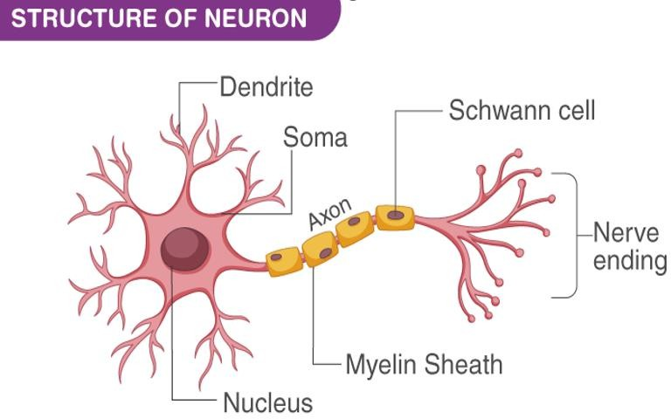

Neurons (also called neurones or nerve cells) are the fundamental units of the brain and nervous system, the cells responsible for receiving sensory input from the external world, for sending motor commands to our muscles, and for transforming and relaying the electrical signals at every step in between. More than that, their interactions define who we are as people. A neuron has three main parts: dendrites, anaxon, and a cell body or soma(see image below), which can be represented as the branches, roots and trunk of a tree, respectively. A dendrite (tree branch) is where a neuron receives input from other cells. Dendrites branch as they move towards their tips,just like tree branches do,and theyeven haveleaf-like structures on them called spines.
A crude comparison of the raw computational resources available to the IBM BLUE GENE supercomputer, a typical personal computer of 2008, and the human brain.

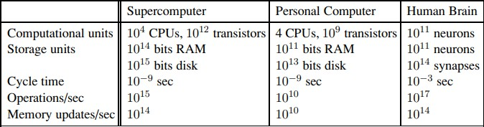

Psychology
Psychology is the scientific study of the mind and behavior. Psychologists are actively involved in studying and understanding mental processes, brain functions,andbehavior. Thefieldof psychologyisconsidereda"Hub Science" withstrongconnectionstothemedicalsciences,socialsciences,andeducation
Cognitive psychology is the branch of psychologydedicated to studying howpeople think. The cognitive perspective in psychology focuses on how theinteractions of thinking, emotion, creativity, and problem-solving abilitiesaffecthowandwhyyouthinkthewayyoudo.Cognitivepsychologyattemptstomeasure different types of intelligence, determine how you organize yourthoughts, and compare different components of cognition.
threekeystepsofaknowledge-basedagent:(1)thestimulusmustbetranslated into an internal representation, (2) the representation is manipulated by cognitiveprocessestoderivenewinternalrepresentations,and(3)thesearein turn retranslated back into action

ComputerEngineering
Computer engineering is defined as the discipline that embodies the science and technology of design, construction, implementation, and maintenance of software and hardware components of modern computing systems and computer-controlled equipment.
Computer engineering has traditionally been viewed as a combination of both computer science (CS) and electrical engineering (EE).
It has evolved over the past three decades as a separate, although intimately related, discipline.
Computer engineering is solidly grounded in the theories and principles of computing,mathematics,science,andengineeringanditappliesthesetheories and principles to solve technical problems through the design of computing hardware, software, networks, and processes.
Increasingly,computerengineersareinvolvedinthedesignofcomputer-based systems to address highly specialized and specific application needs.
Computer engineers work in most industries, including the computer, aerospace, telecommunications, power production, manufacturing, defense, and electronics industries.

ControlTheoryandCybernetics
Controltheory(Goodwinetal.,2001)dealswithinfluencingthebehavior ofdynamical systems. Although a major application of control theory involves control system engineering, which deals with the design of process control systems for industry, other applications range far beyond this. This section presents the basic principles for modeling a dependable systemas a control system.
Cybernetics(Wiener, 1948), control theory, is a transdisciplinary branch of engineering and computational mathematics. It deals with the behavior of dynamicalsystemswithinputsandhowtheirbehaviorismodifiedbyfeedback.
Theobjectiveofcontroltheoryistocontrolasystemsothatthesystem'soutput followsadesiredcontrolsignal,calledthereference.Todothis,a(normally

feedback) controller is designed that determines what output needs to be monitored,howtocompareitwiththereference,whichsystembehaviorsneed to be adjusted, and how to adjust them. The difference between actual and desired output, called the error signal, is applied as feedback to the system input, to bring the actual output closer to the reference.

Linguistics
Linguistics is the scientific study of language, and its focus is the systematic investigation of the properties of particular languages as well as the characteristics of language in general.
It encompasses not only the study of sound, grammar and meaning, but also the history of language families, how languages are acquired by children and adults,andhowlanguageuseisprocessedinthemind and howitis connected to race and gender.
With close connections to the humanities, social sciences and the natural sciences, linguistics complements a diverse range of other disciplines such as anthropology, philosophy, psychology, sociology, biology, computer science, health sciences, education and literature.
ThesubfieldofAppliedLinguisticsemphasizestheuseoflinguisticconceptsin the classroom to help students improve their ability to communicate in their native language or a second language.

HISTORYOF AI

Thegestationofartificialintelligence(1943–1955)
Knowledge of basic psychology, functions of neurons in the brain and propositional logic
Aneural networkis aneural circuit of biologicalneurons, sometimes also calledabiologicalneuralnetwork,oranetworkof artificialneuronsornodesin the case of an artificial neural network.[1]
Artificial neural networks are used for solving artificial intelligence (AI) problems; they model connections of biological neurons as weights between nodes.Apositiveweightreflectsanexcitatoryconnection,whilenegativevalues meaninhibitoryconnections.Allinputsaremodifiedbyaweightandsummed.
Neuron on or off based on stimulation by neighboring neurons
Simple neural network with logical connectives like AND, OR, NOT etc
Hebbian Learning attempts to connect the psychological and neurological underpinnings of learning. he basis of the theory is when our brains learn something new, neurons are activated and connected with other neurons, forming a neural network. These connections start off weak, but each time the stimulus is repeated, the connections grow stronger and stronger, and the action becomes more intuitive.

Thebirthofartificialintelligence(1956)
he field of Artificial Intelligence (AI) was officially born and christened at a workshop organized by John McCarthy in 1956 at the Dartmouth Summer Research Project on Artificial Intelligence. The goal was to investigate ways in

whichmachinescouldbemadetosimulateaspectsofintelligence.
AlthoughtheDartmouthworkshopcreatedaunifiedidentityforthefieldanda dedicated research community, many of the technical ideas that have come to characterize AI existed much earlier.
In the eighteenth century, Thomas Bayes provided a framework for reasoning about the probability of events.
George Boole showed that logical reasoning—dating back to Aristotle— could be performed systematically in the same manner as solving a system of equations.
Emergence of the field of statistics, which enables inferences to be drawn rigorously from data.
The idea of physically engineering a machine to execute sequences of instructions, which had captured the imagination of pioneers such as Charles Babbage, had matured by the 1950s, and resulted in the construction of the first electronic computers.
Primitiverobots,whichcouldsenseandactautonomously,hadalsobeenbuilt by that time.

WhyAIasa separate branch
- AItoduplicatehumanfacilitiessuchascreativity,self-improvementandlanguage use
- Usescomputerscience methodologies
- Designautonomoussystems

Earlyenthusiasm,greatexpectations(1952–1969)
Aphysicalsymbolsystemtakesphysicalpatterns(symbols),combiningtheminto structures(expressions)andmanipulatingthem(usingprocesses)toproducenew expressions.
Eg:
- Formallogic
- Algebra
- Chess
- Computerprogram
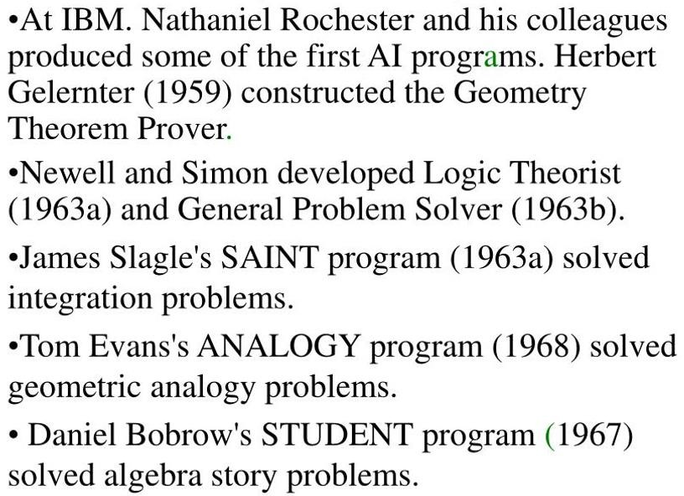

Lisp,anacronymforlistprocessing,isafunctionalprogramminglanguagethat wasdesignedforeasymanipulationofdatastrings.Asoneoftheoldestprogramming languages still in use, Lisp offers several different dialects and has influenced the development of other languages.
A unique feature of early Lisp versions compared to most other programming languagesisthatthecodecouldbedirectlyinterpretedwithoutacompiler.Thesource codeitselfcouldbeparsedandinterpreteddirectlyonasystem.Today,however,most Lispversionsrequirethatcodebecompiledandthenloadedintoanimagetorun.This offers faster program execution speeds compared to direct interpretation.
To cope with thebewildering complexity of thereal world, scientists often ignore less relevant details; for instance, physicists often ignore friction andelasticityin their models. In 1970Marvin Minsky andSeymour Papert of the MIT AI Laboratory proposed that, likewise, AI research should focus on developing programs capable of intelligentbehaviourinsimplerartificial environmentsknownasmicroworlds.Much research has focused on the so-calledblocks world, which consists of coloured blocks of various shapes and sizes arrayed on a flat surface.

Adoseofreality (1966–1973)
1960-70s
Too early for wide applications
Intractability issues: From a computational complexity stance, intractable problems are problems for which there exist no efficient algorithms to solve them.Mostintractableproblemshaveanalgorithm–thesamealgorithm–that provides a solution, and that algorithm is the brute-force search.
The genetic algorithm is a method for solving both constrained and unconstrained optimization problems that is based on natural selection, the process that drives biological evolution. The genetic algorithm repeatedly modifies a population of individual solutions. Genetic algorithms also faced intractability
When training a neural network, there’s going to be some data that the neural networktrainson,andthere’sgoingtobesomedatareservedforcheckingthe performanceoftheneuralnetwork.Iftheneuralnetworkperformswellonthe data which ithas not trained on, we can say it has generalized wellon the given data. Generalization of neural networks did not work

Knowledge-basedsystems:Thekeyto power?(1969–1979)
DENDRAL, an earlyexpert system, developed beginning in 1965 by the artificial intelligence(AI)researcher EdwardFeigenbaumandthegeneticist Joshua Lederberg, both ofStanford Universityin California. HeuristicDENDRAL (later shortened to DENDRAL) was a chemical-analysis expert system.
Thesubstancetobeanalyzedmight,forexample,bea complicatedcompoundofcarbon,hydrogen,andnitrogen.Startingfrom spectrographic data obtained from the substance, DENDRAL would hypothesize the substance’s molecular structure.
DENDRAL’s performance rivaled that of chemists expert at this task, and the program was
usedinindustryandinacademia.
An expert system is a computer program that is designed to solve complex problems and to provide decision-making ability like a human expert. It performs this by extracting knowledge from its knowledge base using the reasoning and inference rules according to the user queries.

The expert system is a part of AI, and the first ES was developed in the year 1970, which was thefirst successful approach of artificial intelligence. It solves themost complex issue as an expert by extracting the knowledge stored in its knowledge base.Thesystemhelpsindecisionmakingforcompsexproblemsusingbothfacts and heuristics like a human expert.
It is called so because it contains the expert knowledge of a specific domain and can solve any complex problem of that particular domain. These systems are designed for a specific domain, such as medicine, science, etc.
MYCIN was an early backward chaining expert system that used AI to identify microorganisms causing severe diseases like bacteremia and meningitis and propose antibiotics based on patient weight.

AIbecomesanindustry (1980–present)
Ithastakenmorethan25yearstogainrecognitionfromtheindustry.Xconwas the very first industrial application of AI. Xcon is an expert system that configures mini-computers to meet user requirements. That process was normally taken 8 hours but xcon did it within 8 minutes.
The neural network was reborn with a backpropagation training algorithm. In thelate1980sAI-basedweaponsweredemonstrated.Thebest exampleofthat is the DART expert system which is used in the gulf war.

AIadoptsthescientificmethod (1987–present)
The field of speech recognition illustrates the pattern. In recent years, approaches based on hidden Markov models (HMMs) have come to dominate thearea.TwoaspectsofHMMsarerelevant.First,theyarebasedonarigorous mathematical theory. Second, they are generated by a process of training on a large corpus of real speech data. This ensures that the performance is robust, andinrigorousblindteststheHMMshavebeenimprovingtheirscoressteadily.
Speech technology and the related field of handwritten character recognition are already making the transition to widespread industrial and consumer applications.
Machinetranslationfollowsthesamecourseasspeechrecognition.Muchofthe work on neural nets in the 1980s was done in an attempt to scope out what couldbedoneandtolearnhowneuralnetsdifferfrom“traditional”techniques. Using improved methodology and theoretical frameworks, the field arrived at an understanding in which neural nets can now be compared with corresponding techniques from statistics, pattern recognition, and machine learning,andthemostpromisingtechniquecanbeappliedtoeachapplication.
Probabilistic Reasoning in Intelligent Systems led to a new acceptance of probability and decision theory in AI. The Bayesian network formalism was invented to allow efficient representation of, and rigorous reasoning with, uncertain knowledge.
Similar gentle revolutions have occurred in robotics, computer vision, and knowledge representation. A better understanding of the problems and their complexity properties,combinedwith increasedmathematical sophistication, has led to workable research agendas and robust methods.

Agentsand Environments
Anagentisanythingthatcanbeviewedasperceivingitsenvironmentthrough sensors and SENSOR acting upon that environment through actuators. A human agenthaseyes,ears,andotherorgansforsensorsandhands,legs,vocaltract,andso on for actuators. A robotic agent might have cameras and infrared range finders for sensors and various motors for actuators. A software agent receives keystrokes, file contents, and network packets as sensory inputs and acts on the environment by displayingonthescreen.Perceptreferstotheagent’sperceptualinputsatany given instant. An agent’s percept sequence is the complete history of everything the agent has ever perceived.
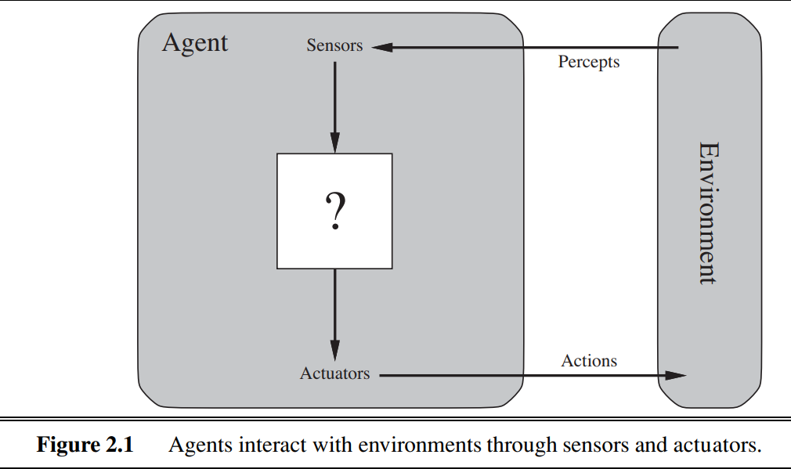

Agentfunctionmapsanygivenperceptsequencetoaction.Agentprogram implements agent function in a physical system.

Eg:Vacuumcleanerfor2locations
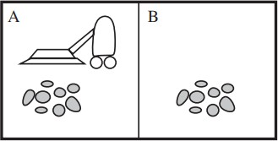

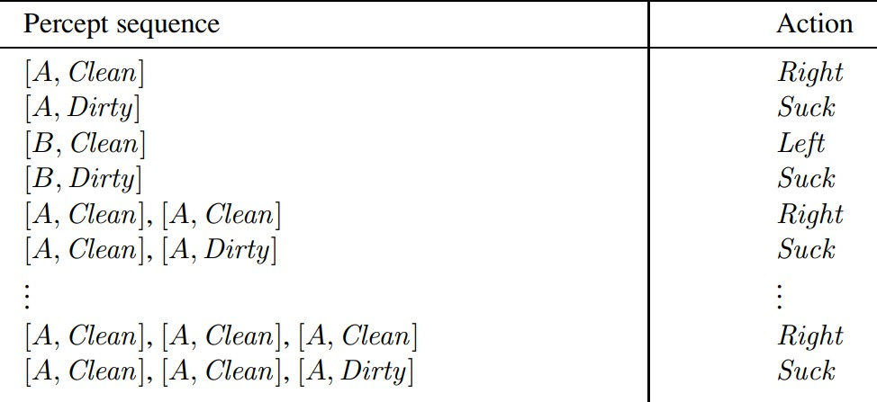

RationalAgents
A rational agent is a computer program that uses logical reasoning and the ability to make decisions to determine its following action. An excellent example of a rational agent is a chess player. A chess player can analyze the board and determine which moves will result in the most advantageous outcome for itself. It can move one piece over another, move its king out of danger, or attack an opponent's piece.
Arationalagenthasfourprimarycharacteristics:
- Perception:Theabilitytoperceivethecurrentstateoftheenvironmentand gather relevant information.
- Actuators:Theabilitytotakeactionswithintheenvironmenttoachieveits goals.
- Performancemeasure:Awaytoevaluatethesuccessorfailureofthe agent's actions.
- Rationality:Theabilitytomakedecisionsbasedonlogicalreasoningand optimize behavior to achieve its goals, considering its perception of the environment and the performance measure.

PEAS
PEAS in AI is an acronym representing the foundational components that define an artificial intelligence agent's behavior. It stands for Performance Measure, Environment, Actuators, and Sensors.
Performance Measure refers to the criterion an AI agent uses to evaluate its actions; the environment encompasses the external context it operates within, Actuators are the mechanisms enabling the agent to interact with the environment, and Sensors provide the agent with the means to perceive and gather information.
PEAS serves as a structured approach to designing and understanding AI systems, aiding in conceptualizing objectives, interactions, and constraints. Whether applied toself-driving cars, virtual assistants, or medicaldiagnosis,

thePEASframeworkoffersasystematiclenstodissectandmodelAI'srole within its surroundings.
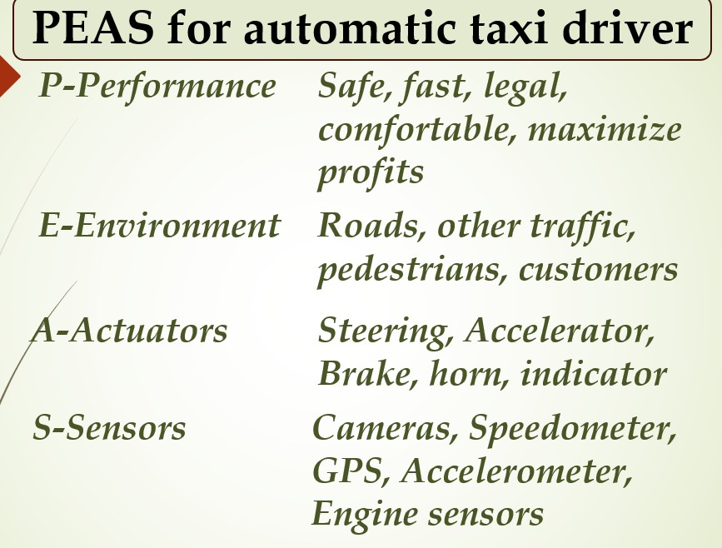

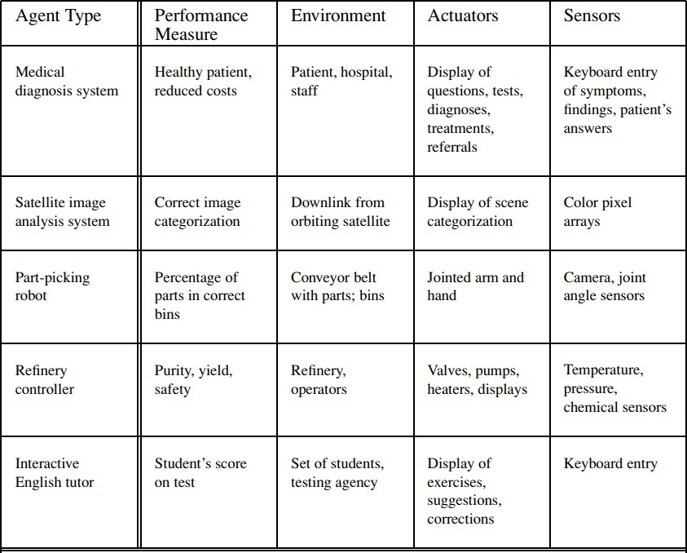

TypesofEnvironmentsinAI
Anenvironmentinartificialintelligenceisthesurroundingoftheagent.Theagent takes input from the environment through sensors and delivers the output to the environment through actuators. There are several types of environments:
- FullyObservablevsPartiallyObservable
- DeterministicvsStochastic
- CompetitivevsCollaborative
- Single-agentvsMulti-agent
- StaticvsDynamic
- DiscretevsContinuous
- EpisodicvsSequential
- KnownvsUnknown

FullyObservablevsPartiallyObservable
When an agent sensor is capable to sense or access the complete state of an agent at each point in time, it is said to be a fully observable environment else it is partially observable.
Maintaining a fully observable environment is easy as there is no need to keep track of the history of the surrounding.
An environment is calledunobservablewhen the agent has no sensors in all environments.
Examples:
  - Chess–theboardisfullyobservable,andsoaretheopponent’s
moves.
  - Driving–theenvironmentispartiallyobservablebecausewhat’s
aroundthecornerisnotknown.

DeterministicvsStochastic
When a uniqueness in the agent’s current state completely determines the next
stateoftheagent,theenvironmentissaidtobe deterministic.
Thestochasticenvironmentisrandominnaturewhichisnotuniqueandcannot be completely determined by the agent.
Examples:
  - Chess –there would be only a few possible moves for a coin at the current state and these moves can be determined.
  - Self-Driving Cars-the actions of a self-driving car are not unique, it varies time to time.

Competitivevs Collaborative
An agent is said to be in a competitive environment when it competes against another agent to optimize the output.
Thegameof chess is competitiveas the agentscompete witheach otherto win the game which is the output.
Anagentissaidtobeinacollaborativeenvironmentwhenmultipleagents cooperate to produce the desired output.

When multiple self-driving cars are found on the roads, they cooperate with each other to avoid collisions and reach their destination which is the output desired.

Single-agentvsMulti-agent
Anenvironmentconsistingofonlyoneagentissaidtobeasingle-agentenvironment.
A person left alone in a maze is an example of the single-agent system.
Anenvironmentinvolvingmorethanoneagentisamulti-agentenvironment. The game of football is multi-agent as it involves 11 players in each team.

Dynamicvs Static
Anenvironmentthatkeepsconstantlychangingitselfwhentheagentisupwith some action is said to be dynamic.
Arollercoasterrideisdynamicasitissetinmotionandtheenvironmentkeeps changing every instant.
An idle environment with no change in its state is called a static environment.
Anemptyhouse is staticas there’sno change in thesurroundingswhen an agent
enters.

DiscretevsContinuous
Ifanenvironmentconsistsofafinitenumberofactionsthatcanbedeliberated intheenvironmenttoobtaintheoutput,itissaidtobeadiscreteenvironment.
Thegameofchessisdiscreteasithasonlyafinitenumberofmoves.The
numberofmovesmightvarywitheverygame,butstill,it’sfinite.
The environment in which the actions are performed cannot be numbered i.e. is not discrete, is said to be continuous.
Self-driving cars are an example of continuous environments as their actionsare driving, parking, etc. which cannot be numbered.

EpisodicvsSequential
Inan Episodic task environment, each of the agent’s actions is divided into atomic incidents or episodes. There is no dependency between current and previous incidents. In each incident, an agent receives input from the environment and then performs the corresponding action.
Example:Consideranexampleof PickandPlacerobot,whichis usedtodetect defectivepartsfromtheconveyorbelts.Here,everytimerobot(agent)willmake thedecisiononthecurrentparti.e.thereisnodependencybetweencurrentand previous decisions.
In aSequential environment, the previous decisions can affect all future decisions. The next action of the agent depends on what action he has taken previously and what action he is supposed to take in the future.
Example:
Checkers-Wherethepreviousmovecanaffectallthefollowingmoves.

Knownvs Unknown
Inaknownenvironment,theoutputforallprobableactionsisgiven.Obviously, incaseofunknownenvironment,foranagenttomakeadecision,ithastogain knowledge about how the environment works.

Agentprogram
The task of AI is to design an agent program which implements the agent function. The structure of an intelligent agent is a combination of architecture and agent program. It can be viewed as:
Agent=Architecture+Agentprogram
FollowingarethemainthreetermsinvolvedinthestructureofanAI agent:
Architecture:ArchitectureismachinerythatanAIagentexecuteson.
AgentFunction:Agentfunctionisusedtomapapercepttoan action.
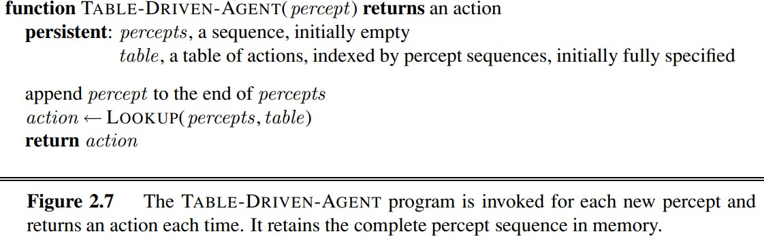

TypesofAgentsin AI
Agentscanbegroupedintofiveclassesbasedontheirdegreeofperceivedintelligence and capability. All these agents can improve their performance and generate better action over the time. These are given below:
- SimpleReflexAgent
- Model-basedreflexagent
- Goal-basedagents
- Utility-basedagent
- Learningagent
- SimpleReflexagent:
  - The Simple reflex agents are the simplest agents. These agents take decisions on the basis of the current percepts and ignore the rest of the percept history.
  - Theseagentsonlysucceedinthefullyobservableenvironment.
  - The Simple reflex agent does not consider any part of percepts history during their decision and action process.
  - The Simple reflex agent works on Condition-action rule, which means it maps thecurrentstatetoaction.SuchasaRoomCleaneragent,itworksonlyifthere is dirt in the room.
  - Problemsforthesimplereflexagentdesignapproach:
    - Theyhaveverylimitedintelligence
    - Theydonothaveknowledgeofnon-perceptualpartsofthecurrentstate
    - Mostlytoobigtogenerateandto store.
    - Notadaptivetochangesintheenvironment.

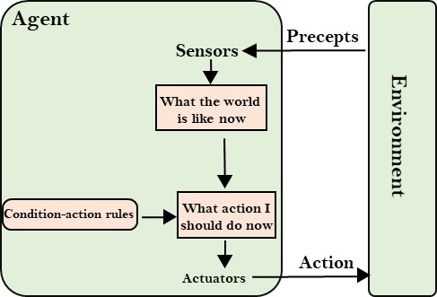
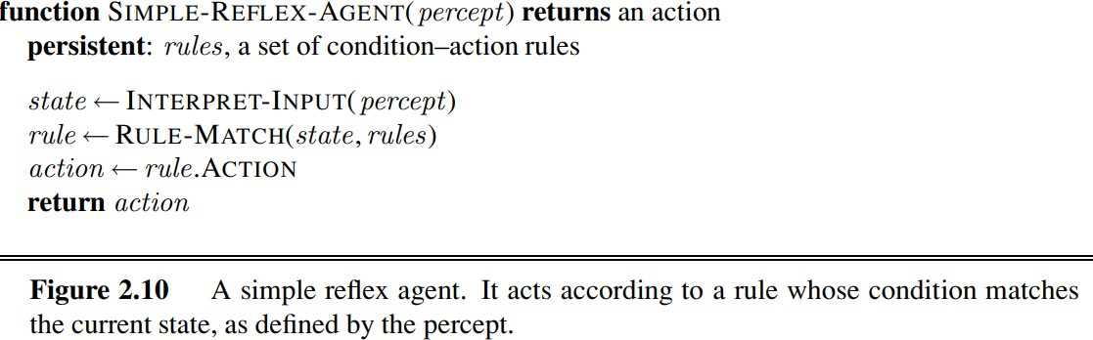
- Model-basedreflexagent
  - The Model-based agent can work in a partially observable environment, andtrack the situation.
  - Amodel-basedagenthastwoimportantfactors:
    - Model:Itisknowledgeabout"howthingshappenintheworld,"soitis called a Model-based agent.
    - InternalState:Itisarepresentationofthecurrentstatebasedon percept history.
  - These agents have the model, "which is knowledge of the world" and based on the model they perform actions.
  - Updatingtheagentstaterequiresinformationabout:
    - Howtheworldevolves
    - Howtheagent'sactionaffectstheworld.

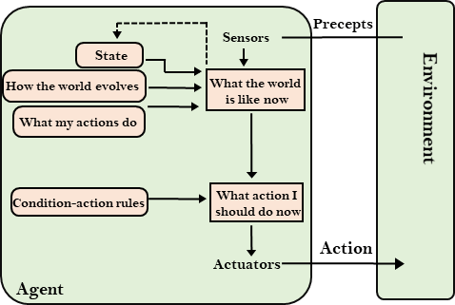
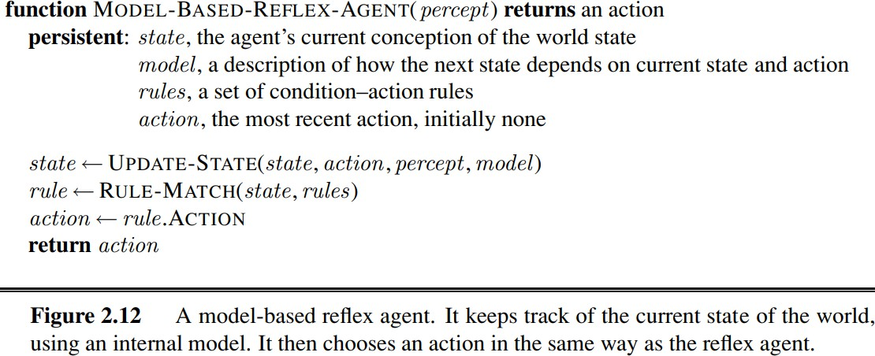

- Goal-basedagents
  - The knowledge of the current state environment is not always sufficient to decide for an agent to what to do.
  - Theagentneedstoknowitsgoalwhichdescribesdesirablesituations.
  - Goal-based agents expand the capabilities of the model-based agent by having the "goal" information.
  - Theychooseanaction,sothattheycanachievethegoal.
  - These agents may have to consider a long sequence of possible actions before deciding whether the goal is achieved or not. Such considerations of different scenario are called searching and planning, which makes an agent proactive.

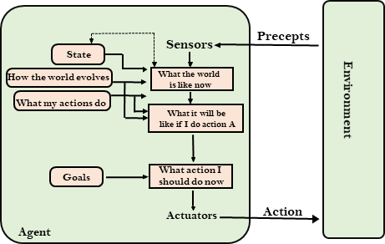

- Utility-basedagents
  - These agents are similar to the goal-based agent but provide an extra component of utility measurement which makes them different by providing a measure of success at a given state.
  - Utility-basedagentactbasednotonlygoalsbutalsothebestwaytoachievethe goal.
  - TheUtility-basedagentisusefulwhentherearemultiplepossiblealternatives, and an agent has to choose in order to perform the best action.
  - The utility function maps each state to a real number to check how efficiently each action achieves the goals.
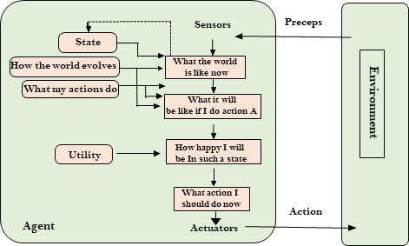

- LearningAgents
  - AlearningagentinAIisthetypeofagentwhichcanlearnfromitspast experiences, or it has learning capabilities.
  - Itstartstoactwithbasicknowledgeandthenabletoactandadapt automatically through learning.
  - Alearningagenthasmainlyfourconceptualcomponents,whichare:

- Learning element:It is responsible for making improvements by learning from environment
- Critic:Learning element takes feedback from critic which describes that how well the agent is doing with respect to a fixed performance standard.
- Performanceelement:Itisresponsibleforselectingexternal action
- Problem generator:This component is responsible for suggesting actions that will lead to new and informative experiences.
  - Hence,learningagentsareabletolearn,analyzeperformance,andlookfornew ways to improve the performance.
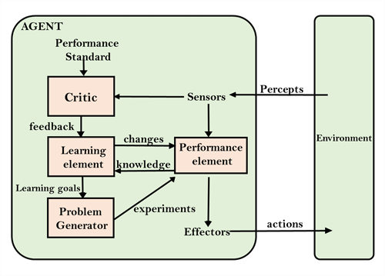

Agentcomponents
Agentscanberepresentedinthreeways:
Atomic/factored/structured is a qualitative measure of how much "internal structure" those models have, from least to most. Atomic models have no internal structure; thestate either does or does not match what you're looking for. In a sliding tile puzzle, for instance, you either have the correct alignment of tiles or you do not.
Factored models have more internal structure, although exactly what will depend on the problem. Typically, you're looking at variables or performance metrics of interest; in a sliding puzzle, this might be a simple heuristic like "number of tiles out of place," or "sum of manhatten distances."
Structured models have still more; again, exactly what depends on the problem, but they're often relations either of components of the model to itself, or components of the model to components of the environment.

MODULE-2

ProblemSolvingAgents
In goal formulation, we decide which aspects we are interested in and which aspects can be ignored.
In the goal formulation process, the goal is to be set and we should assess those states in which the goal is satisfied.
In problem formulation, we decide how to manipulate the important aspects, and ignore the others. So, without doing goal formulation, if we do the problem formulation,wewouldnotknowwhattoincludeinourproblemandwhattoleave, and what should be achieved.
So problem formulation must follow goal formulation. That means problem formulation must be done only after the goal formation is done.
The process of looking for a sequence of actions that reaches the goal is called search.A search algorithm takes a problem as input and returns a solution in the form of an action sequence.
Once a solution is found, the actions it recommends can be carried out. This is called the execution phase. Thus, we have a simple “formulate, search, execute” design for the agent.
SimpleproblemsolvingAgent
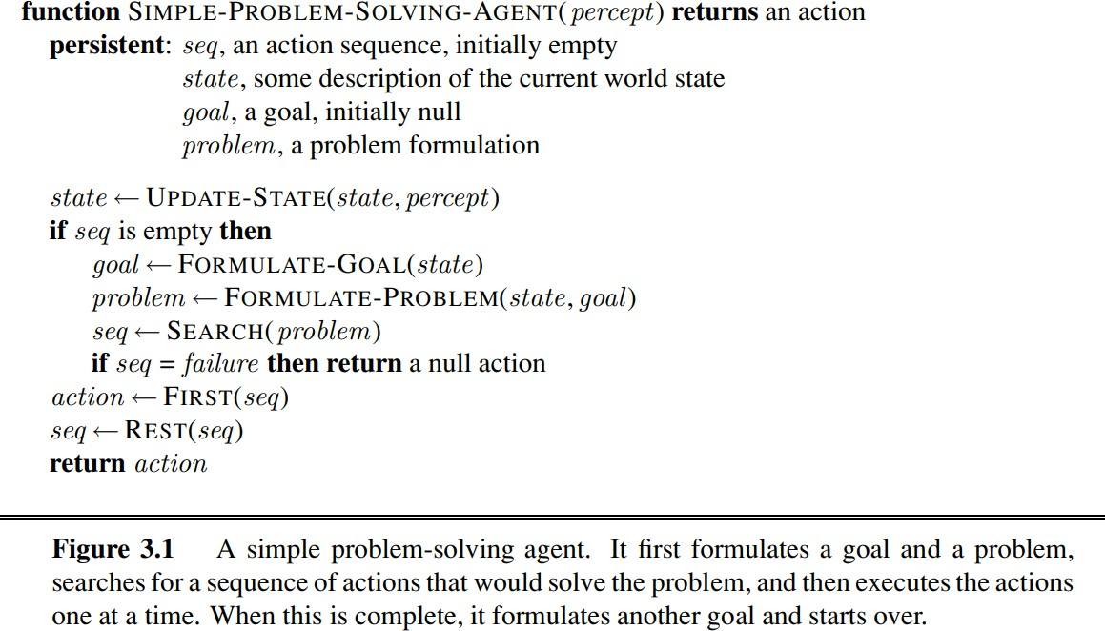

StepsperformedbyProblem-solvingagent

Goal Formulation: It is the first and simplest step in problem-solving. It organizes the steps/sequence required to formulate one goal out of multiple goals as well as actions to achieve that goal.

Problem Formulation: It is the most important step of problem-solving which decides what actions should be taken to achieve the formulated goal.
There are following five components involved in problem formulation:
InitialState:Itisthestartingstateorinitialstepoftheagenttowardsitsgoal. Actions: It is the description of the possible actions available to the agent.
Transition Model: It describes what each action does.
Goal Test: It determines if the given state is a goal state.
Path cost: It assigns a numeric cost to each path that follows the goal. The problem solving agent selects a cost function, which reflects its performance measure.
    - State-space of a problem is a set of all stateswhich can be reached from the initial state followed by any sequence of actions. The state-space formsadirectedmaporgraphwherenodesarethestates,linksbetween thenodes are actions, and the path is a sequence of states connected by the sequence of actions.
Search: It identifies all the best possible sequence of actions to reach the goal statefromthecurrentstate.Ittakesaproblemasaninputandreturnssolution as its output.
Solution: It finds the best algorithm out of various algorithms, which may be proven as the best optimal solution.
Execution:Itexecutesthebestoptimalsolutionfromthesearching algorithms to reach the goal state from the current state n goal formulation.

Exampleproblems
Basically,therearetwotypesofproblemapproaches:
ToyProblem:Itisaconciseandexactdescriptionoftheproblemwhichisused by the researchers to compare the performance of algorithms.
Real-worldProblem:Itisreal-worldbasedproblemswhichrequiresolutions. Unlike a toy problem, it does not depend on descriptions, but we can have a general formulation of the problem.
SomeToy Problems

Vaccuumcleaner problem
Thiscanbeformulatedasaproblemas follows:
States: The state is determined by both the agent location and the dirt locations. The agent is in one of two locations, each of which might or might not contain dirt. Thus, there are 2 × 22= 8 possible world states.
Initial state: Any state can be designated as the initial state.
Actions: In this simple environment, each state has just three actions: Left, Right, and Suck. Larger environments might also include Up and Down.
Transitionmodel:Theactionshavetheirexpectedeffects,exceptthatmoving Leftintheleftmostsquare,movingRightintherightmostsquare,andSucking in a clean square have no effect.
Goal test: This checks whether all the squares are clean.
Pathcost:Eachstepcosts1,sothepathcostisthenumberofstepsinthepath.

StatespaceofVacuumcleanerproblem
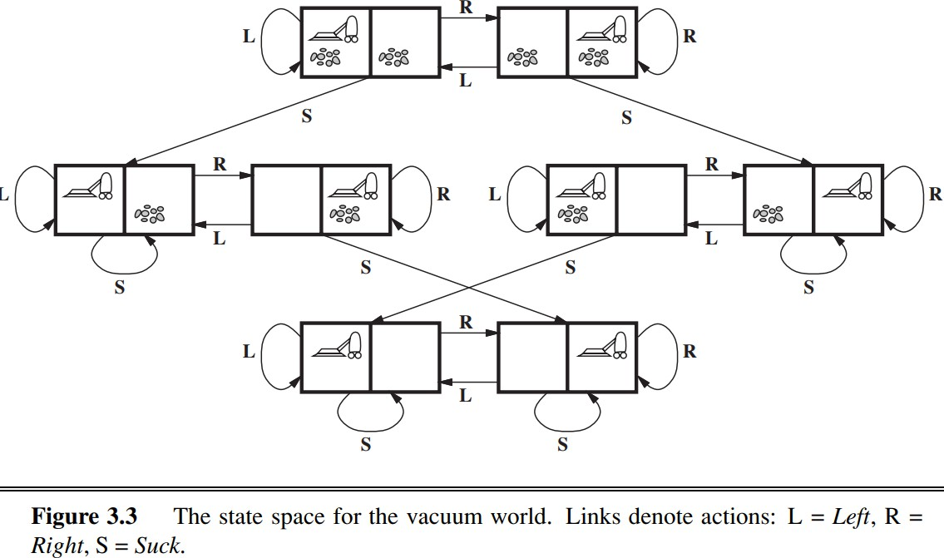

8PuzzleProblem:
Here, we have a 3×3 matrix with movable tiles numbered from 1 to 8 with a blank space.Thetileadjacenttotheblankspacecanslideintothatspace.Theobjectiveisto reachaspecifiedgoalstatesimilar tothegoal state,asshown inthebelowfigure. The taskistoconvertthecurrentstateintogoalstatebyslidingdigitsintotheblankspace.
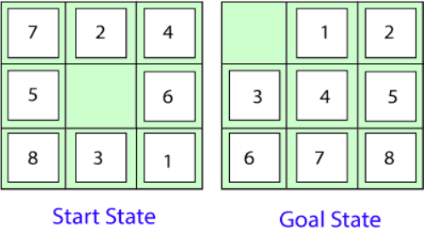

Herethetaskistoconvertthecurrent(Start)stateintogoalstatebyslidingdigitsinto the blank space. The problem formulation is as follows:
States:Itdescribesthelocationofeachnumberedtilesandtheblanktile. Initial State: We can start from any state as the initial state.
Actions:Here,actions oftheblankspaceisdefined,i.e.,either left,right,upor down
TransitionModel:Itreturnstheresultingstateasperthegivenstateand actions.
Goal test: It identifies whether we have reached the correct goal-state.
Pathcost:Thepathcostisthe numberofstepsinthe pathwherethe costof each step is 1.

Note:The8-puzzleproblemisatypeofsliding-blockproblemwhichisusedfortesting new search algorithms in artificial intelligence.

8-queensproblem:
Theaimofthisproblemistoplaceeightqueensonachessboardinanorderwhereno queen may attack another. A queen can attack other queens either diagonally or in same row and column. From the following figure, we can understand the problem as well as its correct solution
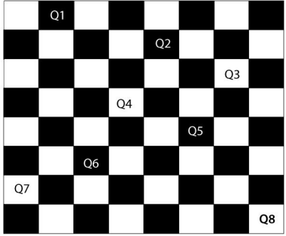
It is noticed from the above figure that each queen is set into the chessboard in a positionwherenootherqueenisplaceddiagonally,insameroworcolumn.Therefore, itisonerightapproachtothe8-queensproblem.Forthisproblem,therearetwomain kindsof formulation:1.Incrementalformulation:Itstartsfromanemptystatewhere the operator augments a queen at each step. Following steps are involved in this formulation:
States:Arrangementofany0to8queensonthechessboard .•Initial State: An empty chessboard
Actions: Add a queen to any empty box.
Transition model: Returns the chessboard with the queen added in a box.
Goal test: Checks whether 8-queens are placed on the chessboard without any attack. •Path cost: There is no need for path cost because only final states are counted.Inthisformulation,thereisapproximately1.8x1014possiblesequence to investigate.
Complete-state formulation: It starts with all the 8-queens on the chessboard and moves them around, saving from the attacks. Following steps are involved in this formulation
States:Arrangementofallthe8queensonepercolumnwithnoqueenattacking the other queen.
Actions: Move the queen at the location where it is safe from the attacks.
This formulation is better than the incremental formulation as it reduces the state space from 1.8 x 1014to 2057, and it is easy to find the solutions.

Numberproblem
Knuth conjectured that, starting with the number 4, a sequence of factorial, square root, and floor operations will reach any desired positive integer.

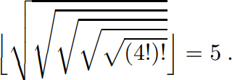

Theproblemdefinitionisverysimple:
- States:Positivenumbers.
- Initialstate:4.
- Actions:Applyfactorial,squareroot,orflooroperation(factorialforintegersonly).
- Transitionmodel:Asgivenbythemathematicaldefinitionsoftheoperations.
- Goaltest:Stateisthedesiredpositiveinteger

Real-world problems Route-findingalgorithms
Theyareusedinavarietyofapplications.Some,suchasWebsitesandin-car
systems that provide driving directions, are relatively straightforward extensions of theRomania example. . Consider theairline travel problems that must be solved by a travel-planning Web site:
States:Eachstateobviouslyincludesalocation(e.g.,anairport)andthecurrent time.
Initial state: This is specified by the user’s query.
Actions:Takeanyflightfromthecurrentlocation,inanyseatclass,leavingafter the current time, leaving enough time for within-airport transfer if needed.
Transition model: The state resulting from taking a flight will have the flight’s destination as the current location and the flight’s arrival time as the current time.
Goal test: Are we at the final destination specified by the user?
Path cost: This depends on monetary cost, waiting time, flight time, customs and immigration procedures, seat quality, time of day, type of airplane, frequent-flyer mileage awards, and so on

Touringproblems
They are closely related to route-finding problems, but with an important difference. As with route finding, the actions correspond to trips between adjacent cities.Thestatespace,however,isquitedifferent.Eachstatemustincludenotjustthe current location but also the set of cities the agent has visited. The goal test would check whether the agent is in a place and all cities have been visited

Thetravellingsalesmanproblem
Itisagraphcomputationalproblemwherethesalesmanneedstovisitallcities (representedusingnodesinagraph)inalistjustonceandthedistances(represented using edges in the graph) between all these cities are known. The solution that is needed to be found for this problem is the shortest possible route in which the salesman visits all the cities and returns to the origin city.

AVLSIlayout problem
Thisrequirespositioningmillionsof componentsand connectionsonachipto minimize area, minimize circuit delays, minimize stray capacitances, and maximize manufacturing yield. The layout problem comes after the logical design phase and is usually split into two parts: cell layout and channel routing.
In cell layout, the primitive components of the circuit are grouped into cells, eachofwhichperformssomerecognizedfunction.Eachcellhasafixedfootprint(size andshape)andrequiresacertainnumberofconnectionstoeachoftheothercells.The aim is to place the cells on the chip so that they do not overlap and so that there is room for the connecting wires to be placed between the cells.
Channel routing finds a specific route for each wire through the gaps between the cells. These search problems are extremely complex, but definitely worth solving.

Robotnavigation
Here a robot can move in a continuous space with (in principle) an infinite set of possible actions and states. For a circular robot moving on a flat surface, the space isessentiallytwo-dimensional.Whentherobothasarmsandlegsorwheelsthatmust alsobecontrolled,thesearchspacebecomesmany-dimensional.Advancedtechniques are required just to make the search space finite.

Proteindesignproblem
Thegoalinrationalproteindesignistopredict aminoacid sequences that willfoldto a specific protein structure. Although the number of possible protein sequences is vast, growing exponentially with the size of the protein chain, only a subset of them will fold reliably and quickly to one native state.
Protein design involves identifying novel sequences within this subset. The native state of a protein is the conformational free energy minimum for the chain.
In design, atertiary structure is specified, and a sequence that will fold to it is identified. Hence, it is also termed inverse folding. Protein design is then an optimizationproblem:usingsomescoringcriteria,anoptimizedsequencethatwill fold to the desired structure is chosen.

SearchingforSolutions
Searchtreeisatreegeneratedasthesearchspaceistraversed.Thesearchspace itselfisnotnecessarilyatree,frequentlyitisagraph.Thistreespecifiespossible paths through the search space.
Expansionofnodesoccursasstatesareexplored,thecorrespondingnodesare expanded by applying the successor function which generates a new set of (child) nodes.
Fringe (frontier) is the set of nodes not yet visited and newly generated nodes are added to the fringe.
Searchstrategydeterminestheselectionofthenextnodetobeexpanded.Itcan be achieved by ordering the nodes in the fringe – e.g. queue (FIFO), stack (LIFO), “best” node w.r.t. some measure (cost).
Aloopypathisaspecialcaseofredundantpaths,wheretherearemorethanone pathsfrom onestateto another(forexample,Arad—Sibiu andArad —Zerind
—Oradea— Sibiu).

Theredundantpathsituationoccursinalmosteveryproblem,andoftenmakes thesolutionalgorithmlessefficient,worseningtheperformanceofthesearching agent.Onewaytoeliminatetheredundancyistoutilizetheadvantagegivenby theproblemdefinitionitself.Forexample,inthecaseoftravelingfromAradto Bucharest,sincethepathcostsareadditiveandstepcostsarenon-negative,only one path among the various redundant paths has the least cost (and it is the shortestdistancebetweenthetwostates),andloopypathsareneverbetterthan the same path with loops removed.

GraphSearch
Treesearchcanbeusedisthestatespaceisatree,otherwisegraphsearchmust beused. All search algorithms(BFS,DFS, uniform-cost,A*, etc) are variations of one of these (usually graph search). The only difference between tree search and graph search is that tree search does not need to store the explored set, because we are guaranteed never to attempt to visit the same state twice.

TreeSearchAlgorithm:
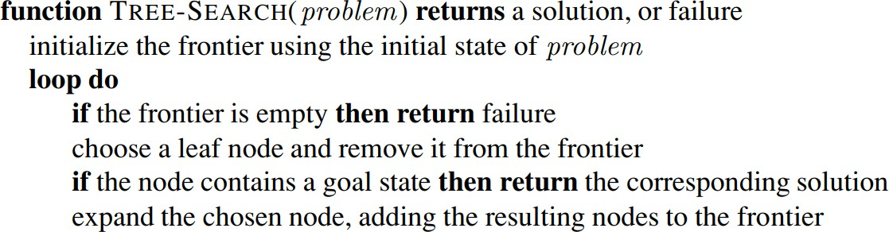

GraphSearchAlgorithm:
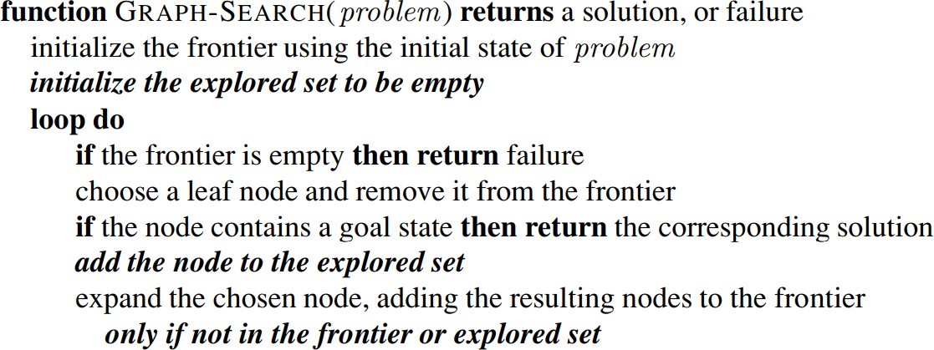

The separation property of GRAPH-SEARCH is illustrated on a rectangular-grid problem in the following figure. The frontier (white nodes) always separates the explored region of the state space (black nodes) from the unexplored region (gray nodes). In (a), just the root has been expanded. In (b), one leaf node has been expanded. In (c), the remaining successors of the root have been expanded in clockwise order.

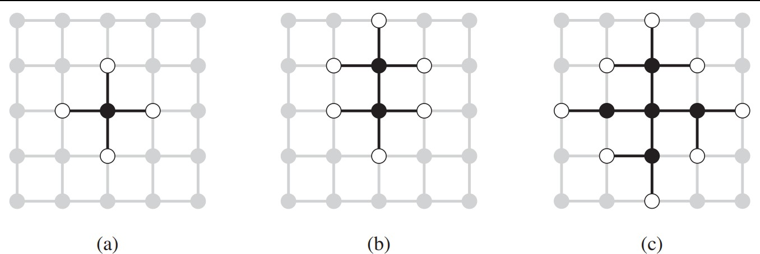

InfrastructureforSearchAlgorithms
Foreachnodenofthetree,wehaveastructurethatcontainsfivecomponents: n.STATE: the state in the state space to which the node corresponds.
n.PARENT: the node in the search tree that generated this node.
n.ACTION: the action that was applied to the parent to generate the node.
n.DEPTH: the depth of tho node n, i.e., number of nodes in the path from the rood to this node n.
n.PATH-COST:thecost,traditionallydenotedbyg(n),ofthepathfromthe initial state to the node, as indicated by the parent pointers.
Eg:
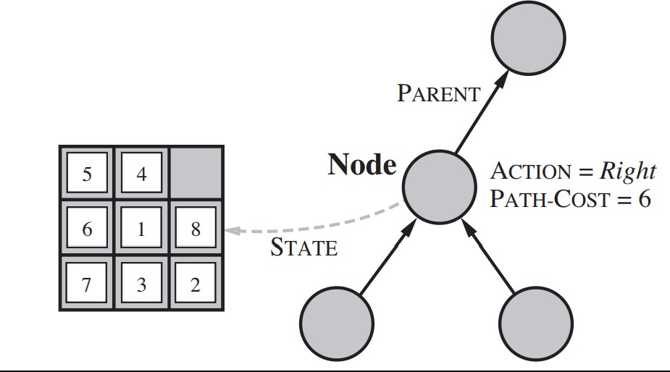
Algorithmformaintenanceoftheinfrastructure
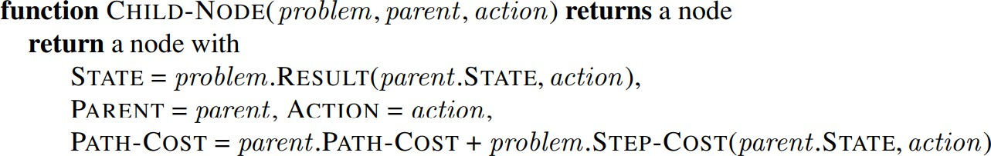

MeasuringPerformanceofSearchalgorithms:
Strategiesareevaluatedbasedon:
completeness—does it always find a solution if one exists?
time complexity—number of nodes generated/expanded space

complexity—maximumnumberofnodesinmemory optimality—doesitalwaysfindaleast-costsolution?
Time and space complexity are measured in terms of : b—maximumbranchingfactorofthesearchtree d—depth of the least-cost solution
m—maximum depth of the state space (may be ∞)

Typesofsearchalgorithms
Based on the search problems we can classify the search algorithms into uninformed (Blind search) search and informed search (Heuristic search) algorithms.
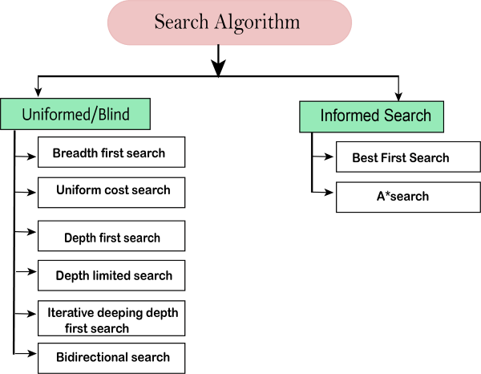

Uninformed/BlindSearch:
Theuninformedsearchdoesnotcontainanydomainknowledgesuchascloseness,the location of the goal. It operates in a brute-force way as it only includes information about how to traverse the tree and how to identify leaf and goal nodes. Uninformed search applies a way in which search tree is searched without any information about thesearchspacelikeinitialstateoperatorsandtestforthegoal,soitisalsocalledblind search. It examines each node of the tree until it achieves the goal node.

Breadth-firstSearch:
- Breadth-firstsearchisthemostcommonsearchstrategyfortraversingatreeor graph. This algorithm searches breadthwise in a tree or graph, so it is called breadth-first search.
- BFS algorithm starts searching from the root node of the tree and expands all successor node at the current level before moving to nodes of next level.
- The breadth-first search algorithm is an example of a general-graph search algorithm.
- Breadth-firstsearchimplementedusingFIFOqueuedatastructure. Advantages:
- BFSwillprovideasolutionifanysolution exists.

- Iftherearemorethanonesolutionsforagivenproblem,thenBFSwillprovide the minimal solution which requires the least number of steps.
Disadvantages:
- Itrequireslotsofmemorysinceeachlevelofthetreemustbesavedinto memory to expand the next level.
- BFSneedslotsoftimeifthesolutionisfarawayfromtheroot node.
Example:
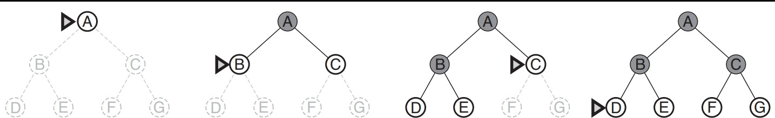

Algorithm:
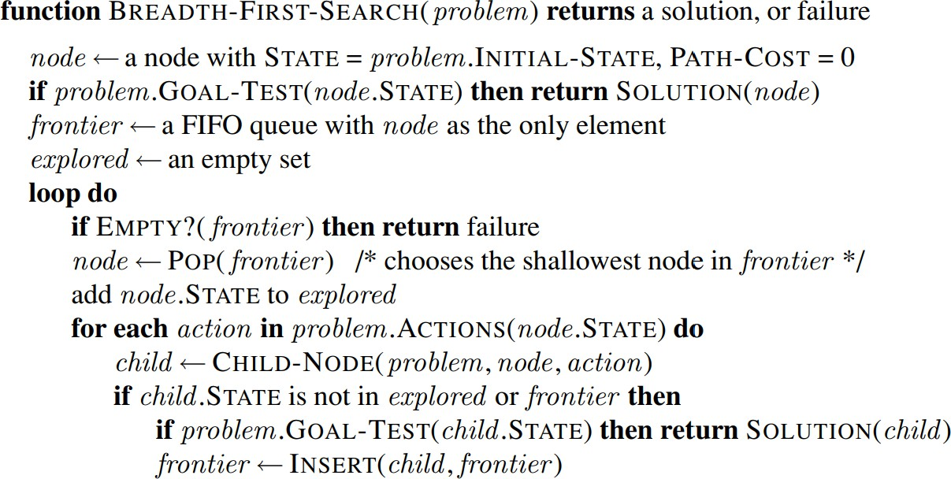

Time Complexity:Time Complexity of BFS algorithm can be obtained by the number of nodes traversed in BFS until the shallowest Node. Where the d= depth of shallowest solution and b is a node at every state.
T(b) =1+b2+b3+.+bd=O(bd)
SpaceComplexity:Space complexityof BFSalgorithmisgivenbytheMemorysize of frontier which is O(bd).
Completeness:BFSiscomplete,whichmeansiftheshallowestgoalnodeisatsome finite depth, then BFS will find a solution.
Optimality:BFS is optimal if path cost is a non-decreasing function of the depth of the node.

Uniform-costSearchAlgorithm:
Uniform-cost search is a searching algorithm used for traversing a weighted tree or graph.Thisalgorithmcomesintoplaywhenadifferentcostisavailableforeachedge. The primary goal of the uniform-cost search is to find a path to the goal node which hasthelowestcumulativecost.Uniform-costsearchexpandsnodesaccordingtotheir

pathcostsformtherootnode.Itcanbeusedtosolveanygraph/treewheretheoptimal cost is in demand. A uniform-cost search algorithm is implemented by the priority queue. It gives maximum priority to the lowest cumulative cost. Uniform cost search is equivalent to BFS algorithm if the path cost of all edges is the same.
Advantages:
- Uniform cost search is optimal because at every state the path with the leastcost is chosen.
Disadvantages:
- It does not care about the number of steps involve in searching and only concerned about path cost. Due to which this algorithm may be stuck in an infinite loop.
Eg:
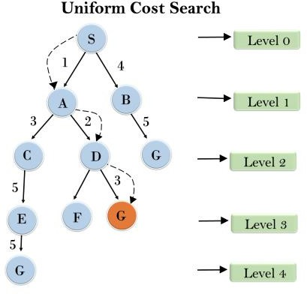

Henceateachlevel,minimumcostisconsideredandotherpathsarediscarded.
Completeness:
Uniform-costsearchiscomplete,suchasifthereisasolution,UCSwillfindit.
TimeComplexity:
Let C*isCost of theoptimal solution,andεis eachstepto get closerto thegoal node. Thenthenumberofstepsis=C*/ε+1.Herewehavetaken+1,aswestartfromstate0 and end to C*/ε.Hence, the worst-case time complexity of Uniform-cost search is O(b1 + [C*/ε])/.
Space Complexity:
Thesamelogicisforspacecomplexityso,theworst-casespacecomplexityofUniform- cost search is O(b1 + [C*/ε]).
Optimal:
Uniform-cost search is always optimal as it only selects a path with the lowest pathcost.

Algorithm:
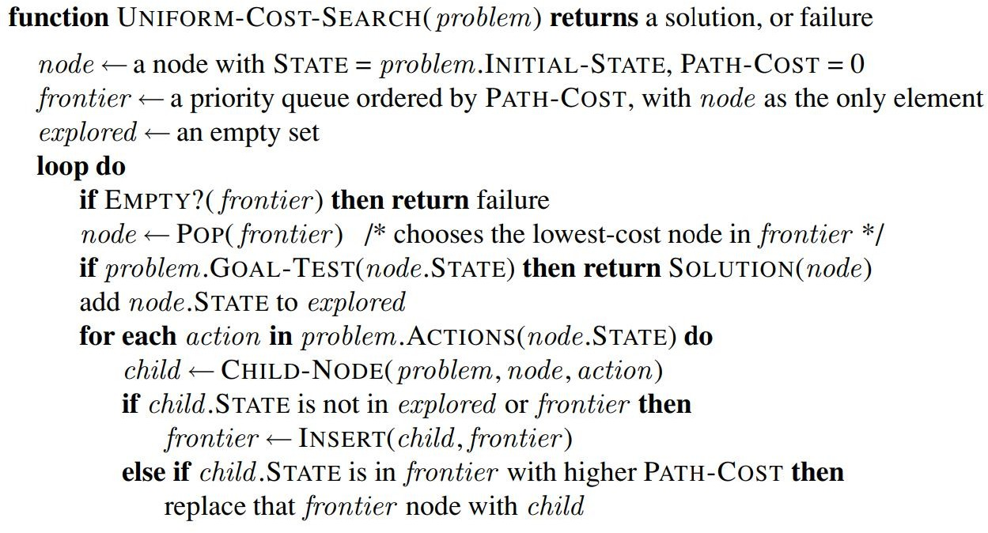

Depth-firstSearch
- Depth-first search isa recursive algorithm for traversing a tree or graph datastructure.
- Itiscalledthedepth-firstsearchbecauseitstartsfromtherootnodeandfollows each path to its greatest depth node before moving to the next path.
- DFSusesastackdatastructureforits implementation.
- TheprocessoftheDFSalgorithmissimilartotheBFSalgorithm.
Advantages:
- DFSrequiresverylessmemoryasit onlyneedstostorea stackofthenodeson the path from root node to the current node.
- IttakeslesstimetoreachtothegoalnodethanBFSalgorithm(ifittraversesin the right path).
Disadvantages:
- Thereisthepossibilitythatmanystateskeepre-occurring,andthereisno guarantee of finding the solution.
- DFS algorithm goes for deep down searching and sometime it may go to theinfinite loop.
- Completeness:DFS search algorithm is complete within finite state space as it will expand every node within a limited search tree.
- TimeComplexity:TimecomplexityofDFSwillbeequivalenttothenode traversed by the algorithm. It is given by:
- T(n)=1+n2+n3+. + nm=O(nm)
- Where, m= maximum depth of any node and this can be much larger than d (Shallowest solution depth)
- SpaceComplexity:DFSalgorithmneedstostoreonlysinglepathfromtheroot node, hence space complexity of DFS is equivalent to the size of the fringe set, which is O(bm).
- Optimal:DFSsearchalgorithmisnon-optimal,asitmaygeneratealarge

numberofstepsorhighcosttoreachtothegoalnode.
Example:
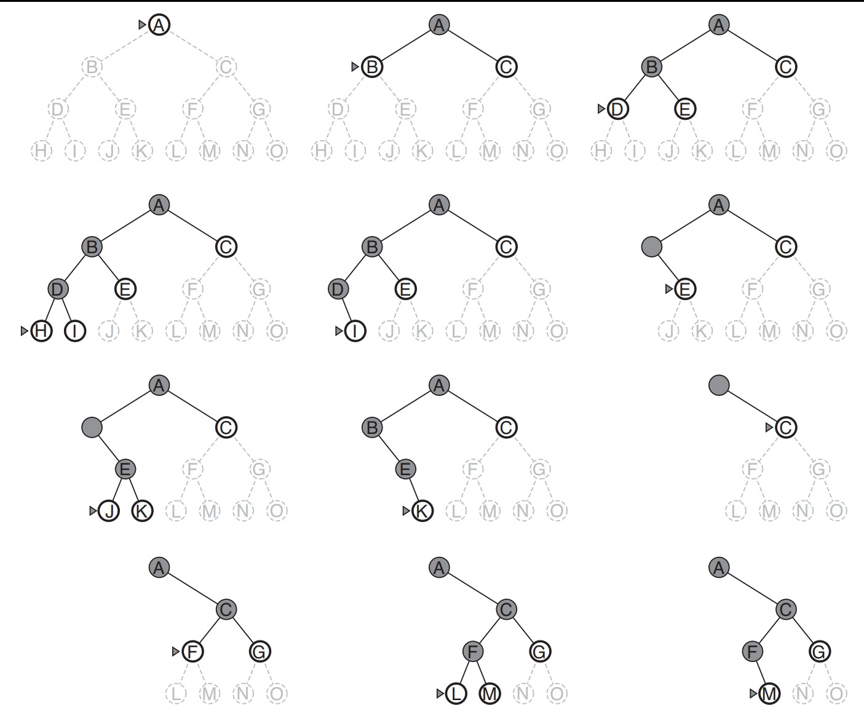
Onceawrongpathischosen,thenpruningofentiresubtreeisdone.

Depth-LimitedSearchAlgorithm:
Adepth-limitedsearchalgorithmissimilartodepth-firstsearchwithapredetermined limit. Depth-limited search can solve the drawback of the infinite path in the Depth- first search. In this algorithm, the node at the depth limit will treat as it has no successor nodes further.
Depth-limitedsearchcanbeterminatedwithtwoConditionsof failure:
- Standardfailurevalue:Itindicatesthatproblemdoesnothaveanysolution.
- Cutofffailurevalue:Itdefinesnosolutionfortheproblemwithinagivendepth limit.

Advantages:
Depth-limitedsearchisMemoryefficient.
Disadvantages:
- Depth-limitedsearchalsohasadisadvantage of incompleteness.
- Itmaynotbeoptimaliftheproblemhasmorethanonesolution.

Algorithm:
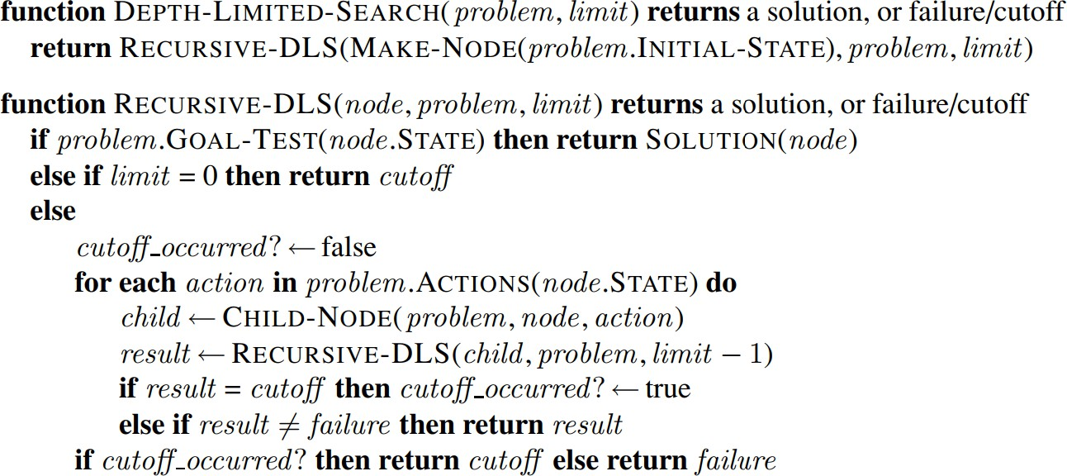

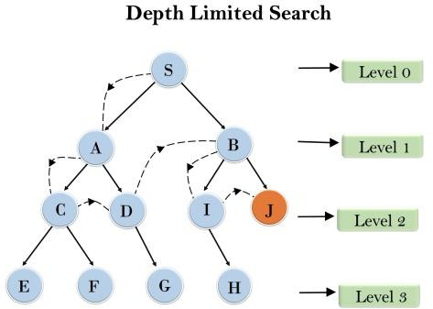Eg:
Limit=2

IterativedeepeningDepth-firstSearch:
The iterative deepening algorithm is a combination of DFS and BFS algorithms. This searchalgorithmfindsoutthebestdepthlimitanddoesitbygraduallyincreasingthe limit until a goal is found. This algorithm performs depth-first search up to a certain "depthlimit",anditkeepsincreasingthedepthlimitaftereachiterationuntilthegoal node is found. This Search algorithm combines the benefits of Breadth-first search's fast search and depth-first search's memory efficiency.
The iterative search algorithm is useful uninformed search when search space is large, and depth of goal node is unknown.

Advantages:
- ItcombinesthebenefitsofBFSandDFSsearchalgorithmintermsoffast search and memory efficiency.

Disadvantages:
- ThemaindrawbackofIDDFSisthatitrepeatsalltheworkoftheprevious phase.

Eg:
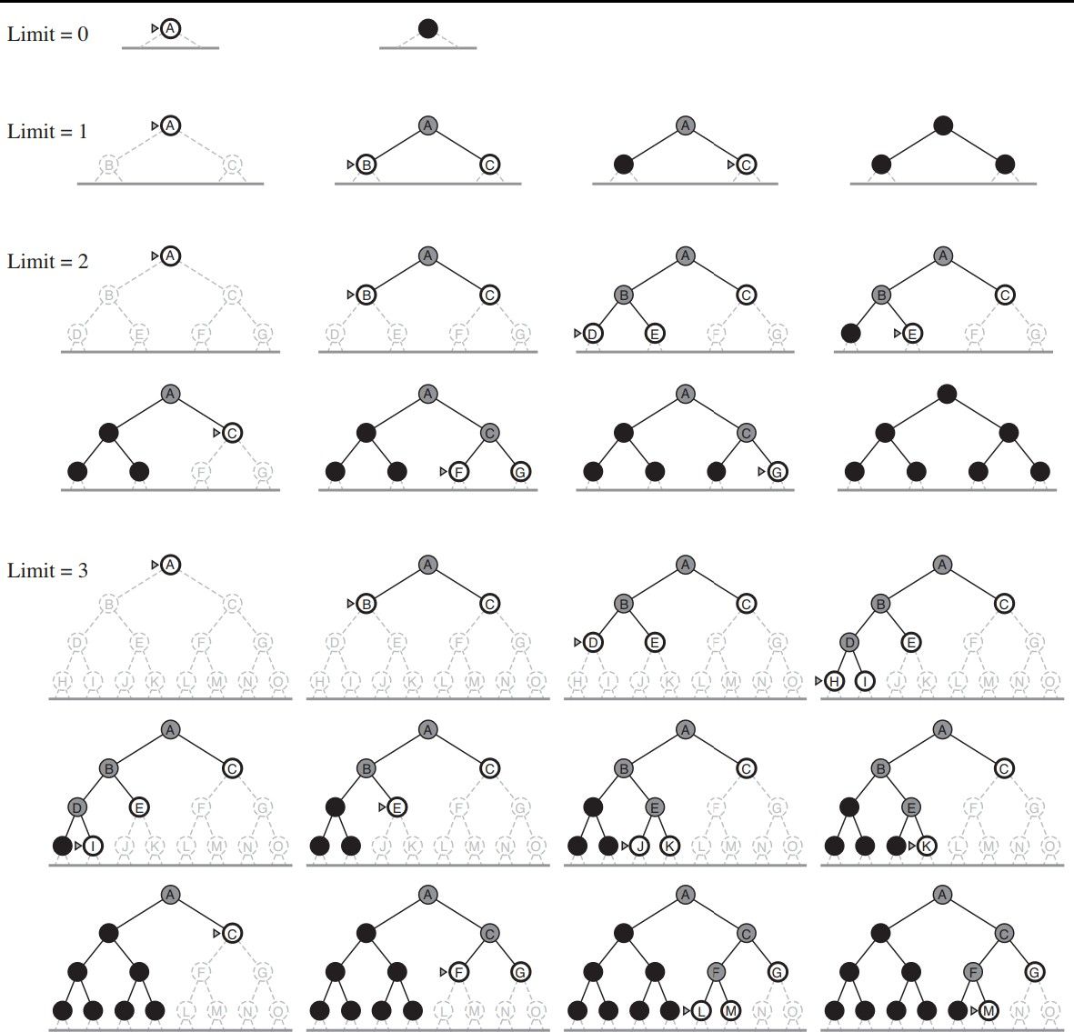
DifferentiterationsofIterativeDeepeningSearch

BidirectionalSearchAlgorithm:
Bidirectional search algorithm runs two simultaneous searches, one form initial state called as forward-search and other from goal node called as backward-search, to find the goal node. Bidirectional search replaces one single search graph with two small subgraphs in which one starts the search from an initial vertex and other starts from goalvertex.Thesearchstopswhenthesetwographsintersecteachother.Bidirectional search can use search techniques such as BFS, DFS, DLS, etc.

Advantages:
- Bidirectionalsearchis fast.
- Bidirectionalsearchrequireslessmemory
Disadvantages:
- Implementationofthebidirectionalsearchtreeis difficult.

- Inbidirectionalsearch,oneshouldknowthegoalstatein advance.
Example:
In the below search tree, bidirectional search algorithm is applied. This algorithm divides one graph/tree into two sub-graphs. It starts traversing from node 1 in the forward direction and starts from goal node 16 in the backward direction.
Thealgorithmterminatesatnode9wheretwosearchesmeet.
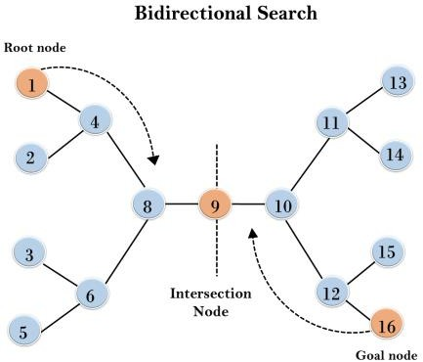
Completeness:BidirectionalSearchiscompleteifweuseBFSinbothsearches. Time Complexity: Time complexity of bidirectional search using BFS is O(bd). Space Complexity: Space complexity of bidirectional search is O(bd).
Optimal:BidirectionalsearchisOptimal.

Informed(Heuristic)SearchStrategies
Informed search algorithm contains an array of knowledge such as how far we arefromthegoal,pathcost,howtoreachtogoalnode,etc.Thisknowledgehelp agents to explore less to the search space and find more efficiently the goal node.
Theinformedsearchalgorithmismoreusefulforlargesearchspace.Informed searchalgorithmusestheideaof heuristic, so it isalsocalledHeuristicsearch.
Heuristics function:Heuristic is a function which is used in Informed Search, and it finds the most promising path. It takes the current state of the agent as its input and produces the estimation of how close agent is from the goal. The heuristic method, however, might not always give the best solution, but it guaranteed to find a good solution in reasonable time. Heuristic function estimates how close a state is to the goal. It is represented by h(n), and it calculates the cost of an optimal path between the pair of states. The value of the heuristic function is always positive.

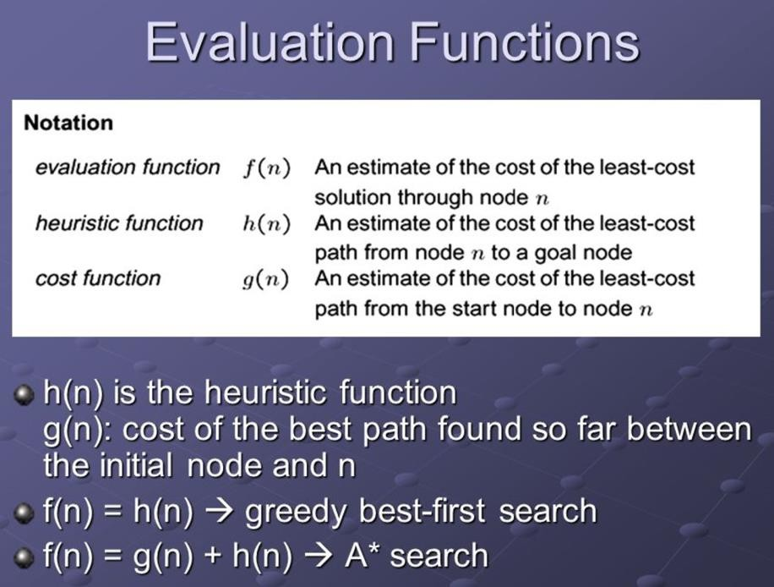

PureHeuristicSearch:
Pure heuristic search is the simplest form of heuristic search algorithms. It expands nodes based on their heuristic value h(n). It maintains two lists, OPEN and CLOSED list.IntheCLOSEDlist,itplacesthosenodeswhichhavealreadyexpandedandinthe OPEN list, it places nodes which have yet not been expanded.
On each iteration, each node n with the lowest heuristic value is expanded and generates all its successors and n is placed to the closed list. The algorithm continues unit a goal state is found. In the informed search there are two main algorithms:
- BestFirstSearchAlgorithm(Greedysearch)
- A*SearchAlgorithm

Best-firstSearchAlgorithm(GreedySearch):
Greedy best-first search algorithm always selects the path which appears best at that moment. It is the combination of depth-first search and breadth-first search algorithms.Itusestheheuristicfunctionandsearch.Best-firstsearchallowsustotake the advantages of both algorithms. Withthehelp of best-first search, at each step, we canchoosethemostpromisingnode.Inthebestfirstsearchalgorithm,weexpandthe node which is closest to the goal node and the closest cost is estimated by heuristic function, i.e.
f(n)=h(n).
Were,h(n)=estimatedcostfromnodentothegoal.
Advantages:
- BestfirstsearchcanswitchbetweenBFSandDFSbygainingtheadvantagesof both the algorithms.
- ThisalgorithmismoreefficientthanBFSandDFSalgorithms.
Disadvantages:
- Itcanbehaveasanunguideddepth-firstsearchintheworst case scenario.

- ItcangetstuckinaloopasDFS.
- Thisalgorithmisnot optimal.

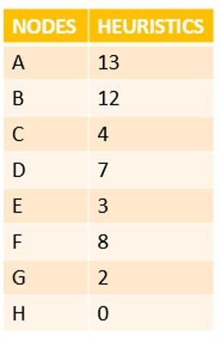
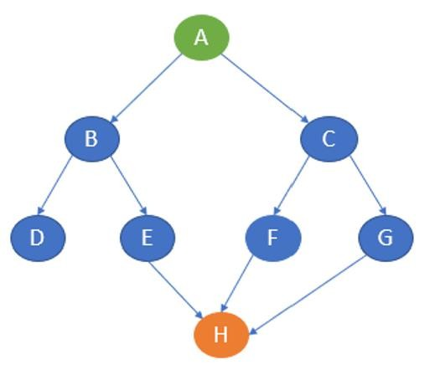
Problem

Solution:

Solution:

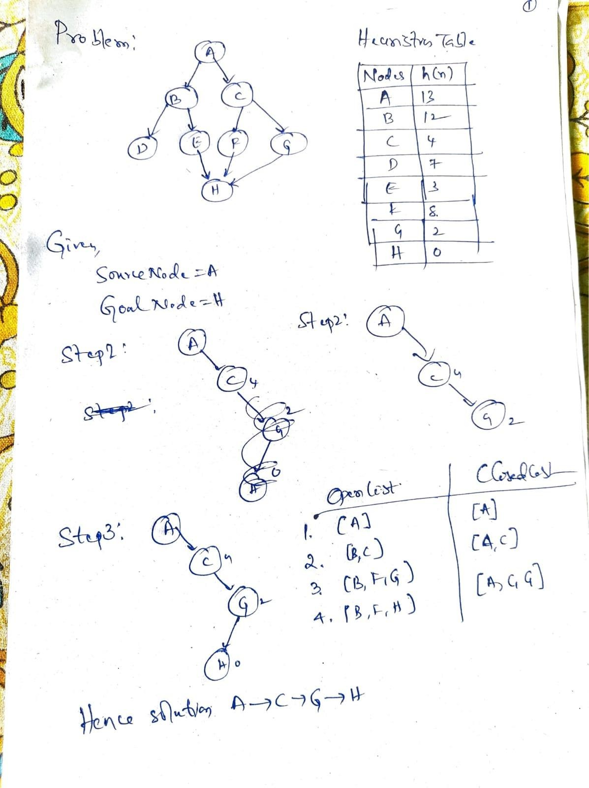

Problem:
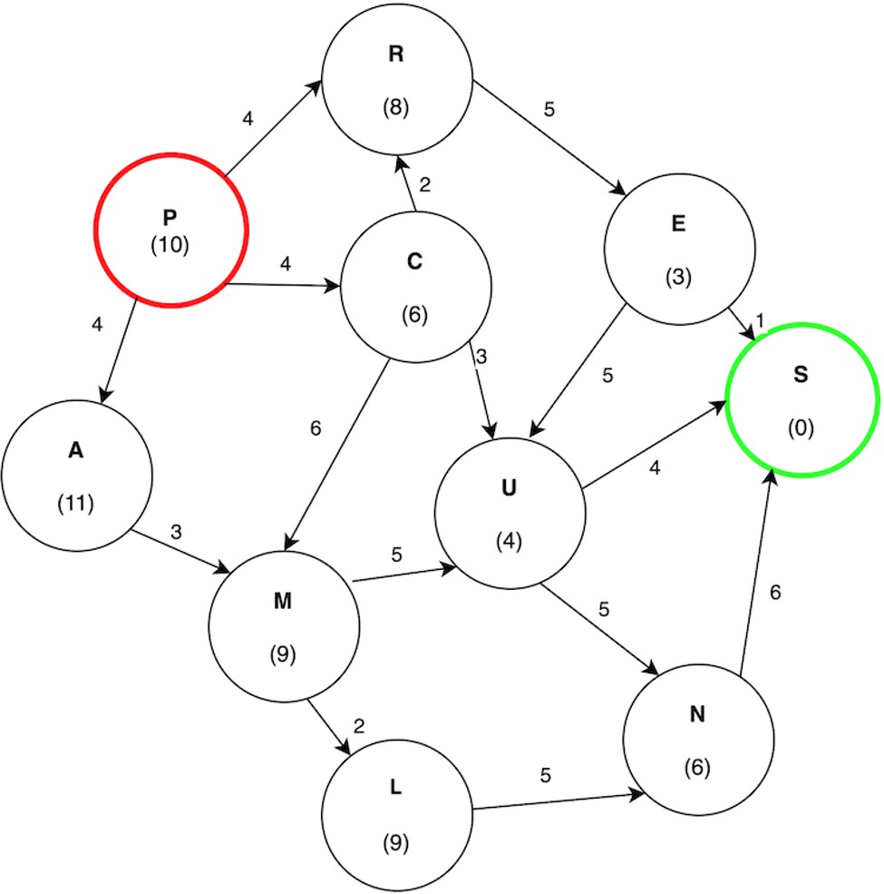

Solution:

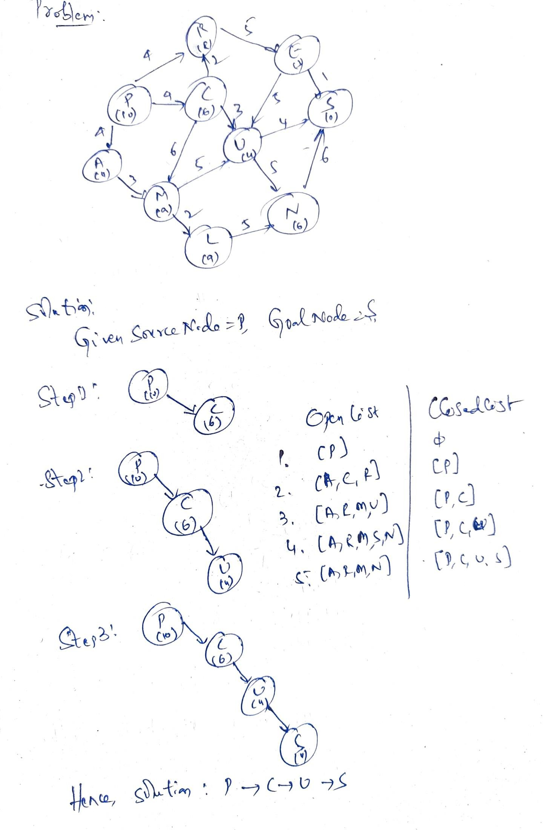

Problem:
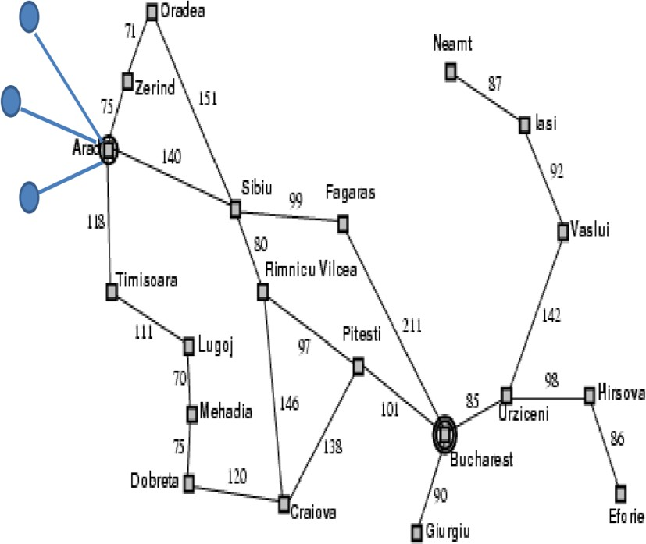
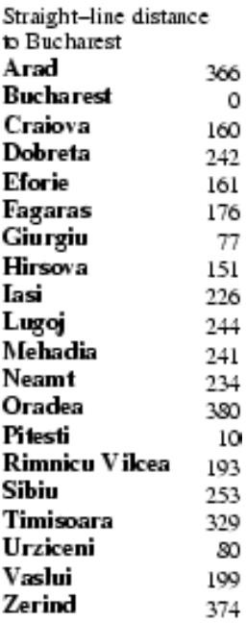
Solution:
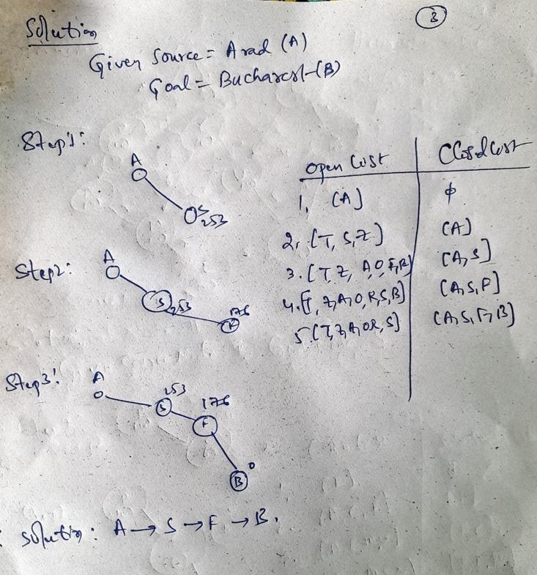

A*SearchAlgorithm:
A* search is the most commonly known form of best-first search. It uses heuristic function h(n), and cost to reach the node n from the start state g(n). It has combinedfeaturesofUCSandgreedybest-firstsearch,bywhichitsolvestheproblem

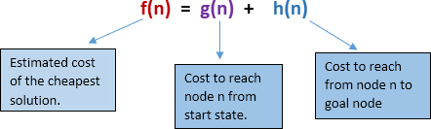
efficiently.A*searchalgorithmfindstheshortestpaththroughthesearchspaceusing the heuristic function. This search algorithm expands less search tree and provides optimal result faster. A* algorithm is similar to UCS except that it uses g(n)+h(n) instead of g(n). In A* search algorithm, we use search heuristic as well as the cost to reachthenode.Hence, wecancombinebothcostsasfollowing,andthissumiscalled as a fitness number.
Advantages:
- A*searchalgorithmisthebestalgorithmthanother searchalgorithms.
- A*searchalgorithmisoptimaland complete.
- Thisalgorithmcansolveverycomplex problems.
Disadvantages:
- It does not always produce the shortest path as it mostly based on heuristicsand approximation.
- A*searchalgorithmhassomecomplexityissues.
- ThemaindrawbackofA*ismemoryrequirementasitkeepsallgenerated nodes in the memory, so it is not practical for various large-scale problems.

Problem:
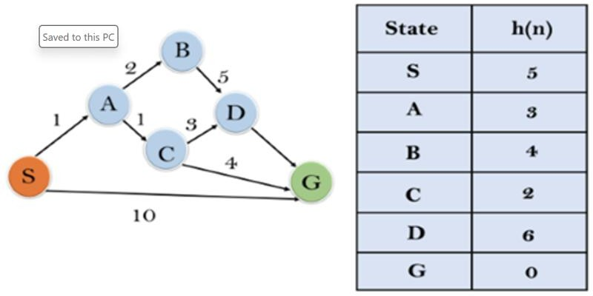
Solution:

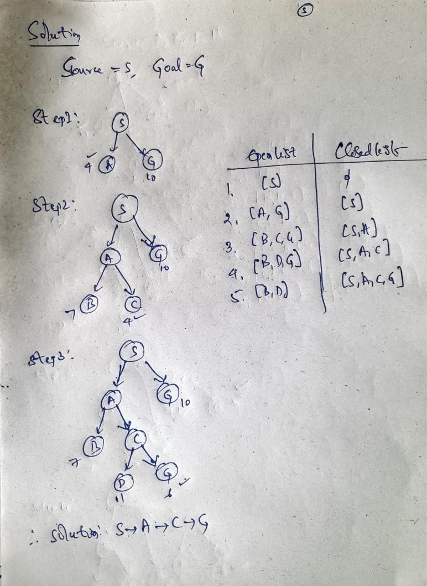

Problem:

Solution:
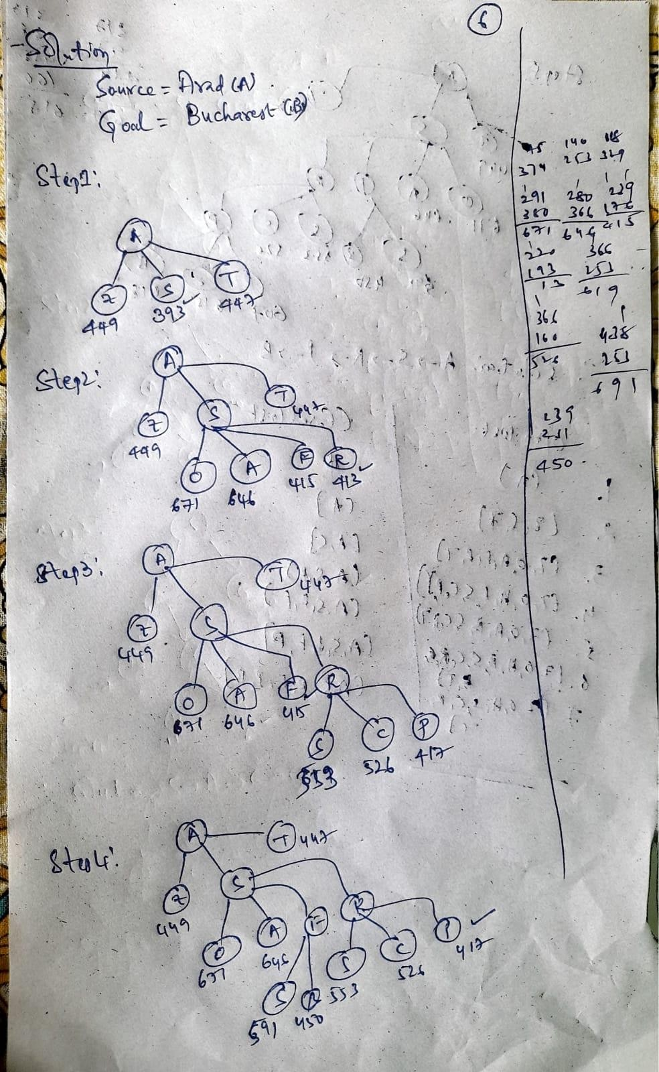

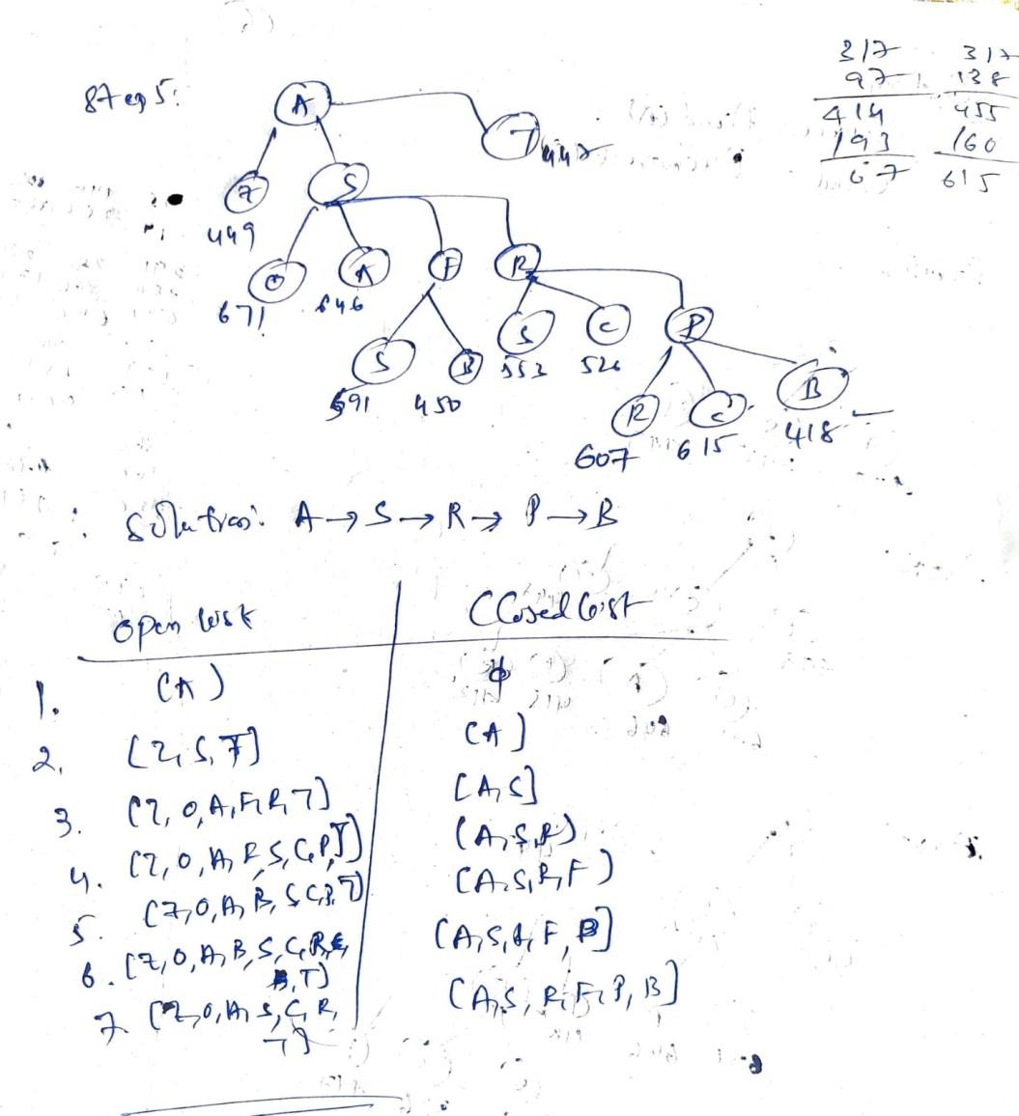
AdmissibilityofA* search:
Theheuristicfunctionh(n)iscalledadmissibleifh(n)isneverlargerthanh*(n), namely h(n) is always less or equal to true cheapest cost from n to the goal.
A* is admissible if it uses an admissible heuristic, and h(goal) = 0
If theheuristicfunction,halwaysunderestimatesthetruecost(h(n)issmaller than h*(n)), then A* is guaranteed to find an optimal solution.
Consistency of A* search:
Aheuristicisconsistentifforeverynoden,everysuccessorn'of ngeneratedby
anyactiona,h(n)≤c(n,a,n')+h(n')
If h is consistent, we have f(n') = g(n') + h(n') = g(n) + c(n,a,n') + h(n') ≥ g(n) +
h(n)=f(n),f(n)isnon-decreasing alonganypath.

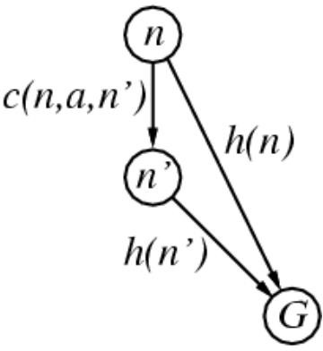
RecursiveBestFirstSearch
It is simple recursive algorithm that resembles the operation of standard best first search but uses only linear space. It is similar to recursive DFS and differs from Recursive DFS as follows: It keeps track of the f value of the best alternative path available from any ancestor of the current node. Instead of continuing indefinitely down the current path.

Algorithm:
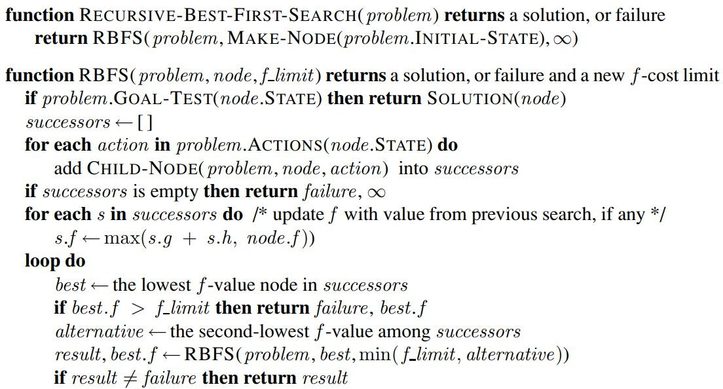

Problem:

Solution:

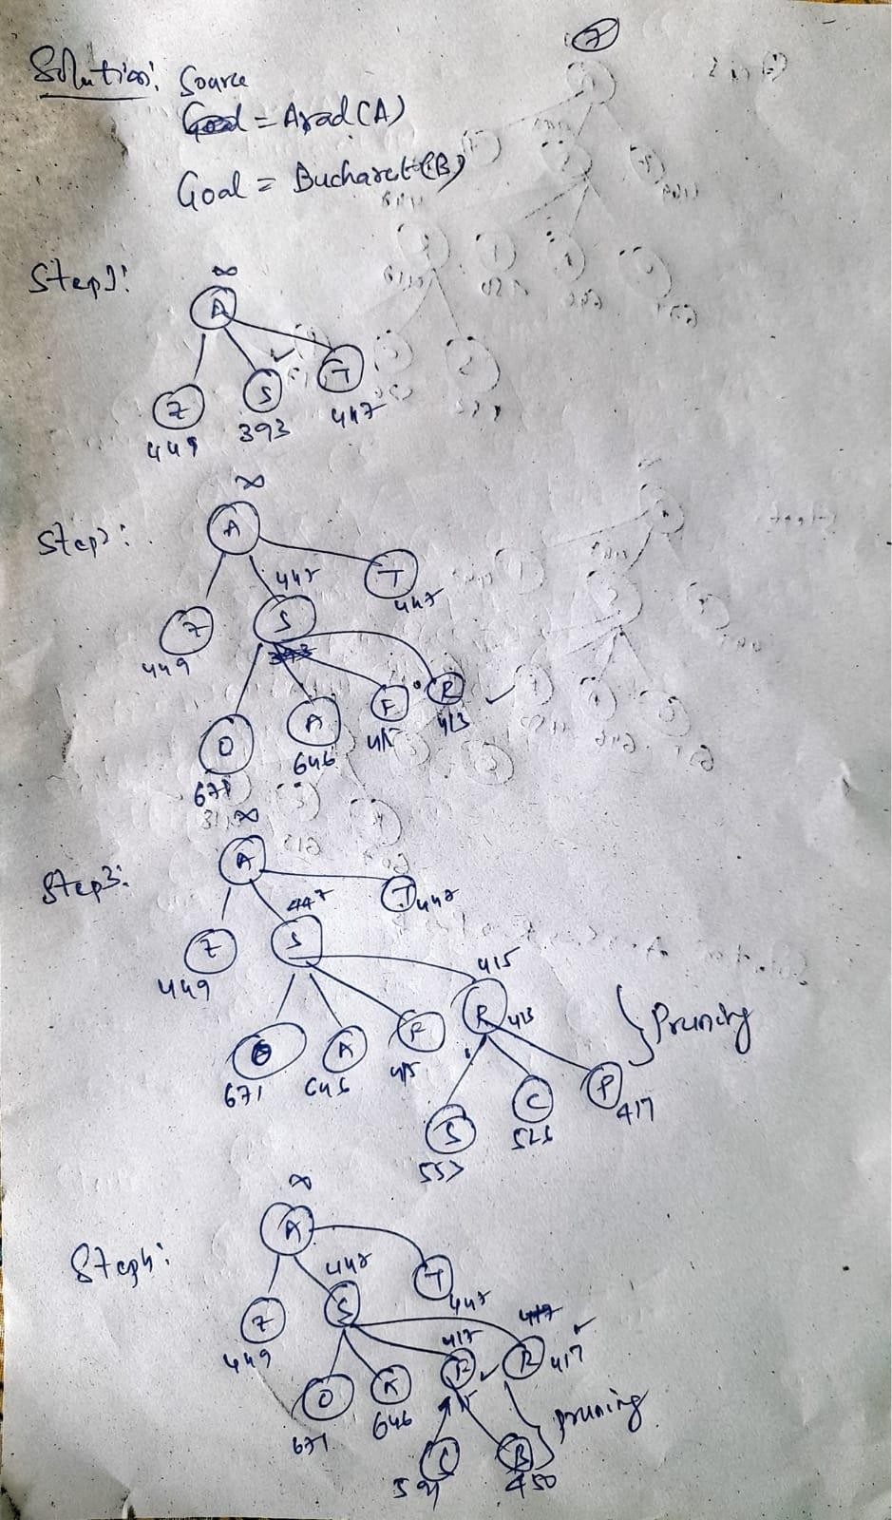

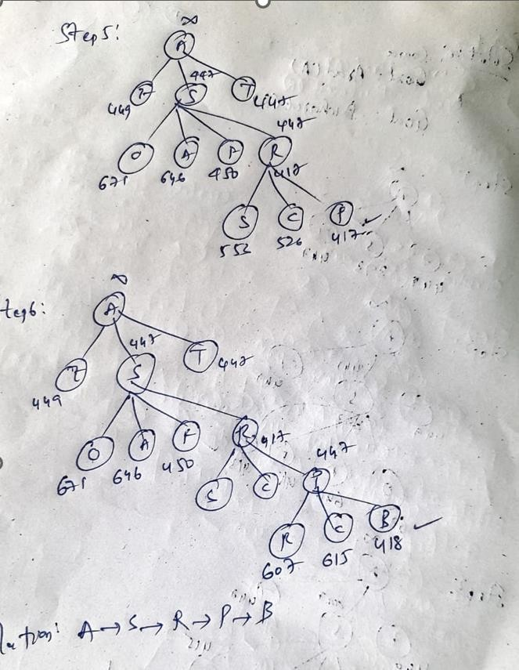
MemoryBoundSearchAlgorithms:

IDA*(Iterative-DeepeningA*)
IDA* algorithm - IDA* uses the same idea of DFID algorithm and uses the admissibility of the heuristic function by limiting the f-cost of the nodes examined by the DFS search, rather than the depth. IDA* (memory-bounded) algorithm does not keep any previously exploredpath (thesame as A*). It needs to re-expandpath if it is necessary and this will be a costly operation

MemoryBoundedA*(MA*)
MA*isnear-identicaltoA*asidefromkey differences:
When the number of nodes in OPEN and CLOSED reaches some preset limit, MA*prunes the OPEN list by removing the leaf-node with highest f-cost.
Foreachnewsuccessorthef-costispropagatedbackupthetree.
Thiskeepsthetreevery“informed”allowingthesearchtomakebetterdecisions,at
thecostofsomeoverhead.

SimplifiedMA*(SMA*)
SMA∗ proceedsjustlikeA*,expandingthebestleafuntilmemoryisfull.Atthispoint, itcannotaddanewnodetothesearchtreewithoutdroppinganoldone.SMA∗always drops the worst leaf node—the one with the highest f-value. Like RBFS, SMA∗then backsupthevalueoftheforgottennodetoitsparent.Inthisway,theancestorofa

forgotten subtree knows the quality of the best path in that subtree. With this information,SMA∗regeneratesthesubtreeonlywhenallotherpathshavebeenshown to look worse than the path it has forgotten. Another way of saying this is that, if all thedescendantsofanodenareforgotten,thenwewillnotknowwhichwaytogofrom n, but we will still have an idea of how worthwhile it is to go anywhere from n

HeuristicFunctions:
Aheuristicfunctioninartificialintelligence,alsoknownasaheuristicorsimply a heuristic, is an evaluation function used to estimate the cost or potential of reaching a goal state from a given state in a problem-solving domain.
Heuristicsaretypicallyrulesofthumborapproximatestrategiesthatguidethe search for a solution. They provide a way to assess the desirability of different options without exhaustively exploring every possibility.
Heuristics are used to make informed decisions in situations where it's computationallyexpensivetosearchthroughallpossiblestatesoractions.They help prioritize the exploration of more promising paths.

KeyPropertiesofHeuristicFunctions
HeuristicfunctionsareessentialcomponentsofAIproblem-solving.Toensure theireffectiveness,it'scrucialtounderstandtheirkeyproperties.Let'sdiveinto two critical properties: admissibility and consistency.
Admissibility is a fundamental property of heuristic functions that profoundly influences their use in AI problem-solving.
Admissibilityreferstoapropertyofheuristicfunctionsthatensurestheynever overestimate the true cost to reach a goal state. In other words, an admissible heuristic provides a lower bound on the actual cost.
Imagine planning a road trip using a GPS navigation system. If the GPS estimates the travel time to be 4 hours, it's admissible if you reach your destinationinlessthanorexactly4hours,butit'sinadmissibleifittakeslonger. Admissible heuristics set an upper limit on the estimated cost.
Admissible heuristics guarantee that search algorithms exploring the state spacewon'toverlookoptimalsolutions.Theycreateabalance,ensuringthatthe algorithm doesn't prematurely discard paths that might lead to the best outcome.
Consistency,alsoknownasthemonotonicityproperty,isanothercriticalaspect of heuristic functions.
Consistency defines a heuristic's behavior by considering the estimated cost from the current state to a successor state along with the heuristic value of the successor state. If this combined value is always greater than or equal to the heuristic value of the current state, the heuristic is considered consistent.
Let'sreturntoourtravelanalogy.Supposewe'reassessingtraveltimesbetween cities.If theestimatedtravel timefromCityAto CityB(thecurrentstate) plus the estimated travel time from City B to City C (the successor state) is greater thanorequaltotheestimatedtraveltimefromCityAtoCityC(thegoalstate), then the heuristic is consistent.
Consistent heuristics are particularly advantageous in informed search algorithms like A*. They ensure that as the search algorithm progresses, it doesn'tencountersituationswhereamorepromisingpathisoverlookeddueto heuristic inconsistencies.

Methods for Designing and Developing Heuristic Functions: Whenitcomestodesigningheuristicfunctions,severalmethodsandstrategiescanbe employed.Thesemethodsareinstrumentalindevelopingheuristicsthatprovide valuable guidance to search algorithms.
ApproachesforHeuristicDesign:
- DomainKnowledge:Leveragingexpertknowledgeabouttheproblemdomainto construct heuristics.
- Relaxation:Creating a simplifiedversionof theproblem where heuristicsaremore easily derived and then transferring these heuristics back to the original problem.
- PatternDatabases: Storingprecomputedheuristicvaluesforspecificproblem subgoals, enabling efficient lookup during search.

KnowledgebasedAgents
Knowledge-basedagentsarethoseagentswhohavethecapabilityofmaintaining an internal state of knowledge, reason over that knowledge, update their knowledge after observations and take actions. These agents can represent the world with some formal representation and act intelligently.
Knowledge-based agents are composed of two main parts:
  - Knowledge-baseand
  - Inferencesystem.
Aknowledge-basedagentmustabletodothefollowing:
Anagentshouldbeabletorepresentstates,actions,etc. An agent Should be able to incorporate new percepts
Anagentcanupdatetheinternalrepresentationoftheworld Anagentcandeducetheinternalrepresentationoftheworld An agent can deduce appropriate actions.

Knowledgebase(KB)
Knowledge-base is a central component of a knowledge-based agent, it is also known as KB. It is a collection of sentences (here 'sentence' is a technical term and it is not identical to sentence in English). These sentences are expressed in a language which iscalledaknowledgerepresentationlanguage.TheKnowledge-baseofKBAstoresfact about the world. Knowledge-base is required for updating knowledge for an agent to learn with experiences and take action as per the knowledge.

OperationsPerformedbyKBA
FollowingarethreeoperationswhichareperformedbyKBAinordertoshowthe intelligent behavior:
- TELL:Thisoperationtellstheknowledgebasewhatitperceivesfromthe environment.
- ASK:Thisoperationaskstheknowledgebasewhatactionitshouldperform.
- Perform:Itperformstheselectedaction.
Followingisthestructureoutlineofagenericknowledge-basedagentsprogram: function KB-AGENT(percept):
persistent:KB,aknowledgebase
t, a counter, initially 0, indicating time TELL(KB,MAKE-PERCEPT-SENTENCE(percept,t))

Action = ASK(KB, MAKE-ACTION-QUERY(t)) TELL(KB,MAKE-ACTION-SENTENCE(action,t))
t = t + 1 returnaction

The knowledge-based agent takes percept as input and returns an action as output. The agent maintains the knowledge base, KB, and it initially has some background knowledge of the real world. It also has a counter to indicate the time for the whole process, and this counter is initialized with zero.
The MAKE-PERCEPT-SENTENCE generates a sentence as setting that the agent perceived the given percept at the given time.
The MAKE-ACTION-QUERY generates a sentence to ask which action should be done at the current time.
MAKE-ACTION-SENTENCE generates a sentence which asserts that the chosen action was executed.

Variouslevelsofknowledge-basedagent:
Aknowledge-basedagentcanbeviewedatdifferentlevelswhicharegiven below:

Knowledgelevel
Knowledge level is the first level of knowledge-based agent, and in this level, we need to specify what the agent knows, and what the agent goals are. With these specifications, we can fix its behavior. For example, suppose an automated taxi agent needs to go from a station A to station B, and he knows the way from A to B, so this comes at the knowledge level.

Logicallevel:
At this level, we understand that how the knowledge representation of knowledge is stored.Atthislevel,sentencesareencodedintodifferentlogics.Atthelogicallevel,an encodingofknowledgeintologicalsentencesoccurs.Atthelogicallevelwecanexpect to the automated taxi agent to reach to the destination B.

Implementation level:
Thisisthephysicalrepresentationoflogicandknowledge.Attheimplementationlevel agent perform actions as per logical and knowledge level. At this level, an automated taxi agent actually implements his knowledge and logic so that he can reach to the destination.

Approachestodesigningaknowledge-basedagent:
Therearemainlytwoapproachestobuildaknowledge-based agent:
  - Declarative approach:We can create a knowledge-based agent by initializing withanemptyknowledgebaseandtellingtheagentallthesentences withwhich we want to start with. This approach is called Declarative approach.
  - Procedural approach:In the procedural approach, we directly encode desired behaviorasaprogramcode.Whichmeanswejustneedtowriteaprogramthat already encodes the desired behavior or agent.

However, in the real world, a successful agent can be built by combining both declarative and procedural approaches, and declarative knowledge can often be compiled into more efficient procedural code.

Wumpusworld:
The Wumpus world is a simple world example to illustrate the worth of a knowledge-basedagentandtorepresentknowledgerepresentation.Itwasinspiredby a video game Hunt the Wumpus by Gregory Yob in 1973.
TheWumpusworldisacavewhichhas4/4roomsconnectedwithpassageways. So there are total 16 rooms which are connected with each other. We have a knowledge-basedagentwhowillgoforwardinthisworld. Thecave hasaroom witha beast which is called Wumpus, who eats anyone who enters the room. The Wumpus canbeshotbytheagent,buttheagenthasasinglearrow.IntheWumpusworld,there are some Pits rooms which are bottomless, and if agent falls in Pits, then he will be stuck there forever. The exciting thing with this cave is that in one room there is a possibilityoffindinga heapofgold.Sotheagentgoalistofindthegoldandclimbout thecavewithoutfallenintoPitsoreatenbyWumpus.Theagentwillgetarewardifhe comes out with gold, and he will get a penalty if eaten by Wumpus or falls in the pit.
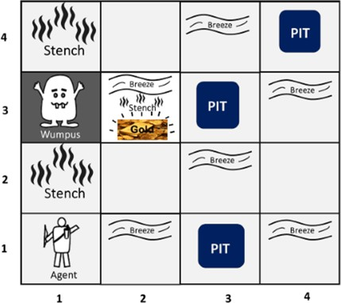

TheroomsadjacenttotheWumpusroomaresmelly,sothatitwouldhavesome stench.
TheroomadjacenttoPITshasabreeze,soiftheagentreachesneartoPIT,then he will perceive the breeze.
There will be glitter in the room if and only if the room has gold.
TheWumpuscanbekilledbytheagentiftheagentisfacingtoit,andWumpus will emit a horrible scream which can be heard anywhere in the cave.

PEASdescriptionofWumpusworld:
ToexplaintheWumpusworldwehavegivenPEASdescriptionasbelow:

Performancemeasure:
+1000 reward points if the agent comes out of the cave with the gold.
-1000pointspenaltyforbeingeatenbytheWumpusorfallingintothepit. -1 for each action, and -10 for using an arrow.
The game ends if either agent dies or came out of the cave.

Environment:
A 4*4 grid of rooms.
The agent initially in room square [1, 1], facing toward the right.
LocationofWumpusandgoldarechosenrandomlyexceptthefirstsquare[1,1]. Eachsquareofthecavecanbeapitwithprobability0.2exceptthefirstsquare.

Actuators:
Left turn, Rightturn
Moveforward Grab
Release Shoot.

Sensors:
TheagentwillperceivethestenchifheisintheroomadjacenttotheWumpus. (Not diagonally).
Theagentwill perceive breezeifheisintheroomdirectlyadjacenttothePit. The agent will perceive the glitter in the room where the gold is present.
The agent will perceive the bump if he walks into a wall.
When the Wumpus is shot, it emits a horrible screamwhich can be perceived anywhere in the cave.
These percepts can be represented as five element list, in which we will have different indicators for each sensor.
Example if agent perceives stench, breeze, but no glitter, no bump, and no scream then it can be represented as: [Stench, Breeze, None, None, None].

TheWumpusworldProperties:
Partially observable:The Wumpus world is partially observable because the agent can only perceive the close environment such as an adjacent room.
Deterministic:It is deterministic, as the result and outcome of the world are already known.
Sequential: Theorder isimportant, soitissequential. Static:ItisstaticasWumpusandPitsarenotmoving. Discrete: The environment is discrete.
One agent:The environment is a single agent as we have one agent only and Wumpus is not considered as an agent.

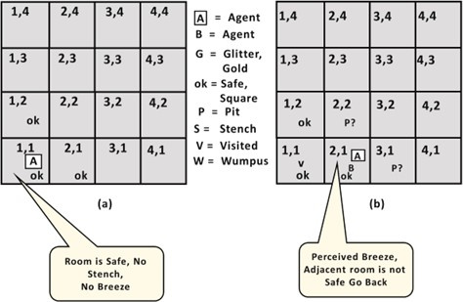
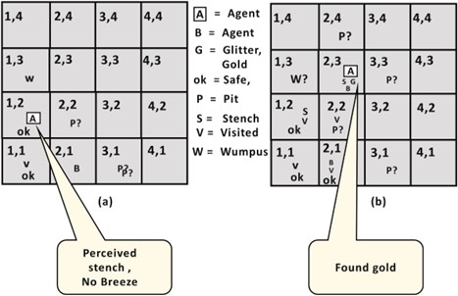
ExploringtheWumpusworld:

Atroom[2,2],herenostenchandnobreezespresentsolet'ssupposeagentdecides to move to [2,3]. At room [2,3] agent perceives glitter, so it should grab the gold and climb out of the cave.
Logic
Logicisaformallanguagetoexpressrealworldsentences Syntax – notation to express sentences
Semantics – meaning of the sentences
Truthvalue–sentencetruthvalue(TrueorFalse) Model – World for sentences

Entailment
If I was to tell you that either I was going to be promotedor get abig bonus because I just landed a huge account for the company I work for, then you would think a few things:
If he doesn’t get promoted, then at least he’ll get compensated with a bonus
Ifhedoesn’tgetabonus,thenatleasthe’llgetcompensatedwithapromotion His company won’t both not promote him and not give him a bonus.
Alloftheseclaimsfollowfromtheoriginalclaim.They“follow”inthesensethatif theoriginalclaimisinfacttrue,thenthisconclusion mustbetrue.There’ssomesense inwhichthey“meanthesamething”:theydescribethesameworldorclaimthesame thingtobetrueabouttheworld.Alotoflogicconsequenceissimilar:it’sarelationship of “following” or “entailment” between statements which mean essentially the same thing. Other logical consequences are cases where one statement entails another statement(ifthefirstistrue,thesecond mustbetrue),butnotbecausetheyessentially meanthesamething.Instead,becausethefirststatementismakinga“stronger”claim than the other.

Logicalentailmentisdenotedby: Which means 𝛽 follows from𝛼
Eg:
𝜶|=𝜷

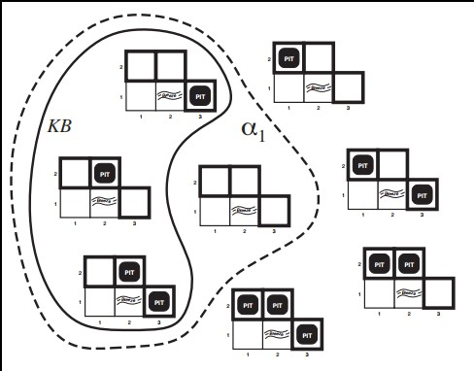

𝛂-Nopit in[1,2]
𝟏
Then,𝑲𝑩|=𝜶_{𝟏}
Anotherexample:

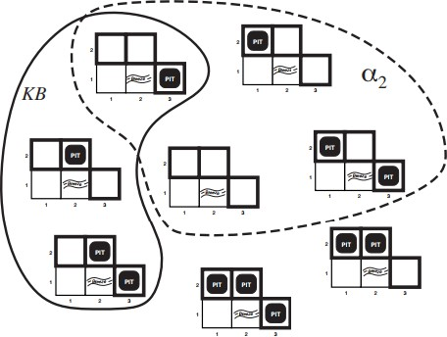

𝛂𝟐-Nopitin [2,2]
𝑲𝑩|≠𝜶𝟐
Entailment is like the needle being in the haystack; inference is like finding it. This distinctionisembodiedinsomeformalnotation:ifaninferencealgorithmicanderive α from KB, we write
KB⊢iα,whichispronounced“αisderivedfromKBbyi”or“iderivesαfromKB.” An inference algorithm that derives only entailment is called “sound”
An inference algorithm that derives all possible entailment is called “complete”

LogicalReasoningwithEntailment
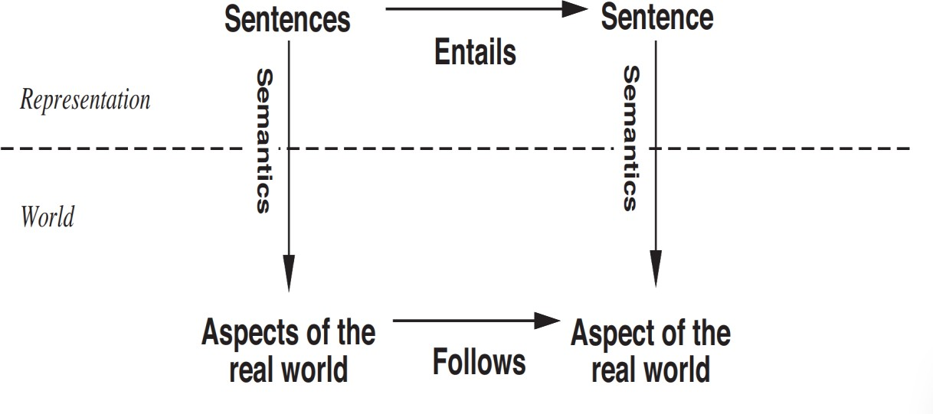
Grounding
It is the connection between logical reasoning processes and the real environment in whichtheagentexists.Inparticular,howdoweknowthatKBistrueinthereal

world?. A simple answer is that the agent’s sensors create the connection. For example, the wumpus-world agent has a smell sensor. The agent program creates a suitable sentence whenever there is a smell. Then, whenever that sentence is in the knowledge base, it is true in the real world.

PropositionallogicinArtificialintelligence
Propositionallogic(PL)isthesimplestformoflogicwhereallthestatementsaremade by propositions. A proposition is a declarative statement which is either true or false. It is a technique of knowledge representation in logical and mathematical form.
Example:
ItisSunday.
TheSunrisesfromWest(Falseproposition) 3+3= 7(False proposition)
5 is a prime number.

PropositionalLogicsyntax:
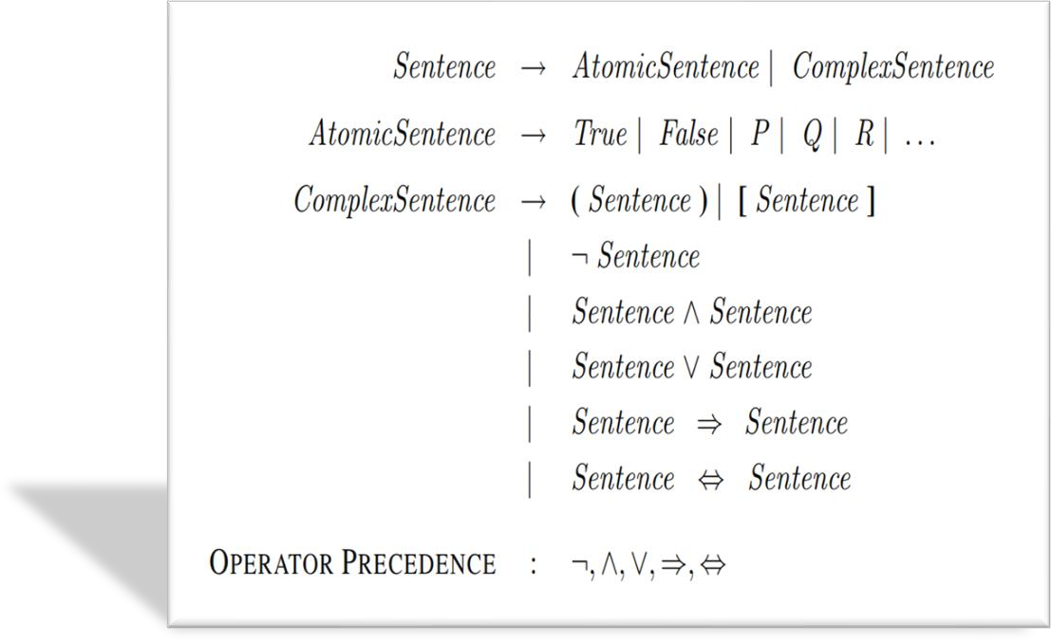

Atomic propositions are the simple propositions. It consists of a single proposition symbol. These are the sentences which must be either true or false.
Compoundpropositionsare constructedby combining simpler or atomicpropositions, using parenthesis and logical connectives.
Logical connectives are used to connect two simpler propositions or representing a sentence logically. We can create compound propositions with the help of logical connectives. There are mainly five connectives, which are given as follows:
- Negation:A sentence such as ¬ P is called negation of P. A literal can be either Positive literal or negative literal.
- Conjunction:A sentence which has ∧ connective such as, P ∧Qis called a conjunction.
Example:Rohanisintelligentandhardworking.Itcanbewrittenas,P= Rohan is intelligent,Q= Rohan is hardworking. → P∧ Q.

- Disjunction:A sentence which has ∨ connective, such asP ∨ Q. is called disjunction,wherePandQarethepropositions. Example: "Ritika is a doctor or Engineer", Here P= Ritika is Doctor. Q= Ritika is Doctor, so we can write it as P ∨ Q.
- Implication:A sentence such as P → Q, is called an implication. Implications are also known as if-then rules. It can be represented as: If it is raining, then thestreetiswet. Let P= It is raining, and Q= Street is wet, so it is represented as P → Q
- Biconditional:AsentencesuchasP⇔QisaBiconditionalsentence,exampleIf I am breathing, then I am alive, P= I am breathing, Q= I am alive, it can be represented as P ⇔ Q.
TruthTable:
Inpropositionallogic,weneedtoknowthetruthvaluesofpropositionsinallpossible scenarios.We can combine all thepossible combinationwithlogical connectives, and the representation of these combinations in a tabular format is called Truth table. Following are the truth table for all logical connectives:
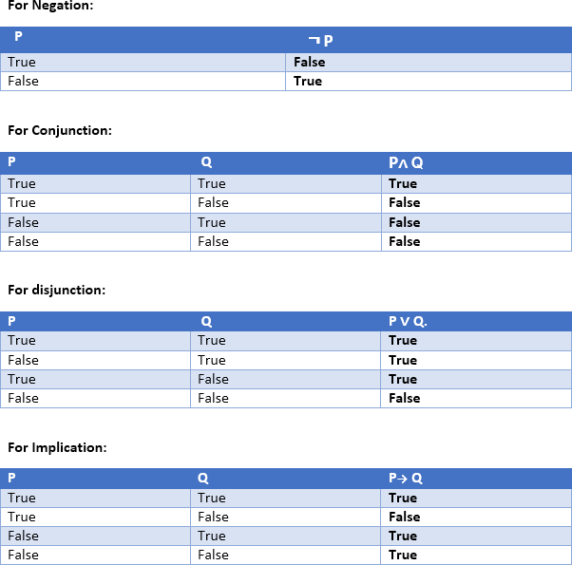
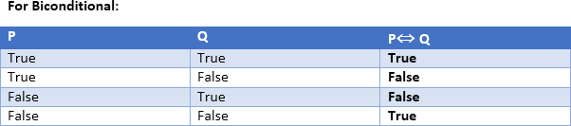

WritethefollowingEnglishsentencesinsymbolicform
- Ifitrains,thenIwillstayathome P: It rains
Q: I will stay at home Representation:P->Q

- Heispoorbut honest.
P:Heispoor, Q: Heishonest, Representation: P∧Q
- Birdsflyifandonlyifskyis clear.
P:Birdsfly,Q:Skyisclear,Representation:P⇔Q
- Iwillgoonlyifhestays. I will go if he stays.
P:Iwillgo,Q:Hestays,Representation:P->Q
- Itishotorelseitisbothcoldandcloudy
P:Itishot,Q:Itis coldR:itiscloudy,Representation:P𝜈 (𝑄𝛬R)
- EithertodayisSundayor Monday
P:TodayisSunday,Q:TodayisMonday,Representation:P 𝜈𝑄
Consider,
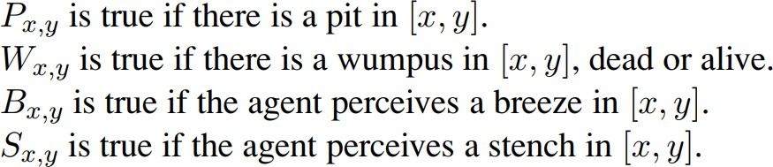
Thereisnopitin [1,1]
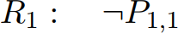
Asquareisbreezyifandonlyifthereis apitinaneighboring square.
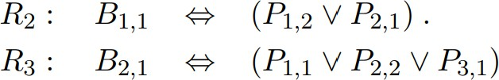
For:
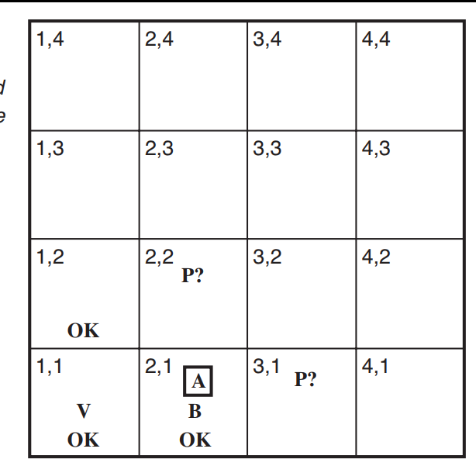
Writebreezeforsquares visited

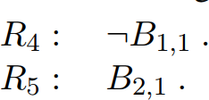

StandardLogicalEquivalences
Logical equivalenceis thecondition of equalitythat exists between two statementsor sentences in propositional logic. The relationship between the two statements translatesverballyinto"ifandonlyif."Inmathematics,logicalequivalenceistypically symbolized by a double arrow (⟺ or ⟷) or triple lines (≡).
This expression provides an example of logical equivalence between two simple statements:
A∨B⟺B∨A
TheexpressionincludesthestatementsA∨ BandB∨ A,whichareconnectedtogether by the IIF function. Each statement uses the OR Boolean function (∨) to indicate an inclusive disjunction between variables A and B. This means that the statement returnsatruevalueifeithervariableistrueorifbothvariablesaretrue,butitreturns a false value if both variables are false. The expression in its entirety is effectively stating that the statement "variable A or variable B" is logically equivalent to the statement "variable B or variable A."
Someofthestandardlogical equivalences:
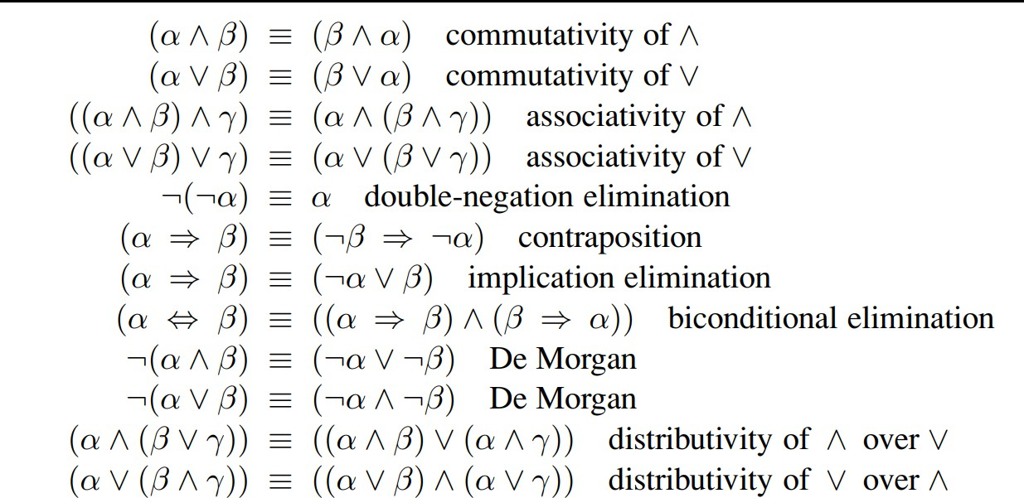

Inferencerules:
Inference rules are the templates for generating valid arguments. Inference rules are applied to derive proofs in artificial intelligence, and the proof is a sequence of the conclusionthatleadstothedesiredgoal.Ininferencerules,theimplicationamongall the connectives plays an important role. Following are some terminologies related to inference rules:

- Implication:ItisoneofthelogicalconnectiveswhichcanberepresentedasP
→Q.ItisaBoolean expression.
- Converse:The converse of implication, which means the right-hand side proposition goes to the left-hand side and vice-versa. It can be written as Q → P.
- Contrapositive:Thenegationofconverseistermedascontrapositive,anditcan be represented as ¬ Q → ¬ P.
- Inverse:Thenegationofimplicationiscalledinverse.Itcanberepresentedas
¬P→¬Q.
Proof:
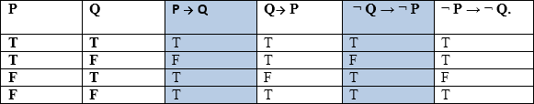

TypesofInference rules:

ModusPonens:
The Modus Ponens rule is one of the most important rules of inference, and it states thatifPandP→Qistrue,thenwecaninferthatQwillbetrue.Itcanberepresented as:
Example:
Statement-1:"IfIamsleepythenIgotobed"==>P→Q Statement-2: "I am sleepy" ==> P
Conclusion:"Igotobed."==>Q.
Hence,wecansaythat,ifP→QistrueandPistruethenQwillbe true.

AND Elimination:
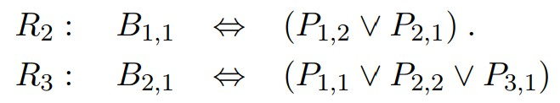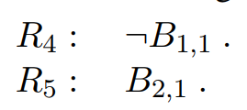Thisrulestatesthatif P∧ Qistrue,thenQor Pwillalsobetrue.Itcanberepresented as:
Provelogicallythatthereisnopitin[1,2] Knowledgebase:

Proof:

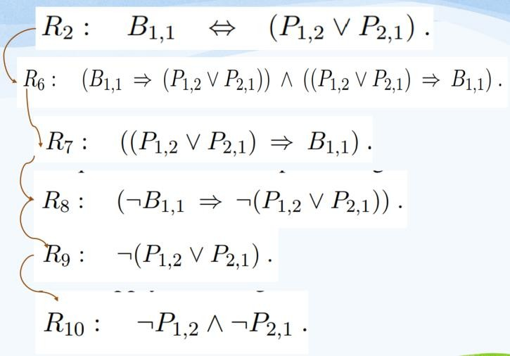

Proofbyresolution
Theideaofresolutionissimple:ifweknowthat
- pistrueorqistrue
- andwe alsoknowthatpisfalseorr istrue
- thenitmustbethecasethatqistrueorristrue. This line of reasoning is formalized in the
ResolutionTautology:
(pV q)𝛬(¬pV r) ->q V r
Eg:Giventhefollowing hypotheses:
- Ifitrains,Joebringshisumbrella(r->u)
- IfJoehasanumbrella, hedoesn'tgetwet(u->NOTw)
- Ifitdoesn'train,Joedoesn'tgetwet(NOTr ->NOTw) prove that Joes doesn't get wet (NOT w)
WefirstputeachhypothesisinCNF:
- r->u ==(NOT r ORu)
- u->NOTw==(NOTuORNOT w)
- NOTr->NOT w==(r ORNOT w)
Wethenuseresolutiononthehypothesestoderivetheconclusion(NOTw):
- NOTrORu Premise
- NOTuORNOT w Premise
- rORNOT w Premise

- NOTrORNOT w L1,L2, resolution
- NOTwORNOT w L3,L4,resolution

- NOT w L5, idempotence

Provelogicallythatthereisapitin [3,1]
𝑩𝟐,𝟏↔𝑷𝟏,𝟏V𝑷𝟑,𝟏V𝑷𝟐,𝟐

(𝑩𝟐,𝟏→𝑷𝟏,𝟏V𝑷𝟑,𝟏V𝑷𝟐,𝟐)𝜦(𝑷𝟏,𝟏V𝑷𝟑,𝟏V 𝑷𝟐,𝟐→𝑩𝟐,𝟏)
𝑩𝟐,𝟏
(𝑷𝟏,𝟏V𝑷𝟑,𝟏V𝑷𝟐,𝟐)
¬𝑷𝟏,𝟏
𝑷𝟑,𝟏V𝑷𝟐,𝟐
¬𝑷𝟐,𝟐
𝑯𝒆𝒏𝒄𝒆,𝑷𝟑,𝟏

ConjunctiveNormalForm
Resolutionworksbestwhentheformulaisofthespecialform:itisan ∧ of∨sof (possibly negated, ¬) variables (called literals).
Eg:
(yV¬z)𝛬 (¬y)𝛬 (yVz)CNF (x V ¬y 𝛬 z) Not CNF

ToconvertaformulaintoaCNF.
Convert double implication to single OpenuptheimplicationstogetORs. Get rid of double negations.
UseDemorgansLaw Use distributivity
Eg:FV (G 𝛬 H) can be written as
- (FV G)𝛬(FV H)

Eg:ConverttoCNF:A→(B∧C)
¬𝐴𝑉(𝐵∧ C)
(¬𝐴𝑉𝐵)∧(¬𝐴𝑉𝐶)
HornClauseinAI
Theterm"hornclause"referstoadisjunctionofliteralsinwhich,atmost,one literalisnotnegated.Ahornclauseisaclausethathasexactlyoneliteralthatis not negated.The logician Alfred Horn first recognized the importance of Hornclauses in 1951. Horn clauses are a type of logical formula used in logicprogramming,formalspecification,universalalgebra,andmodeltheorydueto theirhelpfulqualitiesintheseareasand others.

TypesofHornClauses:
- Definiteclause/StrictHornclause–Ithaspreciselyonepositiveliteral.
- Unitclause-Definiteclausecontainingnonegativeliterals.

- Goalclause–Hornclauselackingaliteralpositive.
Hornclausesperformafundamentalroleinbothconstructiveandcomputational logic.

Syntax:
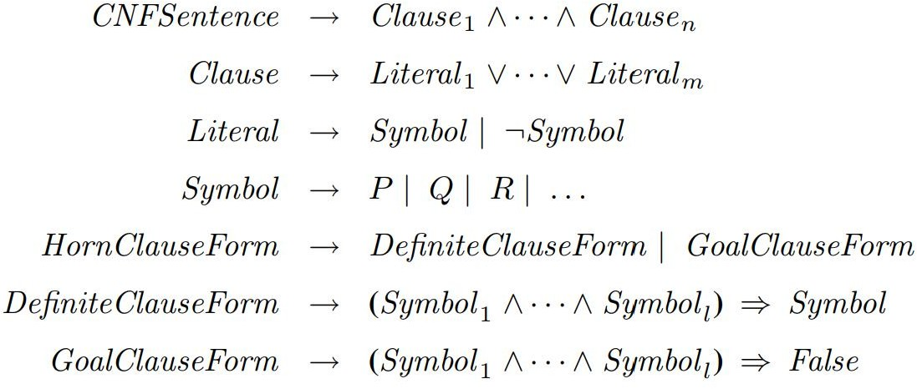

InferenceEngines:
An inference engine is a component of an AI system that is responsible for drawing conclusions based on evidence and information that is provided to it. In other words, it is responsible for making deductions and inferences based on what it knows.
The inference engine is often compared to the human brain, as it is responsible for making the same kinds of deductions and inferences that we do. However, the inference engine is not limited by the same constraints as the human brain. It can process informationmuchfasterandisnot subject to thesamebiasesand errorsthat we are.
The inference engine is a critical component of AI systems because it is responsible for making the decisions that the system needs to make in order to function. Without an inference engine, an AI system would be little more than a collection of data.

TypesofInference engines:
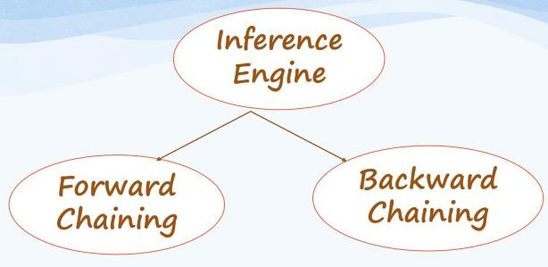
- Forwardchaining:ForwardchainingisaformofreasoningforanAIexpert systemthatstartswithsimplefactsandappliesinferencerulestoextractmore data until the goal is reached.

- Backwardchaining:Backwardchainingisanotherstrategyusedtoshapean AIexpertsystemthatstartswiththeendgoalandworksbackwardthroughthe AI’s rules to find facts that support the goal.
ForwardChaining:
Forward chaining is also known as a forward deduction or forward reasoning method when using an inference engine. The forward-chaining algorithm starts from known facts, triggers all rules whose premises are satisfied and adds their conclusion to the known facts. This process repeats until the problem is solved. In this type of chaining, the inference engine starts by evaluating existing facts, derivations, and conditionsbeforededucingnew information. Anendpoint,orgoal,is achievedthrough the manipulation of knowledge that exists in the knowledge base.
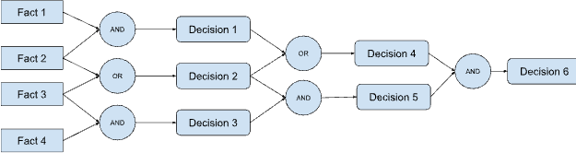

ForwardChainingProperties

- Forwardchainingfollowsadown-upstrategy,goingfrombottomtotop.
- Itusesknownfactstostartfromtheinitialstate(facts)andworkstowardthe goal state, or conclusion.
- Theforwardchainingmethodisalsoknownasdata-drivenbecausewe achieve our objective by employing available data.
- TheforwardchainingmethodiswidelyusedinexpertsystemssuchasCLIPS, business rule systems and manufacturing rule systems.
- Itusesabreadth-firstsearch asithastogothroughallthefacts first.
- Itcanbeusedtodrawmultipleconclusions. Eg:

Knowledgebase:

- John’screditscoreis780.
- Apersonwithacreditscoregreaterthan700hasneverdefaultedontheir loan.
- Johnhasanannualincomeof$100,000.
- Apersonwithacredit scoregreaterthan750isa low-riskborrower.
- Apersonwithacreditscorebetween600to750isamedium-riskborrower.
- Apersonwithacreditscorelessthan600isa high-riskborrower.
- Alow-riskborrowercanbegivenaloanamountupto4Xofhisannualincome at a 10 percent interest rate.
- Amedium-riskborrowercanbegivenaloanamountofupto3Xofhisannual income at a 12 percent interest rate.

- Ahigh-riskborrowercanbegivenaloanamountofupto1Xofhisannual income at a 16 percent interest rate.

Question:

- Whatmaxloanamountcanbesanctionedfor John?
- Whatwilltheinterestratebe?

Solution:
Todeducetheconclusion,weapplyforwardchainingontheknowledgebase.Westart fromthefactswhicharegivenintheknowledgebaseandgothrougheachoneofthem to deduce intermediate conclusions until we are able to reach the final conclusion or have sufficient evidence to negate the same.
John’CS=780ANDCS>750areLowRisk Borrower→JohnisaLowRisk Borrower
LoanAmountforLowRiskBorroweris4XannualincomeANDJohn’sannual
incomeis $100k

→Maxloanamountthatcanbesanctionedis$400kata10%interest rate.
BackwardChaining
Backward chaining is also known as a backward deduction or backward reasoning method when using an inference engine. In this, theinference engine knows thefinal decision or goal. The system starts from the goal and works backward to determine what facts must be asserted so that the goal can be achieved.
Forexample,itstarts directlywiththeconclusion(hypothesis) andvalidates it by backtracking through a sequence of facts. Backward chaining can be used in debugging, diagnostics and prescription applications.
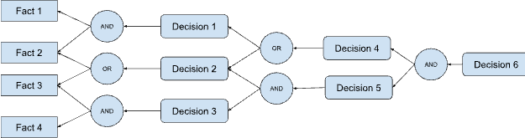

PropertiesofBackwardChaining

- Backwardchainingusesanup-downstrategygoingfromtoptobottom.
- Themodusponensinferenceruleisusedasthebasisforthebackwardchaining process. This rule states that if both the conditional statement (p->q)and the antecedent (p) are true, then we can infer the subsequent (q).

Eg:
- In backward chaining, the goal is broken into sub-goals to prove the facts are true.
- Itiscalledagoal-drivenapproach,asalistofgoalsdecideswhichrulesare selected and used.
- Thebackwardchainingalgorithmisusedin gametheory,automatedtheorem- proving tools, inference engines, proof assistants and various AI applications.
- The backward-chaining method mostly used a depth-first search strategy for proof.

Knowledgebase:

  - JohnistallerthanKim
  - Johnisaboy
  - Kimisagirl
  - JohnandKimstudyinthesame class
  - EveryoneelseotherthanJohnintheclassisshorterthanKim Question:

  - IsJohnthetallestboyinclass?
Now,to apply backward chaining, we start from thegoal and assume that John isthe tallest boy in class. From there, we go backward through the knowledge base comparing that assumption to each known fact to determine whether it is true that John is the tallest boy in class or not.
Height(John)>Height(anyoneintheclass) AND
JohnandKimbothareinthesameclass AND
Height(Kim)>Height(anyoneintheclassexceptJohn) AND
Johnisboy SO
Height(John)>Hight(Kim)
Whichalignswiththeknowledgebasefact.Hencethegoalisproved true.
AO*algorithm–Artificialintelligence
Best-first search is what the AO* algorithm does. The AO* method divides any given difficult problem into a smaller group of problems that are then resolved using the AND-OR graph concept. AND OR graphs are specialized graphs that are used in problems that can be divided into smaller problems. The AND side of the graph represents a set of tasks that must be completed to achieve the main goal, while the OR side of the graph represents different methods for accomplishing the same main goal.

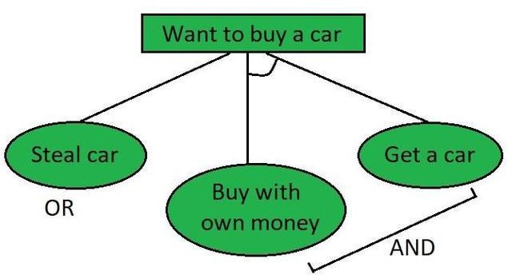

Inthisfigure,the buying of acar maybebrokendownintosmallerproblemsortasks that can be accomplished to achieve the main goal in the above figure, which is an example of a simple AND-OR graph. The other task is to either steal a car that will help us accomplish the main goal or use your own money to purchase a car that will accomplish the main goal. The AND symbol is used to indicate the AND part of the graphs, which refers to the need that all subproblems containing the AND to be resolved before the preceding node or issue may be finished.

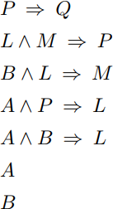
RepresentationofHornclausesusingAND-ORgraphforforwardchaining Consider the example inference rules and facts:

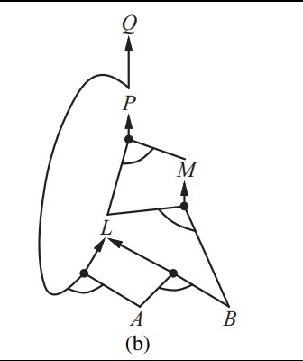
ThecorrespondingAND-ORgraphis:

MODULE-4

LimitationsofPropositionallogic:
- Propositionallogicisapunymechanismtoexpressknowledgeand inferencing
- WecannotrepresentrelationslikeALL,some,ornonewithpropositionallogic. Example:
  - Allthegirlsare intelligent.
  - Someapplesare sweet.
- Propositionallogichaslimitedexpressivepower.
- In propositional logic, we cannot describe statements in terms of their properties or logical relationships.
AlternateSolutions:

Programminglanguauges:
The syntax and semantics of programming languages can be used to express the reasoning. In programming language procedures/methods can be the logic and data structures containing data will be the facts. However programming languages lack following:
One cannot derive facts from other facts
Inferencingnotautomaticandneedstoprogrammedforeachcase They lack expressiveness required to handle partial information
Composionality is missing.

NaturalLanguage libraries:
Natural language processing (NLP) is a branch ofartificial intelligence (AI) that enables computers to comprehend, generate, and manipulate human language. Natural language processing has the ability to interrogate the data with natural languagetextorvoice.Thisisalsocalled“languagein.”Mostconsumershaveprobably interacted with NLP without realizing it. For instance, NLP is the core technology behindvirtualassistants,suchastheOracle DigitalAssistant(ODA),Siri,Cortana,or Alexa.Ambiguity,generallyusedinnaturallanguageprocessing,canbereferredasthe ability of being understood in more than one way. In simple terms, we can say that ambiguity is the capability of being understood in more than one way. Natural language is very ambiguous. NLP has the following types of ambiguities −

LexicalAmbiguity
The ambiguity of a single word is called lexical ambiguity. For example, treating the word silver as a noun, an adjective, or a verb.

SyntacticAmbiguity
This kind of ambiguity occurs when a sentence is parsed in different ways. For example, the sentence “The man saw the girl with the telescope”. It is ambiguous whetherthemansawthegirlcarryingatelescopeorhesawherthroughhistelescope. Semantic Ambiguity
This kind of ambiguity occurs when the meaning of the words themselves can be misinterpreted. In other words, semantic ambiguity happens when a sentence containsanambiguouswordorphrase.Forexample,thesentence“Thecarhitthepole whileitwasmoving”ishavingsemanticambiguitybecausetheinterpretationscanbe “The car, while moving, hit the pole” and “The car hit the pole while the pole was moving”.

AnaphoricAmbiguity

This kind of ambiguity arises due to the use of anaphora entities in discourse. For example, the horse ran up the hill. It was very steep. It soon got tired. Here, the anaphoric reference of “it” in two situations cause ambiguity.

Pragmaticambiguity
Such kind of ambiguity refers to the situation where the context of a phrase gives it multiple interpretations. In simple words, we can say that pragmatic ambiguity arises when the statement is not specific. For example, the sentence “I like you too” canhavemultipleinterpretationslikeIlikeyou (justlikeyou likeme),Ilikeyou (just like someone else dose).

Combiningthebestofformalandnaturallanguages
Formal languagesare languages that are designed by people for specific applications. For example, the notation that mathematicians use is a formal language that is particularly good at denoting relationships among numbers and symbols. Chemists use a formal language to represent the chemical structure of molecules.
Elements of a natural language: Nouns,, and noun phrases that refer to objects (squares, pits, wumpuses) and verbs and verb phrases that refer to relations among objects (is breezy, is adjacent to, shoots). Some of these relations are functions— relationsinwhichthereisonlyone“value”foragiven“input.”Itiseasytostartlisting examples of objects, relations, and functions:
- Objects:people,houses,numbers,theories,RonaldMcDonald,colors,baseball games, wars, centuries
- Relations:thesecanbeunaryrelationsorpropertiessuchasred,round,bogus, prime,
- Functions:fatherof,bestfriend,thirdinningof,onemorethan,beginningof
Eg:Identifytheobjects,relations,functionsandpropertiesifanyinthefollowing examples:
“oneplustwoequals three”
Objects:one,two,three;Relations:equals;Function:plus
“Squaresneighboringwumpusare smelly”
Objects:squares,Wumpus;Relations:neighbouring;Property:smelly;
“EvilKingJohnruledEnglandin1200”
Objects:KingJohn,England,1200;Relation:ruled;Property:Evil

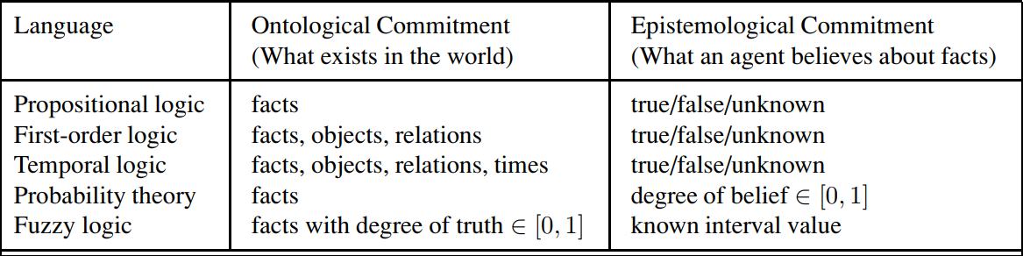
Formallanguagesandtheirontologicalandepistemological commitments.

Propositionallogicisthelogicthatdealswithacollectionofdeclarative

statements which have a truth value, true or false. Propositions are combined with Logical Operators or Logical Connectives like Negation(¬), Disjunction(∨), Conjunction(∧), Exclusive OR(⊕), Implication(⇒), Bi- Conditional or Double Implication(⇔).It cannot deal with sets of entities.
First order logic is an expression consisting of variables with a specified domain. It consists of objects, relations and functions between the objects. It helps analyze the scope of the subject over the predicate. There are three quantifiers : Universal Quantifier (∀) depicts for all, Existential Quantifier (∃) depicting there exists some and Uniqueness Quantifier (∃!) depicting exactly one. It can deal with set of entities with the help of quantifiers.
Temporal logic is a subfield of mathematical logic that deals with reasoning about time and the temporal relationships between events. In artificial intelligence, temporal logic is used as a formal language to describe andreason about the temporal behavior of systems and processes. Temporal logic extends classical propositional and first-order logic with constructs for specifying temporal relationships, such as “before,” “after,” “during,” and “until.” This allows for the expression of temporal constraints and the modeling of temporal aspects of a system, such as its evolution over time and the relationships between events.
Probability is defined as the chance of happening or occurrences of an event. Generally,thepossibilityof analyzing theoccurrenceof anyevent withrespect topreviousdataiscalledprobability.Forexample,if afaircoinistossed,what is the chance that it lands on the head? These types of questions are answered under probability. Probability theory uses the concept of random variablesand probability distribution to find the outcome of any situation. Probability theory is an advanced branch of mathematics that deals with the odds and statistics of happening an event.
Theterm fuzzy referstothingsthatarenotclearorarevague.Intherealworld many times we encounter a situation when we can’t determine whether the state is true or false, their fuzzy logic provides very valuable flexibility for reasoning. In this way, we can consider the inaccuracies and uncertainties of any situation.Fuzzy Logic is a form of many-valued logic in which the truth values of variables may be any real number between 0 and 1, instead of justthe traditional values of true or false. It is used to deal with imprecise or uncertain information and is a mathematical method for representing vagueness and uncertainty in decision-making. Fuzzy Logic is based on the idea that in many cases, the concept of true or false is too restrictive, and that there are many shades of gray in between. It allows for partial truths, where a statement can be partially true or false, rather than fully true or false.
Ontology: the study of what there is in the world that we should know about, andEpistemology: the study of how we should get to know the things in the world. Obviously, this was long before AI was a thing, and they were merely concernedwiththestructureofknowledgeanditsacquisitionbyhumans.when it comes to creating AI we should take an epistemological approach: how does the only working truly intelligent system (the human brain) models the world, innately or by learning. This is in contrast with the ontological approach: focusing on organizing what we know in data ontologies and then trying to instill those in computers.

SyntaxofFirst-Orderlogic:
The syntax of FOL determines which collection of symbols is a logical expression in first-orderlogic.Thebasicsyntacticelementsoffirst-orderlogicaresymbols.Wewrite statements in short-hand notation in FOL.
BasicElementsofFirst-orderlogic:
SyntaxofFirstOrderLogic
ThesyntaxofFirstOrderLogiciswrittenusingBacknausNormal Form.
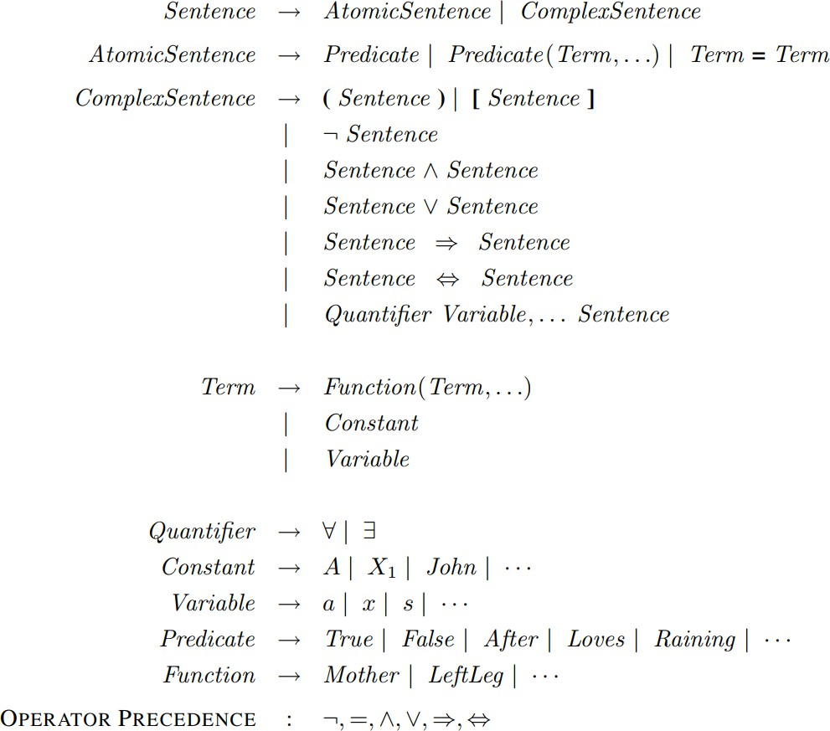

Atomicsentences:
  - Atomic sentences are the most basic sentences of first-order logic. These sentencesareformedfromapredicatesymbolfollowedbyaparenthesiswitha sequence of terms.
  - Wecanrepresentatomicsentencesas Predicate(term1,term2,,termn).
Example:RaviandAjayarebrothers:=>Brothers(Ravi,Ajay).
Chinkyis acat:=>cat (Chinky).

ComplexSentences:
  - Complexsentencesaremadebycombiningatomicsentencesusingconnectives. First-order logic statements can be divided into two parts:
  - Subject:Subjectisthemainpartofthestatement.

  - Predicate:A predicate can be defined as a relation, which binds two atoms together in a statement.
Considerthestatement:"xisaninteger.",itconsistsoftwoparts,thefirstpartxisthe subject of the statement and second part "is an integer," is known as a predicate.
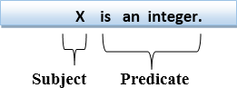

QuantifiersinFirst-orderlogic:
  - A quantifier is a language element which generates quantification, and quantification specifies the quantity of specimen in the universe of discourse.
  - Thesearethesymbolsthatpermittodetermineoridentifytherangeandscope of the variable in the logical expression. There are two types of quantifier:
    - UniversalQuantifier,(forall,everyone,everything)
    - Existentialquantifier,(forsome,atleast one).

UniversalQuantifier:
Universal quantifier is a symbol of logical representation, which specifies that the statementwithinitsrangeistrueforeverythingoreveryinstanceofaparticularthing. TheUniversalquantifierisrepresentedbyasymbol∀,whichresemblesaninvertedA. If x is a variable, then ∀x is read as:
  - Forall x
  - Foreachx
  - Foreveryx. Example:
Allmandrinkcoffee.
Letavariablexwhichreferstoacatso allxcanberepresentedinUODas below:
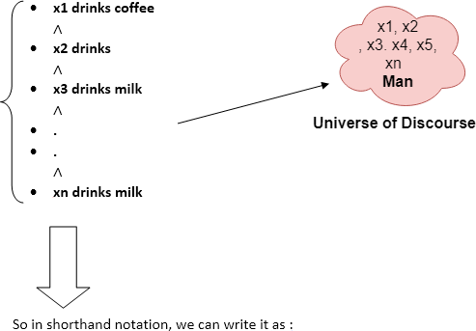

∀xman(x)→drink(x,coffee).
Itwillbereadas:Thereareallxwherexisamanwhodrinkcoffee.

ExistentialQuantifier:
Existential quantifiers are the type of quantifiers, which express that the statementwithin its scope is true for at least one instance of something.
Itisdenotedbythelogicaloperator ∃,whichresemblesasinvertedE.Whenitisused with a predicate variable then it is called as an existential quantifier.
Note: In Existential quantifier we always use AND or Conjunction symbol (∧). If x is a variable, then existential quantifier will be ∃x or ∃(x). And it will be read as:
  - Thereexistsa'x.'
  - Forsome'x.'
  - Foratleastone'x.'Example:
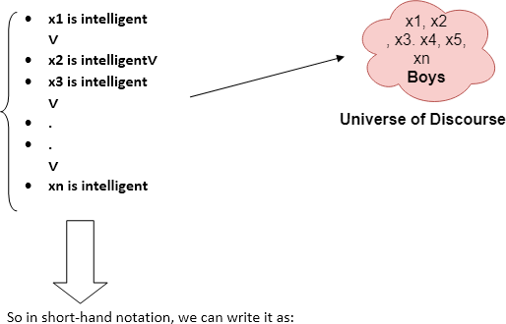
Someboysareintelligent.
∃x:boys(x)∧intelligent(x)
Itwillbereadas:Therearesomexwherexisaboywhois intelligent.
SomeExamplesofFOLusingquantifier:
- Allbirdsfly.
Inthisquestionthepredicateis "fly(bird)."
Andsincethereareallbirdswhoflysoitwillberepresentedasfollows.
∀xbird(x)→fly(x).
- Everymanrespectshisparent.
Inthisquestion,thepredicateis"respect(x,y),"wherex=man,andy=parent. Since there is every man so will use ∀, and it will be represented as follows:
∀xman(x)→respects(x, parent).
- Someboysplay cricket.

Inthisquestion,thepredicateis"play(x,y),"wherex=boys,andy=game.Since there are some boys so we will use ∃, and it will be represented as:
∃xboys(x)→play(x, cricket).
- NotallstudentslikebothMathematicsandScience.
Inthisquestion,thepredicateis"like(x,y),"wherex=student,andy=subject. Since there are not all students, so we will use ∀ with negation, so following representation for this:
¬∀ (x)[student(x)→like(x,Mathematics)∧like(x, Science)].
- Onlyonestudentfailedin Mathematics.
In this question, the predicate is "failed(x, y)," where x= student, and y= subject. Since there is only one student who failed in Mathematics, so we will use following representation for this:
∃(x)[student(x)→failed(x,Mathematics)∧∀(y)[¬(x==y)∧student(y)→
¬failed(x, Mathematics)].

Kinshipdomain
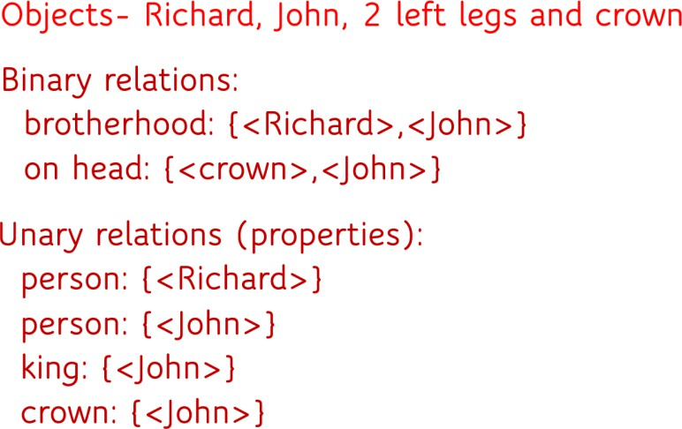
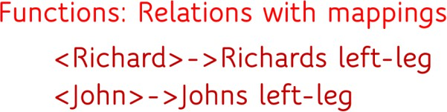

Symbolsand Interpretations
The symbols of the language 0,1, add,prime and so on—have very suggestive names. When we interpret sentences of this language over the domain N, for example, it is clear for which elements of the domain prime“should” be true, and for which it “should” be false. But let us consider a first order language that has only two unary predicate symbols, fancy and tall, then it depends on the domain to define the value. It is undefined for the domain of natural numbers.
Symbolsstandforobjects,relationsandfunctions.Thereare3typesofsymbols:

- Constantsymbolsrepresentingobjects.Eg:John,Richard
- Predicatesymbolsrepresentingrelations.Eg:Brother,OnHead
- Functionsymbolsrepresentingfunctions.Eg:LeftLeg
Each model includes an interpretation that specifies exactly which objects, relations and functions are referred to by the constant, predicate, and function symbols. Logician calls it as Intended Interpretation

NestedQuantifiers
Nestedquantifiersarequantifiersthatoccurwithinthescopeofotherquantifiers. Example: ∀x∃yP(x, y).Quantifier order matters! ∀x∃yP(x, y) ≠ ∃y∀xP(x, y)
LetL(x, y) be thestatement“x loves y,” wherethedomainforbothxandyconsistsof
allpeopleintheworld.Usequantifierstoexpresseachofthesestatements.
- EverybodylovesJerry.∀xL(x, Jerry)
- Everybodylovessomebody.∀x∃yL(x, y)
- Thereissomebodywhomeverybodyloves. ∃y∀xL(x,y)
- Nobodyloveseverybody.∀x∃y¬L(x,y)or¬∃x∀yL(x,y)
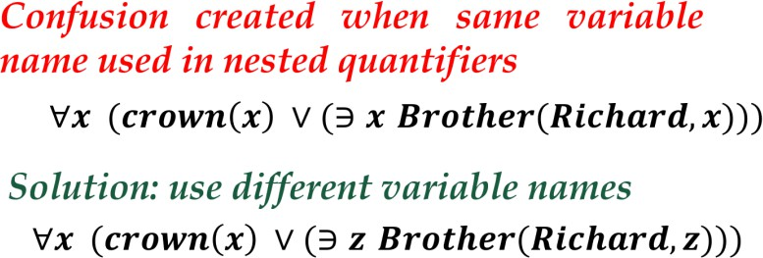
- Everyoneloveshimselforherself ∀xL(x,x)

Connectionsbetween∀and∃
The two quantifiers are actually intimately connected with each other, through negation.Assertingthateveryonedislikesparsnipsisthesameasassertingtheredoes not exist someone who likes them, and vice versa:
∀ x￢Likes(x,Parsnips)isequivalentto￢∃xLikes(x,Parsnips).Wecangoonestep
further:“Everyonelikesicecream”meansthatthereisnoonewhodoesnotlikeice
cream:∀ xLikes(x,IceCream)isequivalentto￢∃ x￢Likes(x,IceCream). Equality
We can use the equality symbol to signify that two terms refer to the same object. For example, Father (John)=Henry says that the object referred to by Father (John) and the object referred to by Henry are the same. The equality symbol can be used to state facts about a given function, as we just did for the Father symbol. It can alsobeusedwithnegationtoinsistthattwotermsarenotthesameobject.Tosaythat Richardhasatleasttwobrothers,wewouldwrite∃x,yBrother(x,Richard)∧Brother
(y,Richard)∧￢(x=y).

USINGFIRSTORDERLOGIC
Sentences are added to a knowledge base using TELL, exactly as in propositional logic. Such sentences are called assertions. For example, we can assert that John is a king, Richard is a person, and all kings are persons:
TELL(KB, King(John)) TELL(KB,Person(Richard))

TELL(KB,∀xKing(x)⇒Person(x))Wecanaskquestionsoftheknowledgebase using ASK.
Forexample,ASK(KB,King(John))returnstrue.QuestionsaskedwithASKare calledqueriesorgoalsIfwewanttoknowwhatvalueofxmakesthesentencetrue,we willneedadifferentfunction,ASKVARS,whichwecallwithASKVARS(KB,Person(x)) andwhichyieldsastreamofanswers.Inthiscasetherewillbetwoanswers:{x/John} and {x/Richard}. Such an answer is called a substitution or binding list.
Thekinship domain
Thefirstexampleweconsideristhedomainoffamilyrelationships,orkinship. This domain includes facts such as “Elizabeth is the mother of Charles” and “Charles is the father of William” and rules such as “One’s grandmother is the mother of one’s parent.”Clearly,theobjectsinourdomainare people.Wehavetwounarypredicates, MaleandFemale.Kinshiprelations—parenthood,brotherhood,marriage,andsoon— are represented by binary predicates: Parent, Sibling, Brother , Sister , Child , Daughter,Son,Spouse,Wife,Husband,Grandparent,Grandchild,Cousin,Aunt,and Uncle.WeusefunctionsforMotherandFather,becauseeverypersonhasexactlyone of each of these.
Forexample,one’smotherisone’sfemaleparent:
∀m,cMother(c)=m⇔Female(m) ∧Parent(m,c).
One’shusbandisone’s male spouse:
∀ w,hHusband(h,w)⇔Male(h)∧Spouse(h,w).
Maleandfemalearedisjoint categories:
∀ xMale(x)⇔ ￢Female(x).Parentandchildareinverserelations: ∀ p, c Parent(p, c) ⇔ Child (c, p) .
Agrandparentisaparentofone’sparent:
∀g,cGrandparent(g,c)⇔∃pParent(g,p)∧Parent(p,c).Asiblingis
anotherchildofone’sparents:∀x,y
Sibling(x, y) ⇔ x _= y ∧ ∃p Parent(p, x) ∧ Parent(p, y) . Each of these sentences can be viewed as an axiom of the kinship domain. Axioms are commonly associated with purely mathematical domains. Our kinship axioms arealsodefinitions;theyhavetheform∀x,yP(x,y)⇔Theaxiomsdefine
theMotherfunctionandtheHusband,Male,Parent,Grandparent,andSibling predicatesintermsofotherpredicates.Forexample,considertheassertionthat siblinghood is symmetric: ∀ x, y Sibling(x, y) ⇔ Sibling(y, x) .

Naturalnumbersinfirst-orderlogic
The natural numberscan be described infirst-order logic.The language of naturalnumbers has
a single constant 0, defined by predicate NatNum(0)
afunctionSuccessor,S(n)whichdefinesnextnumberafternintheseriesof natural number
The successor is expressed as a quantifier:
∀n,NatNum(n)⇒NatNum(S(n))
∀n,0≠S(n)
Two natural numbers cannot have same successor
∀m, n m≠n⇒S(m)≠S(n)
+ is a function defined on two natural numbers and equality is defined between 2 natural numbers using FOL:

∀m,nNatNum(m) ∧ NatNum(n)⇒+(S(m),n)=S(+(m,n))
- 0isanarithmeticidentityas
- ∀m,NatNum(m)⇒+(0,m)=m
Asetisacollectionofobjects;anyoneoftheobjectsinasetiscalleda member or an element of the set.
The basic statement in set theory is element inclusion: an element a is included in some set S. Formally written as:
Ifanelementisnotincluded,wewrite:
Statements are either true or false, depending on the context. For example, given the above sets, the first statement is true, whereas the second is false. If a statement S is trueinagivencontextC,wesaythestatementisvalidinC.Formally,wewritethisas:
Ifthestatementisnotvalidinthatcontext,wewrite:
Theoperatorstocomposenewsetsoutofexistingones are:
  - Aspecialsetis theemptyset,whichcontains noelementsatall:
  - Union:createasetScontainingallelementsfromA,fromB,orfromboth. Formally:
  - Intersection: create a set S containing all elements that are both in A and in B. Formally:
  - Exclusion:createasetSfromtheelementsofAthatarenotinB.Formally:
Thesesetscanbeinterpretedasquantifiedstatements:
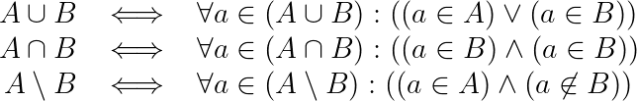

Subsets:
∀s1, s2 s1⊆s2⇔(∀x x∈s1⇒x ∈s2) .

Equalityoftwo sets:
∀s1, s2 (s1=s2) ⇔(s1⊆s2∧s2⊆s1) .

ListvsSets
Listsaresimilartosets.Thedifferencesarethatlistsareorderedandthesameelement can appear more than once in a list. We can use the vocabulary of Lisp for lists:
Nilistheconstantlist withnoelements;
Cons,Append,First,andRestarefunctions;and
Findisthepredicatethatdoesforlistswhat Memberdoesforsets. List? is a predicate that is true only of lists. elements,

FirstOrderLogicwithWumpusWorld
The wumpus agent receives a percept vector with five elements. The corresponding firstorder sentence stored in the knowledge base must include boththeperceptandthetimeatwhichitoccurred;otherwise,theagentwillget confused about when it saw what.
We use integers for time steps. A typical percept sentence would be Percept ([Stench,Breeze,Glitter,None,None],5).Here,Perceptisabinarypredicate, and Stench and so on are constants placed in a list.
The actions in the wumpus world can be represented by logical terms: Turn(Right ), Turn(Left ), Forward , Shoot , Grab, Climb .
Todeterminewhichisbest,theagentprogramexecutesthequeryASKVARS(∃ a BestAction(a, 5)) , which returns a binding list such as {a/Grab}.
The agent program can then return Grab as the action to take.
Therawperceptdataimpliescertainfactsaboutthecurrentstate.Forexample:
∀t,s,g,m,c Percept ([s,Breeze,g,m,c],t) ⇒ Breeze(t) , ∀t,s,b,m,c Percept ([s,b,Glitter,m,c],t) ⇒ Glitter (t) These rules exhibit a trivial form of the reasoning process called perception.
Simple“reflex”behaviorcanalsobeimplementedbyquantifiedimplication
sentences.Forexample,wehave∀tGlitter(t)⇒BestAction(Grab,t).
Giventheperceptandrulesfromtheprecedingparagraphs,thiswouldyieldthe desired conclusion BestAction(Grab, 5)—that is, Grab is the right thing to do.
Forexample,iftheagentisatasquareandperceivesabreeze,thenthatsquare isbreezy:∀ s,tAt(Agent,s,t)∧ Breeze(t)⇒ Breezy(s).Itisusefultoknowthat asquareisbreezybecauseweknowthatthepitscannotmoveabout.Noticethat Breezy has no time argument.
Havingdiscoveredwhichplacesarebreezy(orsmelly)and,veryimportant,not breezy (or not smelly),the agent can deduce where the pits are (and where the wumpusis).first-orderlogicjustneedsoneaxiom:∀sBreezy(s)⇔∃rAdjacent (r, s) ∧ Pit(r) .

InferenceinFirst-Order Logic
Inference in First-Order Logic is used to deduce new facts or sentences from existing sentences. Before understanding the FOL inference rule, let's understand some basic terminologies used in FOL.
Substitution is a fundamental operation performed on terms and formulas. It occurs in all inference systems in first-order logic. The substitution is complex inthepresenceofquantifiersinFOL.Ifwewrite F[a/x],soitreferstosubstitute a constant "a" in place of variable "x".
Equality-First-Order logic does not only use predicate and terms for making atomicsentencesbutalsousesanotherway,whichisequalityinFOL.Forthis, wecanuseequalitysymbolswhichspecifythatthetwoterms refertothesame object.
Example: Brother (John) = Smith.
Asintheaboveexample,theobjectreferredbythe Brother (John) issimilar to the object referred by Smith. The equality symbol can also be used with negation to represent that two terms are not the same objects.
Example: ￢(x=y) which is equivalent to x ≠y.

FOL inference rules for quantifier:
Aspropositionallogicwealsohaveinferencerulesinfirst-orderlogic,sofollowingare some basic inference rules in FOL:
- UniversalInstantiation
- ExistentialInstantiation

UniversalInstantiation:
- Universal instantiation is also called as universal elimination or UI is a validinference rule. It can be applied multiple times to add new sentences.
- ThenewKBislogicallyequivalenttothe previousKB.
- AsperUI,wecaninferanysentenceobtainedbysubstitutingagroundtermfor the variable.
- The UI rule state that we can infer any sentence by substituting a ground term v with gin the universe of discourse.
- 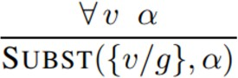
Example:1.
- IF "Every person like ice-cream"=> we can infer "John likes ice-cream" => P(c)
Example:2.
- "AllkingswhoaregreedyareEvil."Soletourknowledgebasecontainsthis detail as in the form of FOL:
- ∀xking(x)∧greedy(x)→Evil(x),
Sofromthisinformation,wecaninferanyofthefollowingstatementsusingUniversal Instantiation:
- King(John)∧Greedy(John)→Evil(John),
- King(Richard)∧Greedy(Richard)→Evil(Richard),
- King(Father(John))∧Greedy(Father(John))→Evil(Father(John)),

ExistentialInstantiation:
- ExistentialinstantiationisalsocalledasExistentialElimination,whichisa valid inference rule in first-order logic.
- Itcanbeappliedonlyoncetoreplacetheexistential sentence.
- The new KB is not logically equivalent to oldKB, but it will be satisfiable if old KB was satisfiable.
- Representedas:
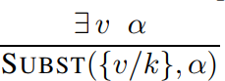

Example:
Fromthegivensentence:∃xCrown(x) ∧OnHead(x,John),
So we can infer: Crown(K) ∧ OnHead( K, John),as long as K does not appear in the knowledge base.
- TheaboveusedKisaconstantsymbol,whichiscalledSkolem constant.
- TheExistentialinstantiationisaspecialcaseofSkolemizationprocess.

GeneralizedModusPonens Rule:
FortheinferenceprocessinFOL,wehaveasingleinferencerulewhichiscalled Generalized Modus Ponens. It is lifted version of Modus ponens.
Generalized Modus Ponens can be summarized as, " P implies Q and P is asserted to be true, therefore Q must be True."
AccordingtoModusPonens,foratomicsentencespi,pi',q.Wherethereisa
substitutionθsuchthatSUBST(θ,pi',)=SUBST(θ,pi),itcanberepresentedas:
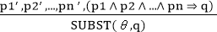
Example:
We will use this rule for Kings are evil, so we will find some x such that x is king, and x is greedy so we can infer that x is evil.
- p1'is king(John) p1isking(x)
- p2'is Greedy(y) p2isGreedy(x)
- θis{x/John,y/John} qisevil(x)
- SUBST(θ,q).

Unification
  - Unification is a process of making two different logical atomic expressions identical by finding a substitution. Unification depends on the substitution process.
  - Ittakestwoliteralsasinputandmakesthemidenticalusingsubstitution.
  - LetΨ1andΨ2betwoatomicsentencesand𝜎beaunifiersuchthat,Ψ1𝜎=Ψ2𝜎, then it can be expressed as UNIFY(Ψ1, Ψ2).
  - Example:FindtheMGUforUnify{King(x),King(John)}
LetΨ1=King(x),Ψ2=King(John),
Substitution θ = {John/x} is a unifier for these atoms and applying this substitution, and both expressions will be identical.
  - TheUNIFYalgorithmisusedforunification,whichtakestwoatomicsentences and returns a unifier for those sentences (If any exist).
  - Unificationisakeycomponentofallfirst-orderinference algorithms.
  - Itreturnsfailiftheexpressionsdonotmatchwitheachother.
  - ThesubstitutionvariablesarecalledMostGeneralUnifierorMGU. Conditions for Unification:
Followingaresomebasicconditionsforunification:
  - Predicate symbol must be same, atoms or expression with different predicate symbol can never be unified.
  - NumberofArgumentsinbothexpressionsmustbeidentical.
  - Unificationwillfailiftherearetwosimilarvariablespresentinthesame expression.

UnificationAlgorithm:
Algorithm:Unify(Ψ1,Ψ2)
Step.1:IfΨ1orΨ2isavariableorconstant,then:
- IfΨ1orΨ2areidentical,thenreturnNIL.
- ElseifΨ1isa variable,
  - thenifΨ1occursinΨ2,thenreturn FAILURE
  - Elsereturn{(Ψ2/Ψ1)}.

- ElseifΨ2isa variable,
  - IfΨ2occursinΨ1thenreturnFAILURE,
  - Elsereturn{(Ψ1/Ψ2)}.
- ElsereturnFAILURE.
Step.2:IftheinitialPredicatesymbolinΨ1andΨ2arenotsame,thenreturn FAILURE.
Step.3:IFΨ1andΨ2haveadifferentnumberofarguments,thenreturnFAILURE. Step. 4: Set Substitution set(SUBST) to NIL.
Step.5:Fori=1tothenumberofelementsinΨ1.
- Call Unify function with the ith element of Ψ1and ith element of Ψ2, and put the result into S.
- IfS=failurethenreturns Failure
- IfS≠NIL thendo,
  - ApplyStotheremainderofbothL1andL2.
  - SUBST=APPEND(S,SUBST).
Step.6:Return SUBST.
Foreachpairofthefollowingatomicsentencesfindthemostgeneralunifier(Ifexist).
- FindtheMGUof{p(f(a),g(Y))andp(X,X)}
Sol:S0=>Here,Ψ1=p(f(a),g(Y)),andΨ2= p(X,X)
SUBSTθ= {f(a)/X}
S1=>Ψ1=p(f(a),g(Y)),andΨ2=p(f(a),f(a))
SUBSTθ={f(a)/g(y)},Unificationfailed.
Unificationisnotpossiblefortheseexpressions.

- FindtheMGUof{p(b,X,f(g(Z)))andp(Z,f(Y),f(Y))}
Here,Ψ1=p(b, X,f(g(Z))), andΨ2=p(Z,f(Y), f(Y))
S0=>{p(b, X,f(g(Z)));p(Z,f(Y), f(Y))}
SUBST θ={b/Z}
S1=>{p(b,X,f(g(b)));p(b,f(Y), f(Y))}
SUBSTθ={f(Y)/X}
S2=>{p(b,f(Y),f(g(b)));p(b,f(Y),f(Y))}
SUBSTθ={g(b) /Y}
S2=>{p(b,f(g(b)),f(g(b));p(b,f(g(b)),f(g(b))} UnifiedSuccessfully. And Unifier = { b/Z, f(Y) /X , g(b) /Y}.

- FindtheMGUof{p(X,X),andp (Z, f(Z))}
Here,Ψ1={p(X,X), andΨ2=p(Z, f(Z))
S0=>{p(X, X),p(Z, f(Z))}
SUBSTθ= {X/Z}
S1=>{p(Z, Z),p(Z, f(Z))}
SUBSTθ={f(Z)/Z},UnificationFailed.

- UNIFY(knows(Richard,x),knows(Richard,John))
Here,Ψ1=knows(Richard,x),andΨ2=knows(Richard,John) S0=> { knows(Richard, x); knows(Richard, John)}
SUBSTθ= {John/x}
S1=>{knows(Richard,John);knows(Richard,John)},SuccessfullyUnified. Unifier: {John/x}.

SubsumptionLattice
Itisastructurecreatedwithmostgenericunifiersatthetopandspecificatthebottom. It helps to answer queries efficiently. Each bottom level is derived by applying single substitution on the top level.Eg:
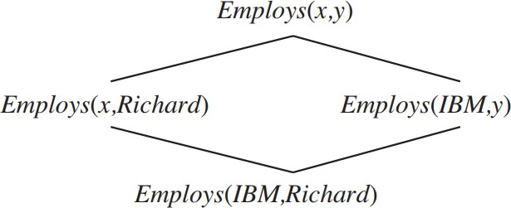
Subsitutey/Richardtogetleftchild,x/IBMtogetrightchild.Laterapplyingthesame yields common child.
Eg:
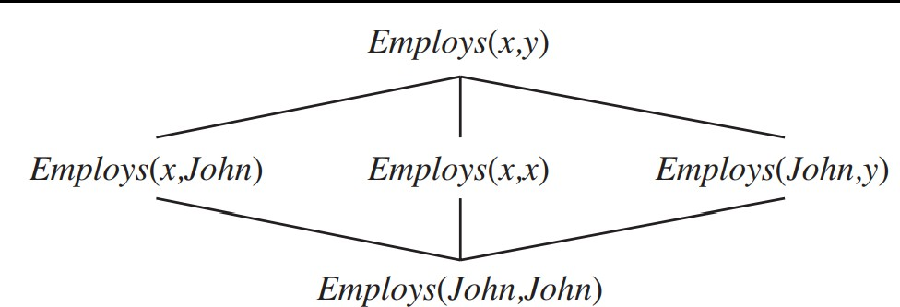

InferenceEngineusingFOL
The inference engine is the component of the intelligent system in artificial intelligence,whichapplieslogicalrulestotheknowledgebasetoinfernewinformation from known facts. The first inference engine was part of the expert system. Inference engine commonly proceeds in two modes, which are:
- Forwardchaining
- Backwardchaining

HornClauseandDefiniteclause:
Horn clause and definite clause are the forms of sentences, which enables knowledge base to use a more restricted and efficient inference algorithm. Logical inference algorithms use forward and backward chaining approaches, which require KB in the form of the first-order definite clause.
Definite clause:A clause which is a disjunction of literals with exactly one positive literal is known as a definite clause or strict horn clause.
Horn clause:A clause which is a disjunction of literals with at most one positive literal is known as horn clause. Hence all the definite clauses are horn clauses.
Example:(¬pV¬qV k).Ithasonlyonepositiveliteralk. It is equivalent to p ∧ q → k.

ForwardChaining
Forwardchainingisalsoknownasa forwarddeductionorforwardreasoningmethod when using an inference engine. Forward chaining is a form of reasoning which start with atomic sentences in the knowledge base and applies inference rules (Modus Ponens) in the forward direction to extract more data until a goal is reached.
The Forward-chaining algorithm starts from known facts, triggers all rules whose premises are satisfied, and add their conclusion to the known facts. This process repeats until the problem is solved.
Example:
"Asperthelaw,itisacrimeforanAmericantosellweaponstohostilenations.Country A, an enemy of America, has some missiles, and all the missiles were sold to it by Robert, who is an American citizen."
Provethat"Robertis criminal."
To solve the above problem, first, we will convert all the above facts into first-orderdefinite clauses, and then we will use a forward-chaining algorithm to reach the goal. Facts Conversion into FOL:
- ItisacrimeforanAmericantosellweaponstohostilenations.(Let'ssayp,q, and r are variables)
American(p) ∧weapon(q) ∧sells(p,q,r)∧hostile(r) →Criminal(p) ...(1)
- CountryAhassomemissiles.?pOwns(A,p)∧ Missile(p).Itcanbewrittenin two definite clauses by using Existential Instantiation, introducing new Constant T1.
Owns(A,T1) (2)
Missile(T1) (3)
- AllofthemissilesweresoldtocountryAbyRobert.
?pMissiles(p) ∧Owns(A,p)→Sells(Robert,p,A) (4)
- Missilesareweapons.
Missile(p)→Weapons(p) (5)
- Enemy of America is known as hostile. Enemy(p, America) →Hostile(p) (6)
- Country A is an enemy of America. Enemy (A, America) (7)
- Robert is American American(Robert) (8)

Forwardchainingproof:
Step-1:
Inthefirststepwewillstartwiththeknownfactsandwillchoosethesentenceswhich do not have implications, such as:American(Robert), Enemy(A, America), Owns(A, T1), and Missile(T1). All these facts will be represented as below.
Step-2:
At the second step, we will see those facts which infer from available facts and withsatisfied premises.
Rule-(1)doesnotsatisfypremises,soitwillnotbeaddedinthefirstiteration. Rule-(2) and (3) are already added.
Rule-(4) satisfy with the substitution {p/T1}, so Sells (Robert, T1, A) is added, which infers from the conjunction of Rule (2) and (3).

Rule-(6)issatisfiedwiththesubstitution(p/A),soHostile(A)isaddedandwhichinfers from Rule-(7).
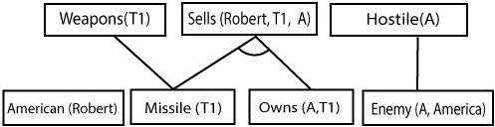
Step-3:
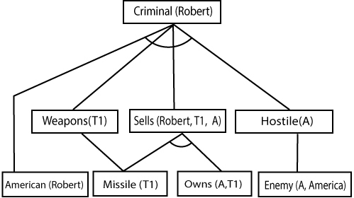
At step-3, as we can check Rule-(1) is satisfied with the substitution {p/Robert, q/T1, r/A}, so we can add Criminal(Robert) which infers all the available facts. And hence we reached our goal statement.
Henceitisprovedthat RobertisCriminalusingforwardchainingapproach.

BackwardChaining:
Backward-chaining is also known as a backward deduction or backward reasoning method when using an inference engine. A backward chaining algorithm is a form of reasoning, which starts with the goal and works backward, chaining through rules to find known facts that support the goal.
Example:
In backward-chaining, we will use the same above example, and will rewrite all therules.
- American(p)∧weapon(q)∧sells(p,q,r)∧hostile(r)→Criminal(p)...(1)
 | Owns(A,T1) (2)
o | Missile(T1)
o | ?pMissiles(p) ∧Owns(A,p)→Sells(Robert,p,A) | . (4)
o | Missile(p)→Weapons(p) (5)
o | Enemy(p,America)→Hostile(p) (6)
o | Enemy(A,America) (7)
o | American(Robert) (8)

Backward-Chainingproof:
InBackwardchaining,wewillstartwithourgoalpredicate,whichisCriminal(Robert), and then infer further rules.
Step-1:
At the first step, we will take the goal fact. And from the goal fact, we will infer other facts,andatlast,wewillprovethosefactstrue.Soourgoalfactis"RobertisCriminal," so following is the predicate of it.
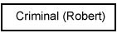
Step-2:
Atthesecondstep,wewillinferotherfactsformgoalfactwhichsatisfiestherules.So as we can see in Rule-1, the goal predicate Criminal (Robert) is present with substitution {Robert/P}. So we will add all the conjunctive facts below the first level and will replace p with Robert.
HerewecanseeAmerican(Robert)isafact,soitisprovedhere.
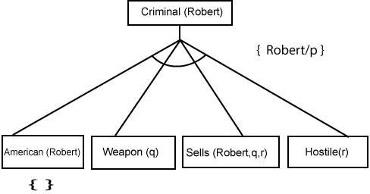
Step-3:tAtstep-3,wewillextractfurtherfactMissile(q)whichinferfromWeapon(q), asitsatisfiesRule-(5).Weapon(q)isalsotruewiththesubstitutionofaconstantT1at q.
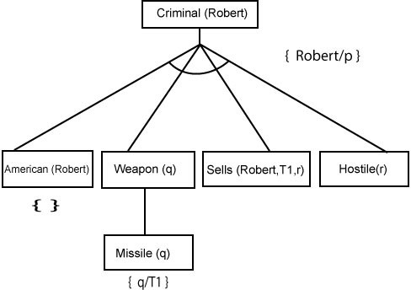
Step-4:

At step-4, we can infer facts Missile(T1) and Owns(A, T1) form Sells(Robert, T1, r) which satisfies theRule- 4, with the substitution of A in place of r. So these two statements are proved here.
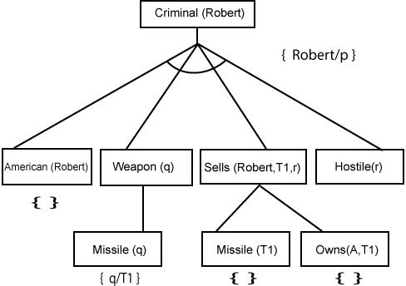
Step-5:
Atstep-5,wecaninferthefact Enemy(A,America) fromHostile(A) whichsatisfies Rule- 6. And hence all the statements are proved true using backward chaining.
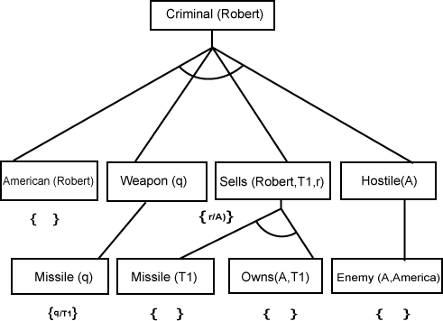

ResolutioninFOL
Resolutionisatheoremprovingtechniquethatproceedsbybuildingrefutationproofs, i.e.,proofsbycontradictions.ItwasinventedbyaMathematicianJohnAlanRobinson in the year 1965. Resolution is used, if there are various statements are given, and we need to prove a conclusion of those statements. Unification is a key concept in proofs by resolutions. Resolution is a single inference rule which can efficiently operate on the conjunctive normal form or clausal form.

Clause:Disjunctionof literals(anatomicsentence) is called a clause. Itis alsoknown as a unit clause.
Conjunctive Normal Form: A sentence represented as a conjunction of clauses is said to be conjunctive normal form or CNF.

Theresolutioninferencerule:
The resolution rule for first-order logic is simply a lifted version of the propositional rule.Resolutioncanresolvetwoclausesiftheycontaincomplementaryliterals,which are assumed to be standardized apart so that they share no variables.
Whereliandmjarecomplementaryliterals.
This rule is also called thebinary resolution rulebecause it only resolves exactly two literals.
Example:
Wecanresolvetwoclauseswhicharegiven below:
[Animal(g(x)VLoves(f(x),x)] and [￢Loves(a,b)V￢Kills(a, b)]
Wheretwocomplimentaryliteralsare: Loves(f(x),x)and￢Loves(a,b)Theseliterals canbeunifiedwithunifierθ=[a/f(x),andb/x] ,anditwillgeneratearesolventclause:
[Animal(g(x)V￢Kills(f(x),x)].

Stepsfor Resolution:
  - Conversionoffactsintofirst-orderlogic.
  - ConvertFOLstatementsintoCNF
  - Negatethestatement whichneedstoprove(proofbycontradiction)
  - Drawresolutiongraph(unification).
Tobetterunderstandalltheabovesteps,wewilltakeanexampleinwhichwewill apply resolution.
Example:
- Johnlikesallkindoffood.
- Appleandvegetablearefood
- Anythinganyoneeatsandnotkilledisfood.
- Anileatspeanutsandstillalive
- Harry eats everything that Anil eats. Prove by resolution that:
- Johnlikes peanuts.
Step-1:ConversionofFactsintoFOL
Inthefirststepwewillconvertallthegivenstatementsintoitsfirstorder logic.

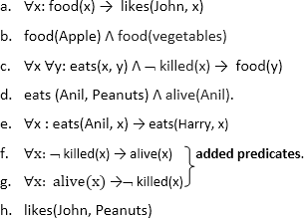
Step-2:ConversionofFOLintoCNF
InFirstorderlogicresolution,itisrequiredtoconverttheFOLintoCNFasCNFform makes easier for resolution proofs.
- Eliminateallimplication(→)andrewrite
  - ∀x¬food(x)Vlikes(John,x)
  - food(Apple)Λfood(vegetables)
  - ∀x∀y¬[eats(x,y)Λ¬killed(x)]Vfood(y)
  - eats(Anil,Peanuts)Λalive(Anil)
  - ∀x¬eats(Anil,x)Veats(Harry,x)
  - ∀x¬[¬killed(x)]Valive(x)
  - ∀x¬alive(x)V ¬ killed(x)
  - likes(John, Peanuts).
- Movenegation(¬)inwardsandrewrite
  - ∀x¬food(x)Vlikes(John,x)
  - food(Apple)Λfood(vegetables)
  - ∀x∀y¬eats(x,y)Vkilled(x)Vfood(y)
  - eats(Anil,Peanuts)Λalive(Anil)
  - ∀x¬eats(Anil,x)Veats(Harry,x)
  - ∀x¬killed(x)]Valive(x)
  - ∀x¬alive(x)V¬ killed(x)
  - likes(John, Peanuts).
- Renamevariablesorstandardizevariables
  - ∀x¬food(x)Vlikes(John,x)
  - food(Apple)Λfood(vegetables)
  - ∀y∀z¬eats(y, z)Vkilled(y)V food(z)
  - eats(Anil,Peanuts)Λ alive(Anil)
  - ∀w¬eats(Anil,w)Veats(Harry,w)
  - ∀g¬killed(g)]Valive(g)
  - ∀k¬alive(k) V¬killed(k)
  - likes(John, Peanuts).
- Eliminateexistentialinstantiationquantifierbyelimination. Inthisstep,wewilleliminateexistentialquantifier∃,andthisprocessisknown asSkolemization. But in this example problem since there is no existential quantifier so all the statements will remain same in this step.

- DropUniversalquantifiers.
Inthisstepwewilldropalluniversalquantifiersinceallthestatementsare not implicitly quantified so we don't need it.
  - ¬food(x)V likes(John,x)
  - food(Apple)
  - food(vegetables)
  - ¬eats(y,z)Vkilled(y)Vfood(z)
  - eats(Anil, Peanuts)
  - alive(Anil)
  - ¬eats(Anil,w)Veats(Harry,w)
  - killed(g)Valive(g)
  - ¬alive(k) V¬killed(k)
  - likes(John, Peanuts).
- Distribute conjunction ∧ over disjunction ¬. This step will not make any change in this problem.

Step-3:Negatethestatementtobeproved
In this statement, we will apply negation to the conclusion statements, which will be written as ¬likes(John, Peanuts)

Step-4: Draw Resolution graph: Now in this step, we will solve the problem by resolution tree using substitution. For the above problem, it will be given as follows:
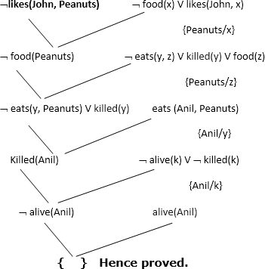
Hencethenegationoftheconclusionhasbeenprovedasacompletecontradictionwith the given set of statements.

ExplanationofResolutiongraph:
- Inthefirststepofresolutiongraph, ¬likes(John,Peanuts),andlikes(John, x)getresolved(canceled)bysubstitutionof {Peanuts/x},andweareleftwith¬ food(Peanuts)

- In the second step of the resolution graph, ¬ food(Peanuts) , and food(z) get resolved (canceled) by substitution of { Peanuts/z}, and we are left with ¬ eats(y, Peanuts) V killed(y) .
- In the third step of the resolution graph, ¬ eats(y, Peanuts) andeats (Anil, Peanuts) getresolvedbysubstitution {Anil/y},andweareleft with Killed(Anil) .
- In the fourth step of the resolution graph, Killed(Anil) and¬ killed(k) get resolve by substitution {Anil/k}, and we are left with ¬ alive(Anil) .
- In the last step of the resolution graph ¬ alive(Anil) and alive(Anil) get resolved.

MODULE-5

ActingUnderuncertainty
A logical agent believes a sentence to be either true or false. Probabilistic agents are thosethathaveadegreeofbeliefaboutthevalidityofagivensentence.Andthebelief could be ranging from 0 to 1.
Uncertainty can arise because of incompleteness and incorrectness in the agents understanding of the properties of the environment. when we are talking of handling uncertainty,oneneedstorecallthatifIamusingfirstorderlogictocopewithcomplex domains, like medical diagnosis or criminal investigation or some form of methods and techniques to figure out false in a system.
Example: diagnosing a toothache – Diagnosis: classic example of a problem with inherentuncertainty–Attempt1:Toothache⇒HasCavity•But:notalltoothachesare causedbycavities.Nottrue!–Attempt2:Toothache⇒Cavity∨GumDisease∨Abscess
∨ etc ∨ etc • To be true: would need nearly unlimited list of options...some unknown. – Attempt 3: Try make causal: Cavity ⇒ Toothache • Nope: not all cavities cause toothaches!
There wouldbe 3 main reasonswhysuch first order logicsystems wouldfail. One, we call it laziness, this is about too much work involved to create the complete set of antecedentsorconsequence,neededtoensureanexceptionlessrule.Anditistoohard to use the enormous rules that result out of this. So, if you are looking for completely covering one of these domains, then it would be too much of task either to list the complete set of incidents or consequence for a given rule or it would be even hard to really get all the rules in the system. Number 2 is about certain ignorance, which is referredtoasthetheoreticalignorance,itisabouttheexpertiseofthearea,whichmay not be sufficient to have complete theory for the domain that is being worked with. And finally we have what is called the practical ignorance. Suppose we know all the rulesyetwemaybeuncertainaboutparticularcases,becauseallthenecessarytestsor evaluations may have not been or possibly cannot be done for that particular case.
Soagent’sknowledgeundersuchasituationcanatbestprovideonlyadegreeofbelief in the relevant sentences. And that is why every sentence in under such a scenario cannot evaluate to being just true or false. We have to associate to each sentence that the knowledge of the agent comprises of to adegree of belief. This is not onlytruefor the medical domain that I have been emphasizing. It is also true for most other judgmental domains like law, business, design, automobile repair, gardening, so on and so forth. So dealing with degrees of belief is what is done through the probability theory, which assigns a numerical degree of belief between 0 and 1 to the sentences.
Probability provides a way of summarizing the uncertainty. And one needs to realize that this uncertainty comes from our laziness and ignorance. Laziness here refers to ourinabilitytocompletelyquantifythedomainandignorancetheirreferencetoeither ourtheoreticalignoranceofthedomainorthepracticalignorancewhenIamworking withcertaincases.Sotomakechoicesthatistomakerationaldecisions,anagentmust firsthavepreferencesbetweenthepossibleoutcomesoftheplansandthisiswherewe use what is called the utility theory.
The utility theory is used to represent and reason with preferences. Here preference refers to options choices, and other alternatives of what is more preferred, outcomes arecompletelyspecifiedstateandtheutilitytheoryisaboutfiguringoutwhichismore useful, or in terms we say the quality of being useful.

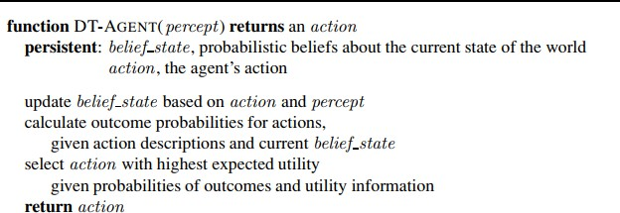

BasicNotationsofProbability
Probability:Probability can be defined as a chance that an uncertain event will occur.Itisthenumericalmeasureofthelikelihoodthataneventwilloccur.Thevalue of probability always remains between 0 and 1 that represent ideal uncertainties.
0≤P(A)≤1,whereP(A)istheprobabilityofaneventA. P(A) = 0,indicates total uncertainty in an event A.
P(A)=1,indicatestotalcertaintyinaneventA.

Wecanfindtheprobabilityofanuncertaineventbyusingthebelow formula.
- P(¬A)=probabilityofanothappeningevent.
- P(¬A)+P(A) =1.
Event:Eachpossibleoutcomeofavariableiscalledanevent.AneventAisanysubset of Ω – Allows us to group possible worlds, e.g., “doubles rolled with dice” – P(A) = Σ{ω∈A} P(ω) – e.g., P(doubles rolled) = P (1,1) + P (2,2) + ... + P (6,6)
Samplespace:Thecollectionofallpossibleeventsiscalledsamplespace.setΩ=all possibleworldsthatmightexist–e.g.,aftertwodiceroll:36possibleworlds(assuming distinguishable dice) – Possible worlds are exclusive and mutually exhaustive. Only onecanbetrue(theactualworld);atleastonemustbetrue –ω∈ Ωisasamplepoint (possible world)
probability space or probability model is a sample space with an assignment P(ω)foreveryω∈ Ωsuchthat:–0≤P(ω)≤1–Σω P(ω)=1–e.g.fordieroll:P(1,1)= P(1,2) = P(1,3) =... = P(6,6) = 1/36
Randomvariables:Random variables are usedtorepresenttheeventsandobjects in the real world.
Apropositionintheprobabilisticworldisthensimplyanassertionthatsomeevent (describing a set of possible worlds) is true. – θ=“doubles rolled” à asserts event “doubles” is true à asserts {[1,1] ∨ [2,2] ∨...∨ [6,6]} is true. – Propositions can be compound:θ=(doubles∧(total>4))–P(θ)=Σω∈θP(ω)àprobabilityofpropositionis sum of its parts
Prior probability:The prior probability of an event is probability computed before observing new information.
Posterior Probability:The probability that is calculated after all evidence or information has taken into account. It is a combination of prior probability and new information.

Conditional probability: Conditional probability is a probability of occurring an event when another event has already happened.
Let's suppose, we want to calculate the event A when event B hasalready occurred,"the probability of A under the conditions of B", it can be written as:
WhereP(A⋀B)=JointprobabilityofaandB P(B)= Marginal probability of B.
If the probability of A is given and we need to find the probability of B, then it will be given as:
It can be explained by using the below Venn diagram, where B is occurred event, so sample space will be reduced to set B, and now we can only calculate event A when event B is already occurred by dividing the probability of P(A⋀B) by P( B ).
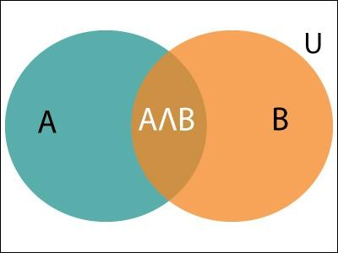

ProbabilityDistributions
One can express the probability of a proposition: –P(Weather=sunny) = 0.6 ; P(Cavity=false) = P(¬cavity)=0.1
Probability Distribution expresses all possible probabilities for some event – So for: P(Weather=sunny)=0.6;P(Weather=rain)=0.1;P(Weather)={0.72,0.1,0.29,0.01} for Weather={sun, rain, clouds, snow}
Hence probability distribution can be seen as totalfunctionthat returns probabilities for all values of Weather. It is normalized, i.e., sum of all probabilities adds up to 1.
JointProbabilityDistribution:forasetofrandomvariables,givesprobabilityforevery combinationofvaluesofeveryvariable.–Givesprobabilityforeveryeventwithinthe sample space – P(Weather, Cavity) = a 4x2 matrix of values:
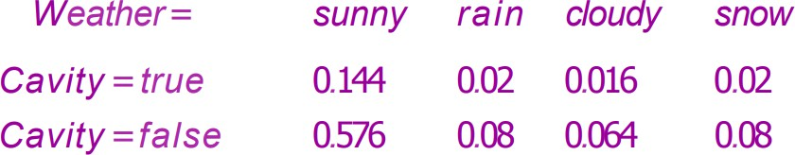
Full Joint Probability Distribution = joint distribution for all random variables in domain. Every probability question about a domain can be answered by full joint distribution, because every event is a sum of sample points (variable/value pairs). if the variables are Cavity, Toothache, and Weather, then the full joint distribution is givenbyP(Cavity,Toothache,Weather).Thisjointdistributioncanberepresentedas a2×2×4tablewith16entries.Becauseeveryproposition’sprobabilityisasumover possibleworlds,afulljointdistributionsuffices,inprinciple,forcalculatingthe

probabilityofanyproposition.
Some variables are continuous, e.g. P(Temp=82.3) = 0.23; P(Temp=82.5)= 0.24; etc.
  - Alsocouldassertranges:P(Temp<85)orP(40<Temp<67)
Wecanexpressdistributionsasaparameterizedfunctionofvalue:•P(X=x)=U[18, 26](x) = uniform density between 18 and 26. It is known as a probability density function(pdf).Pisareallyadensitydistribution;thewholerangeintegratesto1.
Thedistributionpictoriallylookslike:
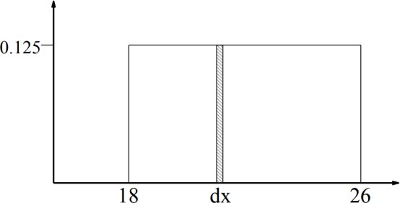

KolomogorovsAxioms:

P(¬a)=1-P(a)
Proof:
P(¬a)=Pω∈¬aP(ω)(Definitionofprobabilityof anyevent)
=Pω∈¬aP(ω) +Pω∈aP(ω) -Pω∈aP(ω)
=Pω∈ΩP(ω)-Pω∈aP(ω)(groupingthefirsttwoterms)
=1-P(a)

Probabilitydistributiononadiscreterandomvariableis1
Proof:LetXbeadiscreterandomvariablesofnevents Then, X={X1,X2, ,Xn}
P(X)=P(X1,X2…,Xn)
=P(X=X1)+P(X=X2)+….+P(X=Xn)

𝑛
=∑
𝑥=1
𝑃(𝑥)

=Pω∈ΩP(ω)(All sample spaces)
=1

P(A|B)=1-P(A’|B)
Proof:
P(B)=P((A∩B)∪(A′∩B))
=P(A∩B)+P(A′∩B) P(A∩B)=P(B)−P(A′∩B)
Divide each term by P(B) P(A∩B)/P(B)=1-P(A′∩B)/P(B)
P(A|B)=1-P(A’|B)(Bydefinitionofconditionalprobability)

Inclusion-Exclusionprinciple
𝑃(𝐴∧𝐵)=𝑃(𝐴)+𝑃(𝐵)−𝑃(𝐴∨𝐵)
Proof:
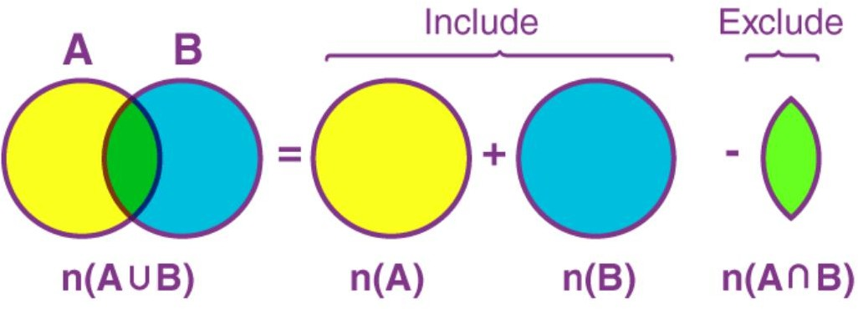
P(AUB)=P(AU(B-A))
=P(A)+P(B-A)
=P(A)+P(B-A)+P(A∩B)-P(A∩B)
=P(A)+P((B-A)U(A∩B))-P(A∩B)
=P(A)+P(B)- P(A∩B)

Eg: Given that bus arriving late=0.3 and a student oversleepingprobability is 0.4., find the probability that student gets late

Let A=event that bus arrives late B=eventthatstudentoversleeps
Given,P(A)=0.3and P(B)=0.4
Asperinclusion-exclusionprinciple
P(studentgetslate)=P(busarriveslateorstudentoversleeps)
=P(AUB)
=P(A)+P(B)- P(A∩B)
=0.3+0.4-P(A).P(B) [as A and B can both occur
independently]
=0.3+0.4-0.3*0.4=0.7-0.12=0.58

Expectationsandprobability
A gambling theory where a money is attached to the outcome of the probability is called expectations. Think of it as a game between two agents: Agent 1 states, “my degree of belief in event a is 0.4.” Agent 2 is then free to choose whether to wager for oragainstaatstakesthatareconsistentwiththestateddegreeofbelief.Thatis,Agent 2 could choose to accept Agent 1’s bet thata will occur, offering $6 against Agent 1’s
$4.OrAgent2couldacceptAgent1’sbetthat ¬awilloccur,offering$4againstAgent 1’s $6. Then we observe the outcome of a, and whoever is right collects the money. If anagent’sdegreesof beliefdonotaccuratelyreflecttheworld,thenyou wouldexpect that it wouldtendtolosemoneyoverthelongrunto anopposingagent whosebeliefs more accurately reflect the state of the world

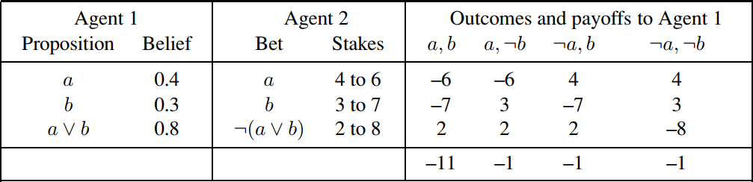
Thusinallcasesagent1losesmoneyduetothebeliefvaluesithas attached.

InferenceusingFullJointDistributions
Logical Inference is asking whether something is true (entailed), given the KB. However,Probabilistic Inference is about asking how likely something is, given the KB . The process is to just compute the posterior probability for query proposition, givenKB!.WeusethefulljointprobabilitydistributionastheKB!Whichcontainsthe probability of all possible worlds!. The mechanism of the inference is to look up the probabilityofaqueryproposition.Further,extractandsumuptheappropriate“slice” of the joint distribution.
Example:Consider aworldwithjustthreebooleanvariables –Toothache(hasoneor not) – Cavity (has or not) – Catch (dentists tool catches or not).
Startwiththefulljointdistributionforthisworld:
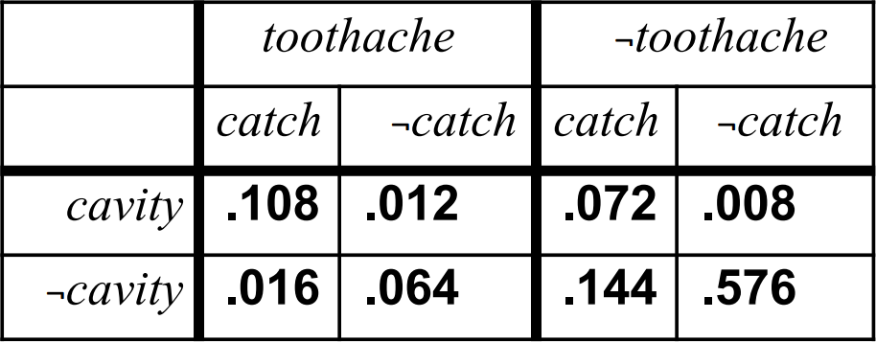

Marginalization:
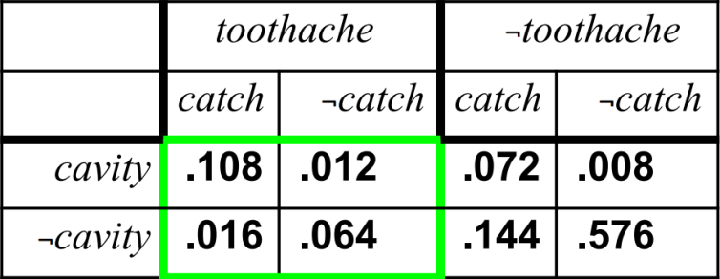
Sumupprobabilitiesacrossvaluesofother(non-specified)variables.Inthiscase: Cavity and Catch.
Generally:P(Y)=Σz∈ZP(Y,z),oralso,byproductrule:P(Y)=Σz∈ZP(Y|z)P(z)

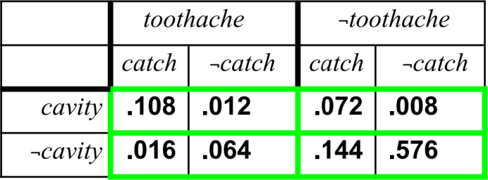
Mutual Exclusion
P(cavity∨toothache)=0.108+0.012+0.072+0.008+0.016+0.064=0.28
Foranypropositionφ,theP(φ)=sumtheatomiceventswhereitistrue: P (φ) = Σω:ω|=φP (ω)

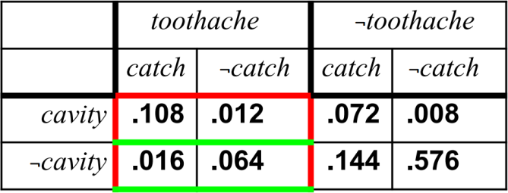
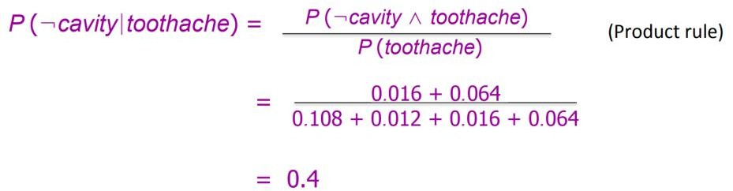
Conditionalprobabilities

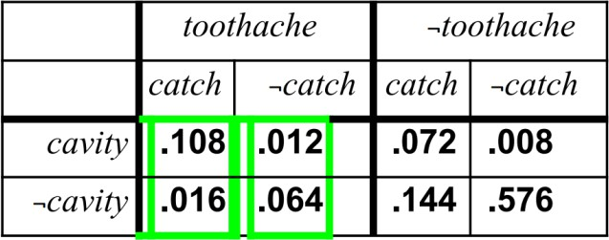
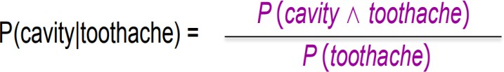
Normalization

Denominatorcanbeviewedasanormalizationconstantαforthedistribution
P(Cavity|toothache)ensuresthattheprobabilityofthedistributionaddsupto1.
P(Cavity|toothache)=αP(Cavity,toothache)
=α[P(Cavity,toothache,catch)+P(Cavity,toothache, ¬catch)]
=α[(0.108,0.016)+(0.012,0.064)]
=α (0.12, 0.08) =(0.6, 0.4)

Notethatproportionsbetween(0.12,0.08)and(0.6,0.4)aresame.Thelatterarejust normalized by application of α to add up to 1. So if α just normalizes, one could also normalize “manually” à divide by sum of two.
Problems

Inashipmentof20apples,3arerotten.3applesarerandomlyselected.What is the probability that all three are rotten if the first and second arenot replaced?
Solution:
P(firstappleisrotten)=3/20
P(second apple is rotten)=2/19 (as first apple is not replaced) P(thirdappleisrotten)=1/18(assecondappleisalsonotreplaced) P(all three are rotten)=3/20 * 2/19 * 1/18=1/1140

Adieiscasttwiceandacoinistossedtwice.Whatistheprobabilitythatthe die will turn a 6 each time and the coin will turn a tail every time?

Solution:
P(die turn up 6 first time)=1/6 P(dieturnup6secondtime)=1/6 P(cointurnuptailfirst time)=1/2
P(cointurnuptailsecond time)=1/2
P(dieturnup6andcointurnuptaileachtime)=1/6*1/6*1/2*1/2=1/144

Aninstructorhasaquestionbankwith300EasyT/F,200DifficultT/F,500Easy MCQ,and 400 Difficult MCQ.Ifaquestion is selectedrandomlyfromthequestionbank,Whatistheprobabilitythatitisaneasyquestiongiven that it is an MCQ?
Solution P(Easy)=800/1400 P(MCQ)=900/1400
P(Easy∧ 𝑀𝐶𝑄)=500/1400
P(Easy|MCQ)=P(Easy∧𝑀𝐶𝑄)/P(MCQ)=500/900=5/9

Independenceofvariables
The problem offull joint distribution get huge fast with the cross-product of all variables, all values in their range. Different probability for every variables...conditionalonallvaluesofallothervariablesisrequired.Butareallofthese variables really related? Is every variable really related to all others?
ConsiderP(toothache,catch,cavity,cloudy)à2x2x2x4jointdistr.=32entries–
Byproductrule:
P(toothache, catch, cavity, cloudy) = P(cloudy|toothache,catch,cavity) P(touchache,catch,cavity).
Butittheweatherreallyconditionalontoothaches,cavitiesanddentist’stools?No!–
So realistically: P(cloudy|toothache,catch,cavity) = P(cloudy). So then actually:
P(toothache,catch,cavity,cloudy)=P(cloudy) P(touchache,catch,cavity).

We say that cloudy and dental variables are independent (also absolute independence). Effectively: the 32-element joint distribution table becomes one 8- element table + 4-element table
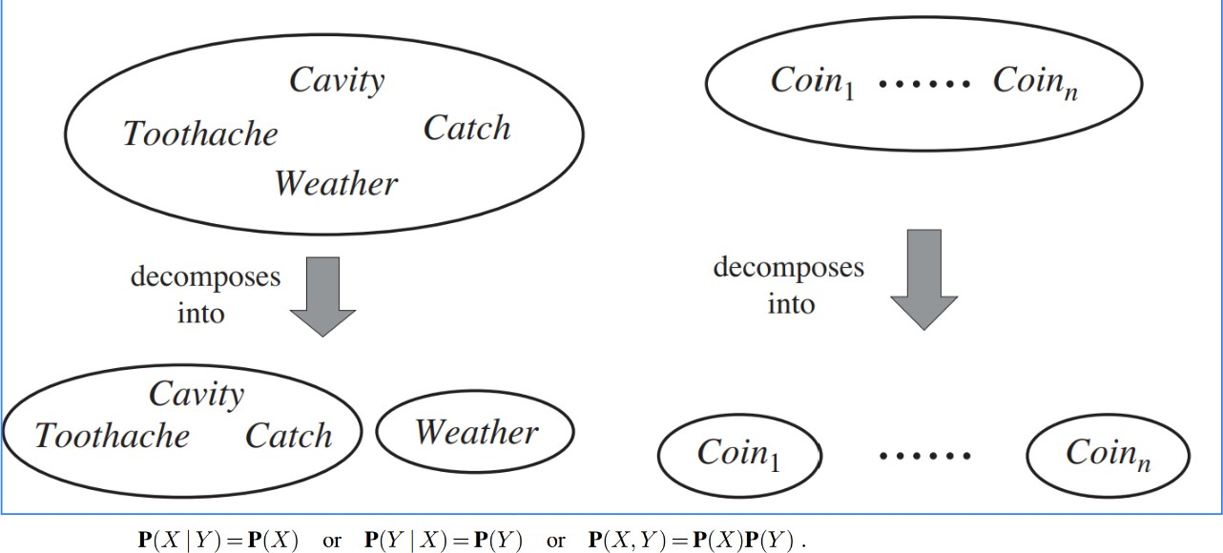
Independence assertions based on judgment, specific knowledge of domain. It can dramatically reduce information needed for full joint distribution

Bayes'theorem:
Bayes'theoremisalsoknownasBayes'rule,Bayes'law,orBayesianreasoning,which determines the probability of an event with uncertain knowledge. In probability theory,itrelatestheconditionalprobabilityandmarginalprobabilitiesoftworandom events. Bayes' theorem was named after the British mathematician Thomas Bayes. TheBayesian inferenceis an application of Bayes' theorem, which is fundamental to Bayesian statistics.
ItisawaytocalculatethevalueofP(B|A)withtheknowledgeof P(A|B).
Bayes'theoremcanbederivedusingproductruleandconditionalprobabilityofevent A with known event B:
Asfromproductrulewecan write:
P(A⋀B)=P(A|B) P(B)or
Similarly,theprobabilityofeventBwithknowneventA:
P(A⋀B)=P(B|A)P(A)
Equatingrighthandsideofboththeequations,wewillget:
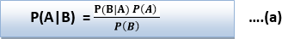
Theaboveequation(a)iscalledasBayes'ruleorBayes'theorem.Thisequationisbasic of most modern AI systems for probabilistic inference.
It shows the simple relationship between joint and conditional probabilities. Here, P(A|B)isknownas posterior,whichweneedtocalculate,anditwillbereadas Probability of hypothesis A when we have occurred an evidence B.
P(B|A) is called the likelihood, in which we consider that hypothesis is true, then we calculate the probability of evidence.
P(A) is called theprior probability, probability of hypothesis before considering the evidence

P(B)iscalledmarginalprobability,pureprobabilityofan evidence.
In the equation (a), in general, we can write P (B) = P(A)*P(B|Ai), hence the Bayes' rule can be written as:
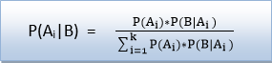
WhereA1,A2,A3,. ,Anisasetofmutuallyexclusiveandexhaustiveevents.
ApplyingBayes'rule:
Bayes'rule allows us tocompute thesingleterm P(B|A)in terms ofP(A|B), P(B),and
P(A).Thisisveryusefulincaseswherewehaveagoodprobabilityofthesethreeterms andwanttodeterminethefourthone.Supposewewanttoperceivetheeffectofsome unknown cause, and want to compute that cause, then the Bayes' rule becomes:
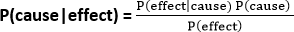

Eg: a doctor knows that the disease meningitis causes the patient to havea stiff neck,say, 70% of the time. probability that a patient has meningitisis 1/50,000, and probability that any patient has a stiff neck is 1%.Findprobability of meningitis due to stiff neck
- TheKnownprobabilitythatapatienthasmeningitisdiseaseis1/50,000.
- TheKnownprobabilitythatapatienthasastiffneckis1%.
Letsbethepropositionthatpatienthasstiffneckandmbethepropositionthatpatient has meningitis. , so we can calculate the following as:
P(m|s) = 0.7 P(m)=1/50000 P(s)= .02
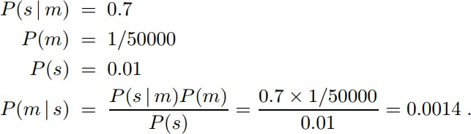

ProblemsonBayes Theorem:

Inaneighbourhood,90%childrenwerefallingsickduefluand10%duetomeasles and no other disease. The probability of observing rashes formeasles is 0.95 and for flu is 0.08. If a child develops rashes, find thechild’s probability of having flu.
Solution:
Let,
F:childrenwithflu
M:childrenwithmeasles
R:childrenshowingthesymptomofrash P(F) = 90% = 0.9
P(M)=10%=0.1
P(R|F)=0.08

P(R|M)=0.95
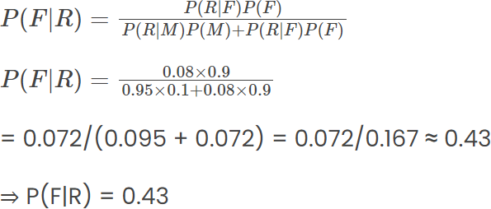

BayesTheoremwithcombinedevidence
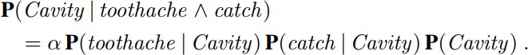
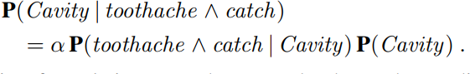

Naive Bayes classifiers are a collection of classification algorithms based on Bayes’ Theorem. It is not a single algorithm but a family of algorithms where all of them share a common principle, i.e. every pair of features being classified is independentof each other. To start with, let us consider a dataset.One of the most simple and effective classification algorithms, the Naïve Bayes classifier aids in the rapid development of machine learning models with rapid prediction capabilities. Naïve Bayes algorithm is used for classification problems. It is highly used in text classification. Intext classification tasks,datacontainshighdimension (aseachword represent one feature in the data). It is used in spam filtering, sentiment detection, rating classification etc. The advantage of using naïve Bayes is its speed. It is fast and making prediction is easy with high dimension of data.
The “Naive” part of the name indicates the simplifying assumption made by the Naïve Bayes classifier. The classifier assumes that the features used to describean observation are conditionally independent, given the class label. The “Bayes” part of the name refers to Reverend Thomas Bayes, an 18th-century statistician and theologian who formulated Bayes’ theorem.

ProbabilityandWumpusworld
Uncertainty arises in the wumpus world because the agent’s sensors give only partial information about the world. For example, Figure below shows a situation in which each of the three reachable squares—[1,3], [2,2], and [3,1]—might contain a pit. Pure logicalinferencecanconcludenothingaboutwhichsquareismostlikelytobesafe,so a logical agent might have to choose randomly. Probabilistic agent performs better than logic agent.

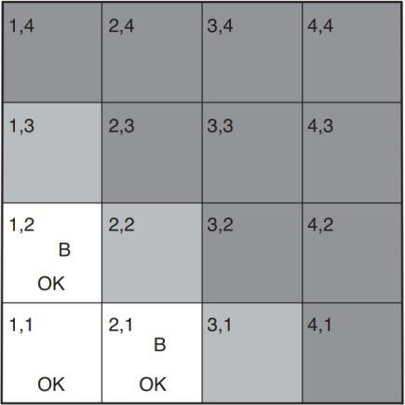
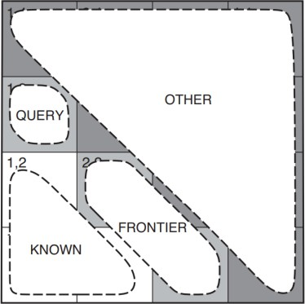
Theaimistocalculatetheprobabilitythateachofthethreesquarescontainsapit.The relevant properties of the wumpus world are that (1) a pit causes breezes in all neighboring squares, and (2) each square other than [1,1] contains a pit with probability 0.2. Wumpus world is divided into three regions: Query node whose probability is seeked. Known nodes whose probability is known. Frontier nodes are nodes adjacent to known nodes except query node. Remaining nodes in the Wumpus world form other nodes.
Differentprobabilitycalculationsareshown.
Case-1:[1,3]asapitandvariouscombinationsoffrontiersarecomputed.
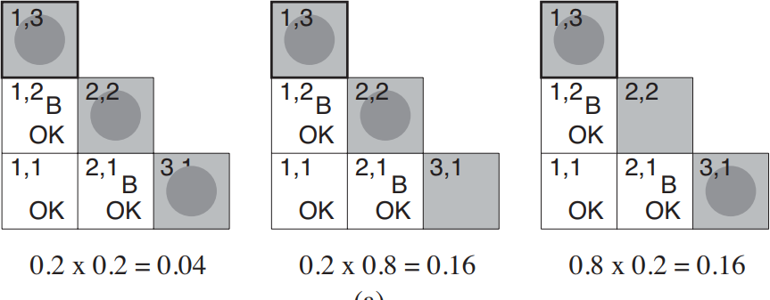
Case-2:[1,3]donothaveputandvariouscombinationsoffrontiersarecomputed.
